

**Enterprise Information System**

**Assignment 3**

**Manahil Khattak 23i-5535**

**Sumayyah Saeed 23i-5567**

**Amnah Asrar 23i-5550**

**Huda Imran 23i-5544**

**Syed Zamin Raza 22i-5501**

Table of Contents

**a)****Introduction** 8

Industry: 8

**E-Commerce.** 8

Project Title: 8

15 Business Processes: 8

**Team Members and Roles:** 9

**Business Problem Statement:** 9

**Proposed Solution:** 9

**System Objectives:** 10

**Scope and Limitations:** 10

Scope: 10

Limitations: 10

**b) Technology Stack** 10

Backend: Spring Boot (Java, JPA/Hibernate) 11

Frontend: React.js 11

The Supply Chain Management (SCM) Frontend is a React-based dashboard designed to integrate with a Java Spring Boot backend that manages suppliers, procurement, catalog, inventory, forecasting, warehouse storage, picking/packing, shipments, tracking, returns, and reconciliation processes. 11

The frontend provides operational visibility through: 11

• Real-time data fetching 11

• CRUD operations across all entities 11

• Monitoring dashboards 11

• Alerts & exceptions 11

• Charts and analytics 11

This documentation describes the architecture, API integration, routing, and UI components, along with placeholders for screenshots. 11

Database: MySQL 11

Testing: Postman 11

Deployment: AWS 12

Justification Summary 12

Technology Stack Justification 12

**c) System Architecture** 13

1. Architecture Overview 13

Layers: 13

Key Architectural Decisions: 13

Package Structure 14

2. Architecture Diagram: 15

3. Component Explanation 15

Client Layer (React.js Frontend) 15

API Layer (Spring Boot Controllers) 15

Service Layer (Business Logic) 16

Data Layer (Repositories + Database) 16

4. Request/Response Flow 16

5. Cross-Process Integration Design 17

Integration Strategy 17

Key Integration Points 17

Data Flow Between Processes 18

Entity Design Strategy 19

Primary Key Strategy: 19

Audit Fields: 19

DTO Pattern Implementation 19

Separation of Concerns: 19

Example: 20

Repository Design 20

Custom Queries for Business Logic: 20

Service Layer Business Logic 21

Transaction Management: 21

Business Rule Enforcement: 21

**d) Implementation Details** 22

1. Code structure 22

15 Business process Classes: 22

2. Error Handling Strategy 33

Global Exception Handling 33

3. Validation Strategy 34

**API Design & REST Conventions** 35

REST Endpoint Design 35

Consistent URL Patterns: 35

Response Standardization 36

Success Response Format: 36

Error Response Format: 37

**Database transaction management** 37

Database Design & Performance 37

Indexing Strategy 37

Relationship Mapping 38

One-to-Many Relationships: 38

Many-to-Many Relationships: 38

Strategy: 39

Error handling within transactions: 39

Performance: 39

**e) Integration Documentation** 40

1. How all 15 processes integrate 40

Integration principles: 40

2. Data flow between processes with arrows 40

3. Inter-process dependencies 41

4. API call sequences (concrete examples for 3 major workflows) 41

Order placement → fulfill → ship (API sequence) 41

Low-stock alert → PO → receiving (API sequence) 41

Exception handling (API sequence) 41

**f) Postman Collection:** 42

**g) API and Error Testing and Results of 15 Processes:** 43

Process#01 43

Error TESTING SCENARIOS For Process 1: 46

PROCESS 2: 48

Error Testing Scenarios For Process 2: 51

PROCESS 3: 52

Error Testing Scenarios for Process 3: 56

PROCESS 4: 56

ERROR Testing SCENARIOS FOR PROCESS 4 60

PROCESS 5: 61

Error Scenarios for Process 5 66

PROCESS 6: 67

API TO TEST LOW STOCK ALERT 71

PROCESS 7: 78

ERROR SCENARIOS FOR PROCESS 7 82

PROCESS 8: 83

ERROR SCENARIOS FOR PROCESS 8 87

PROCESS 9: 88

ERROR SCENARIOS FOR PROCESS 9 92

PROCESS 10: 93

ERROR SCENARIOS FOR PROCESS 10 98

PROCESS 11 99

ERROR SCENARIOS FOR PROCESS 11 104

PROCESS 12: 105

ERROR SCENARIOS FOR PROCESS 12 108

PROCESS 13 109

ERROR SCENARIOS FOR PROCESS 13 113

PROCESS 14: 114

ERROR SCENARIOS FOR PROCESS 14 120

PROCESS 15: 122

ERROR SCENARIOS FOR PROCESS 15 126

**h) Database Design:** 127

Table Structures and Relationships 127

Relationships: 170

CRUD Operations for 15 Main Business Processes 171

1. Inventory Management & Stock Control 171

2. Purchase Order Processing 172

3. Warehouse & Storage Management 173

4. Order Fulfillment & Picking 174

5. Quality Control & Inspection 175

6. Shipping & Dispatch Management 177

7. Delivery & Tracking Management 178

8. Returns Processing 179

9. Supplier & Contract Management 179

10. Demand Forecasting & Planning 180

11. Goods Receipt & Inspection 181

12. Package & Shipment Preparation 181

13. Inventory Reconciliation 182

14. Customer Order Management 183

15. Exception & Resolution Management 183

Primary Data Flow 184

Database Design Documentation 185

Database Design Rationale 185

Normalization Approach 186

Constraints and Their Purposes 186

Constraint Categories by Business Purpose 188

Entity Relationship Diagram: 188

**i)** **Frontend – Supply Chain Management System** 190

1. Project Overview 190

2. Technology Stack 190

3. Project Setup 190

4. API Integration (services/api.js) 192

5. Routing Structure (App.jsx) 193

6. Page-Level Documentation 194

6.1 Dashboard (Charts + Analytics) 194

6.2 Supplier Management 196

6.3 Vendor Contract Management 198

6.4 Procurement 199

6.5 Receiving & Inspection 202

6.6 Catalog & Stock Management 205

6.7 Inventory Monitoring & Alerts 207

6.8 Forecasting & Reorder Planning 208

6.9 Warehouse Storage 209

6.10 Picking & Packaging 210

6.11 Quality Control 211

6.12 Shipment Scheduling 212

6.13 Tracking Updates 213

6.14 Delivery Exceptions 214

6.15 Returns Processing 214

6.16 Reconciliation & Reporting 215

7. Testing & Validation 216

**Conclusion** 217

# **Introduction**

## Industry:

**E-Commerce.**

## Project Title:

**Smart Inventory and Supply Chain Management System for E-Commerce**

## 15 Business Processes:

* + - Process 1: Inventory Monitoring (2 APIs)
    - Process 2: Warehouse Management (2 APIs)
    - Process 3: Demand Forecasting (2 APIs)
    - Process 4: Supplier Management (2 APIs)
    - Process 5: Order Processing (2 APIs)
    - Process 6: Procurement (2 APIs)
    - Process 7: Receiving Goods (2 APIs)
    - Process 8: Quality Control (2 APIs)
    - Process 9: Picking & Packing (2 APIs)
    - Process 10: Route Optimization (2 APIs)
    - Process 11: Shipment Management (2 APIs)
    - Process 12: Tracking (2 APIs)
    - Process 13: Delivery Exceptions (2 APIs)
    - Process 14: Returns Processing (2 APIs)
    - Process 15: Analytics & Reporting (2 APIs)

# **Team Members and Roles:**

| **Team Member** | **Role** | **Key Responsibilities** |
| --- | --- | --- |
| Person 1 | **Backend Development Lead** | Designed and implemented RESTful APIs for core processes (Supplier, Procurement, Orders) using Spring Boot |
| Person 2 | **Database Architect & SQL Documentation Lead** | Created normalized database schema, entity relationships, and SQL documentation |
| Person 3 | **API Testing Lead (Postman Expert)** | Developed and validated all API endpoints through Postman collections and automated test cases |
| Person 4 | **Frontend Developer** | Built React.js interface integrating with backend APIs using Fetch API |
| Person 5 | **Documentation Lead + DevOps (Bonus)** | Prepared comprehensive system documentation, oversaw AWS deployment. |

# **Business Problem Statement:**

E-commerce platforms today face major challenges in managing their supply chain efficiently, from procurement delays and inaccurate stock counts to shipment errors and lack of real-time delivery tracking. Many existing systems are fragmented, with separate tools for inventory, logistics, and order tracking, leading to miscommunication, late deliveries, and unsatisfied customers.  
Businesses require an **integrated, automated, and transparent solution** that synchronizes all supply chain activities, from warehouse to doorstep, in a centralized platform.

# **Proposed Solution:**

The **Smart Inventory and Supply Chain Management System** is a **modular web-based platform** designed to streamline the entire e-commerce fulfillment cycle. It integrates 15 processes, from supplier onboarding to delivery tracking, under one ecosystem.  
The system uses **Spring Boot (Java)** for backend logic, **React.js** for the user interface, and **MySQL** for database management. Each process is accessible via a RESTful API, enabling scalability and integration with external vendor systems.  
This approach ensures that all operations, procurement, inventory updates, quality assurance, and delivery tracking, are automated, monitored, and recorded in real time for transparency and accuracy.

# **System Objectives:**

1. To automate and simplify the entire e-commerce supply chain workflow.
2. To minimize manual errors and improve coordination between procurement, warehouse, and logistics teams.
3. To provide real-time visibility of order and shipment status for both administrators and customers.
4. To enable fast API-driven integration for front-end applications and external systems.
5. To ensure accurate, up-to-date inventory data and improve customer satisfaction through reliable delivery tracking.

# **Scope and Limitations:**

## Scope:

* The system covers 15 interconnected business processes, divided among five development modules.
* Each module includes CRUD operations through REST APIs, ensuring modularity and ease of testing.
* Integration between backend, frontend, and database enables a full end-to-end flow from order placement to final delivery.
* The system architecture follows MVC and Repository design patterns, promoting scalability and maintainability.
* Optional AWS deployment demonstrates DevOps automation and real-time hosting capability.

## Limitations:

* The system currently focuses on process automation and API-level communication rather than advanced AI-based decision-making.
* Real-world logistics integrations are simulated via sample endpoints.
* The user interface is built for demonstration purposes and may require additional optimization for production environments.
* Cloud deployment is optional (bonus), depending on time and infrastructure availability.

# **b) Technology Stack**

The E-Commerce Inventory and Supply Chain Management System integrates a robust and modern technology stack to ensure reliability, scalability, and efficiency across 15 business processes. The chosen technologies enable seamless communication between the backend, frontend, and database layers, while also supporting testing and potential cloud deployment.

## ****Backend: Spring Boot (Java, JPA/Hibernate)****

Spring Boot was chosen as the core backend framework due to its simplicity, modularity, and strong integration capabilities. It allows rapid API development with minimal configuration, supports layered architecture (controller, service, repository), and ensures efficient data handling through JPA/Hibernate ORM. Java provides the robustness and type-safety needed for enterprise-level applications, ensuring the system’s stability and scalability. The backend exposes RESTful APIs to handle all business processes, from inventory monitoring to shipment tracking and delivery updates.

## ****Frontend: React.js****

## The Supply Chain Management (SCM) Frontend is a React-based dashboard designed to integrate with a Java Spring Boot backend that manages suppliers, procurement, catalog, inventory, forecasting, warehouse storage, picking/packing, shipments, tracking, returns, and reconciliation processes.

## The frontend provides operational visibility through:

## • Real-time data fetching

## • CRUD operations across all entities

## • Monitoring dashboards

## • Alerts & exceptions

## • Charts and analytics

## This documentation describes the architecture, API integration, routing, and UI components, along with placeholders for screenshots.

## ****Database: MySQL****

MySQL was selected for its reliability, performance, and wide community support. It effectively stores relational data for suppliers, inventory, orders, and shipments. The use of JPA/Hibernate simplifies interaction with MySQL by automatically mapping Java entities to database tables. Proper indexing and normalization ensure quick query performance and maintain data integrity across all 15 interconnected business processes.

## ****Testing: Postman****

Postman was used extensively for API testing and validation. It enables developers and testers to verify each API’s functionality, response accuracy, and error handling. Each of the 30 APIs (2 per process) was tested under multiple scenarios, including success, validation failure, and missing data, ensuring the system’s robustness. Postman’s documentation and collection export features made it easy to share and reproduce tests across team members.

## ****Deployment: AWS****

Amazon Web Services (AWS) provides a cloud-based environment for deployment, offering scalability, flexibility, and high availability. Using AWS EC2 and RDS, the system can be deployed for real-world scalability, while S3 buckets can store static frontend files. Though deployment was optional, AWS was selected for its cost-effectiveness and enterprise-grade performance if the system is scaled in production.

## ****Justification Summary****

Each technology was chosen to balance **performance, scalability, and ease of collaboration**:

## Technology Stack Justification

| Component | Technology | Justification |
| --- | --- | --- |
| **Framework** | Spring Boot 3.x | Rapid development, production-ready features |
| **Database** | MySQL 8.0 | ACID compliance, enterprise reliability |
| **ORM** | Spring Data JPA | Reduced boilerplate, built-in CRUD operations |
| **Validation** | Bean Validation 3.0 | Declarative validation, reusable constraints |
| **Build Tool** | IntelliJ Maven | Dependency management, standard in Java ecosystem |

* **Spring Boot + Java** ensures a structured, maintainable backend.
* **React.js** provides an interactive and responsive user experience.
* **MySQL** offers reliable relational data storage.
* **Postman** ensures every endpoint works as expected before integration.
* **AWS** allows future-ready cloud deployment and scalability.

Together, this stack forms a cohesive ecosystem capable of managing all inventory, logistics, and delivery operations efficiently, from supplier onboarding to customer delivery updates.

# **c) System Architecture**

The E-Commerce Inventory and Supply Chain Management System follows a well-structured **multi-layered architecture** that ensures scalability, maintainability, and separation of concerns. The system is designed using **Spring Boot** at the backend, **React.js** at the frontend, and **MySQL** as the database, following industry-standard design principles such as **MVC (Model-View-Controller), Repository,** and **DTO** patterns.

## ****1. Architecture Overview****

The architecture consists of **four main layers** that interact seamlessly to support all 15 business processes, from supplier management and procurement to shipment tracking and delivery updates.

### ****Layers:****

1. **Client Layer (Frontend - React.js)**
2. **API Layer (Spring Boot Controllers)**
3. **Service Layer (Business Logic)**
4. **Data Layer (Repositories + Database)**

These layers are connected through RESTful APIs and designed to ensure that the frontend, backend, and database can evolve independently without breaking the system.

The system follows a **layered microservices-inspired architecture** within a monolithic Spring Boot application. Each of the 15 business processes is implemented as an independent module while sharing common infrastructure.

## Key Architectural Decisions:

* **Modular Monolith:** 15 separate packages for each business process
* **RESTful API Design:** Consistent REST conventions across all endpoints
* **Domain-Driven Design:** Each process represents a bounded context
* **Repository Pattern:** Abstract data access layer
* **DTO Pattern:** Separation between persistence and API models

## Package Structure

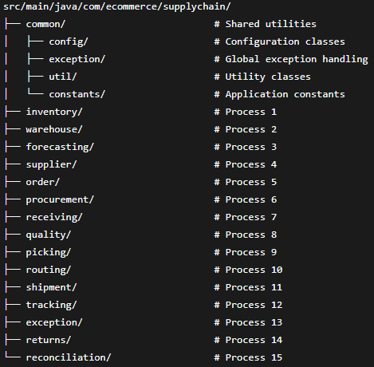

1. Architecture Diagram: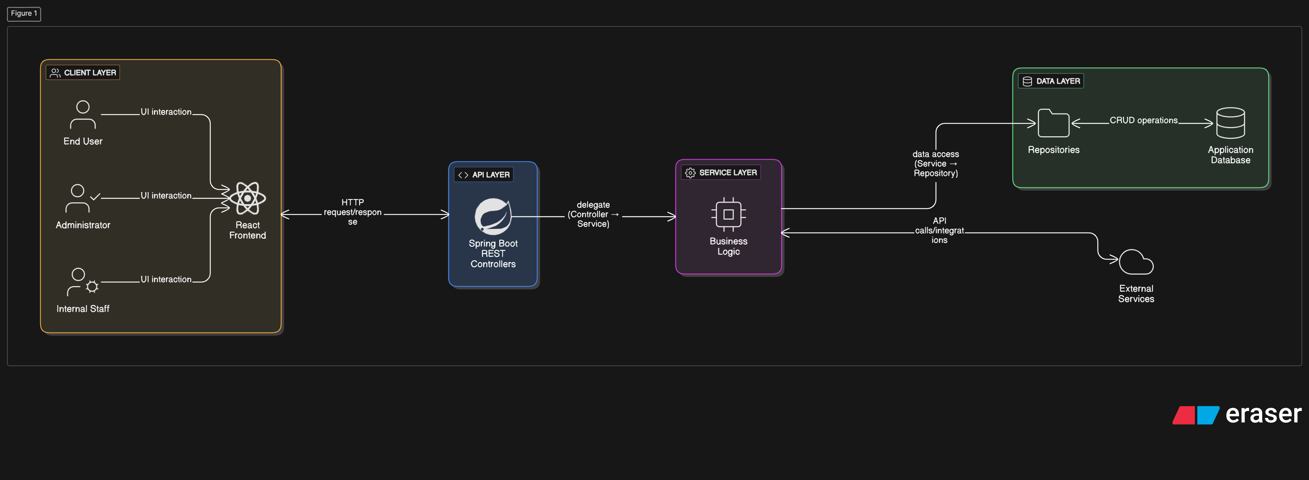

## ****3. Component Explanation****

### ****Client Layer (React.js Frontend)****

The client layer of the Supply Chain Management System is a React (Vite)–based frontend that provides an intuitive, responsive dashboard for all supply chain operations, including suppliers, procurement, catalog, inventory, forecasting, warehouse storage, picking/packing, shipments, tracking, returns, and reconciliation. It integrates directly with the Spring Boot backend using a centralized Fetch API request wrapper that handles JSON parsing, error handling, and all RESTful communication. The UI is built with HTML, CSS, and minimal vanilla styling, while Recharts enables real-time analytics and visualizations across monitoring modules. The application is structured around modular pages—such as SupplierManagement, Procurement, CatalogStockManagement, InventoryMonitoring, DemandForecasting, WarehouseStorage, TrackingUpdates, DeliveryExceptions, and more—each responsible for fetching and managing its own operational data through functions exported from services/api.js. Navigation is implemented using React Router v6 with active route highlighting via <NavLink>, ensuring smooth movement across all SCM workflows. Overall, the frontend ensures real-time visibility, CRUD functionality, alerts and exceptions, and an efficient user experience across the entire supply chain.

### ****API Layer (Spring Boot Controllers)****

The API layer serves as the bridge between the frontend and the backend’s core logic.

* It consists of REST controllers such as InventoryController, OrderController, and ShipmentController.
* Each controller defines endpoints like /api/orders, /api/shipments, or /api/tracking.
* The controllers receive requests from the frontend, validate inputs, and pass the data to the appropriate service class.
* Responses are returned in **JSON** format, ensuring smooth integration with the React frontend.

### ****Service Layer (Business Logic)****

The service layer contains the main business rules and workflows of the system.

* It processes data, applies logic, and interacts with repositories.
* For example, when an order is placed, the service layer checks inventory availability, updates stock, and creates shipment details.
* This layer ensures that all 15 business processes (like procurement, shipment scheduling, tracking, and exception handling) operate according to business rules.
* **DTOs (Data Transfer Objects)** are used here to ensure data consistency between layers and prevent exposing database entities directly to the client.

### ****Data Layer (Repositories + Database)****

The data layer manages all database interactions.

* **Spring Data JPA** repositories abstract away boilerplate SQL, allowing simple method calls like save(), findById(), and deleteById().
* The database used is **MySQL**, which stores relational data for all processes, including suppliers, orders, shipments, and customers.
* **Hibernate ORM** handles entity-to-table mapping automatically based on annotations in model classes.
* The data layer ensures integrity and persistence across all system operations.

## ****4. Request/Response Flow****

The flow of data through the system follows a clear and logical sequence:

1. **Client Request:**  
   The React frontend sends an HTTP request (GET, POST, PUT, or DELETE) using Axios to a specific API endpoint (e.g., /api/shipments/dispatch).
2. **API Controller Handling:**  
   The Spring Boot Controller receives the request, validates input data, and forwards it to the corresponding Service class.
3. **Business Logic Execution:**  
   The Service Layer processes the request, applies business rules, and interacts with Repositories to fetch or update data.
4. **Database Interaction:**  
   The Repository Layer communicates with MySQL through Hibernate to perform the necessary CRUD operation.
5. **Response Generation:**  
   The Service Layer wraps the result into a DTO, and the Controller sends a JSON response back to the frontend.
6. **Frontend Display:**  
   React receives the response and updates the UI dynamically — for example, showing shipment status updates or inventory changes in real time.

## 5. Cross-Process Integration Design

### Integration Strategy

The system uses **internal service calls** for process integration rather than external API calls, ensuring:

* **Transactional consistency** across related operations
* **Reduced network overhead**
* **Simplified error handling**
* **Better performance**

### Key Integration Points

#### **Order Fulfillment Workflow**

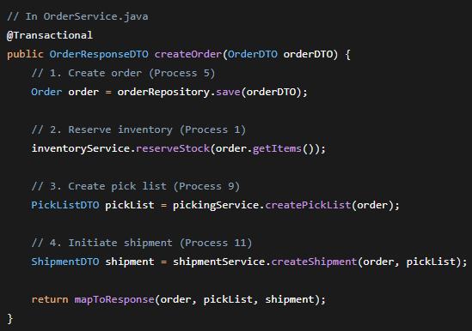

#### **Exception Handling Flow**

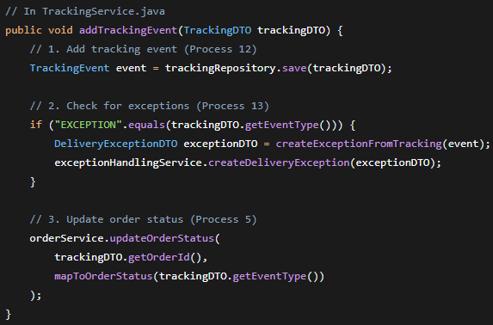

## Data Flow Between Processes

| From Process | To Process | Data Shared | Trigger |
| --- | --- | --- | --- |
| Order Processing (5) | Picking (9) | Order items, quantities | Order confirmation |
| Picking (9) | Shipment (11) | Package details, weights | Pick list completion |
| Shipment (11) | Tracking (12) | Tracking numbers, carrier info | Shipment creation |
| Tracking (12) | Exceptions (13) | Exception events, locations | Delivery issues |
| Inventory (1) | Procurement (6) | Stock levels, reorder points | Low stock alerts |
| Returns (14) | Inventory (1) | Returned items, conditions | Return processing |

## Entity Design Strategy

### Primary Key Strategy:

* All entities use Long with GenerationType.IDENTITY
* Consistent naming: [entityName]Id (e.g., orderId, productId)

### Audit Fields:

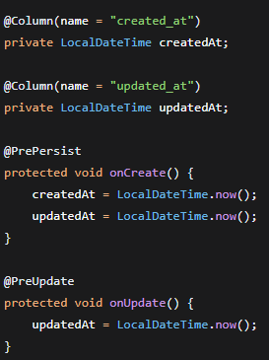

## DTO Pattern Implementation

### Separation of Concerns:

* **Entity Classes:** JPA annotations, database mapping
* **Request DTOs:** Validation annotations, API input
* **Response DTOs:** API output, calculated fields

### Example:

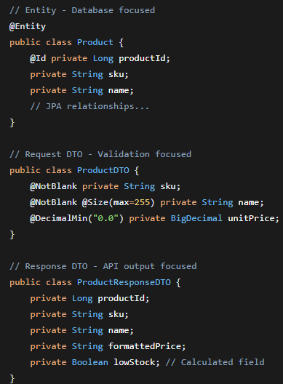

## Repository Design

### Custom Queries for Business Logic:

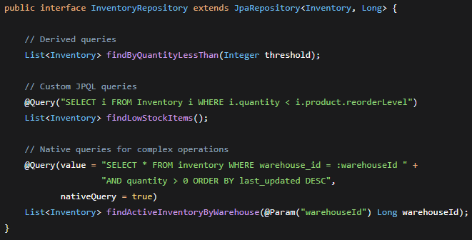

## Service Layer Business Logic

### Transaction Management:

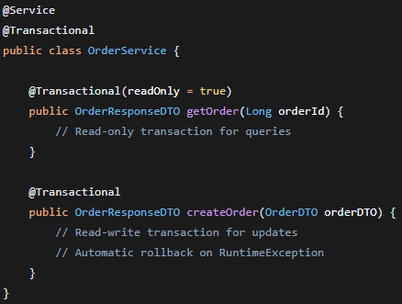

### Business Rule Enforcement:

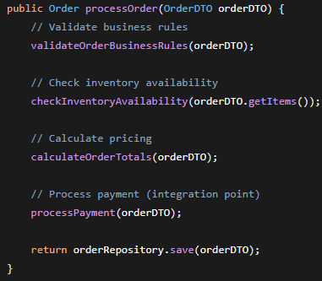

# **d) Implementation Details**

## 1. Code structure

## 15 Business process Classes:

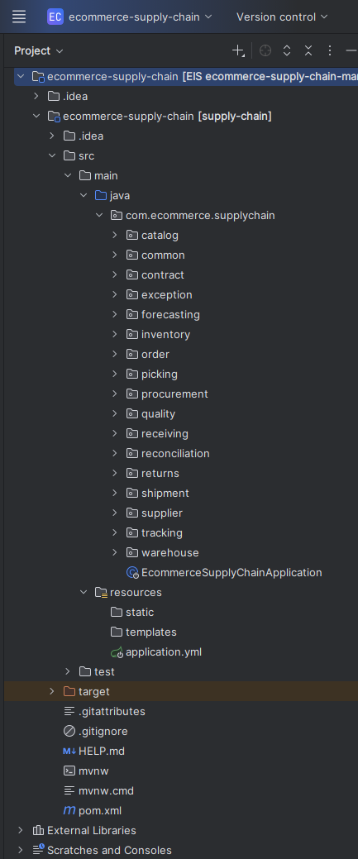

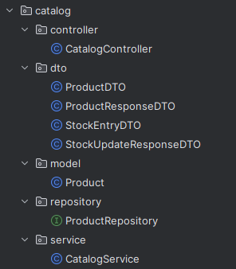

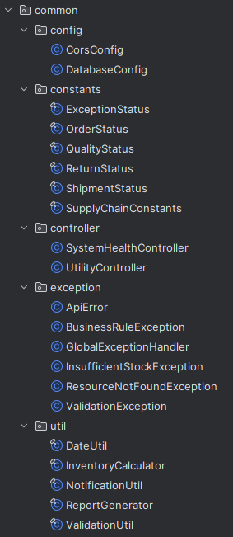

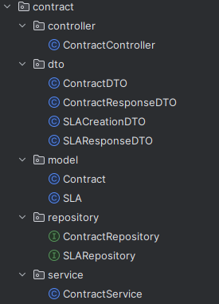

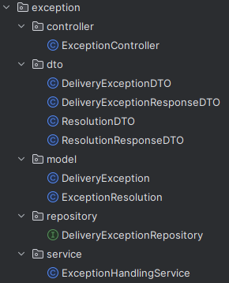

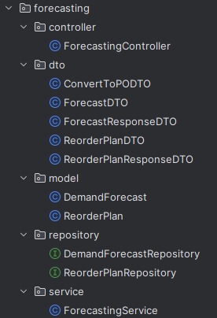

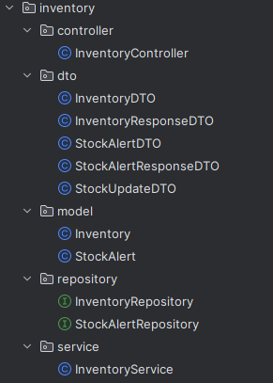

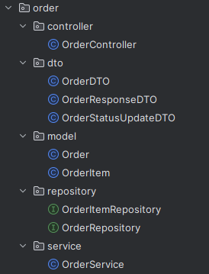

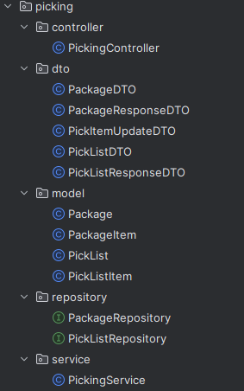

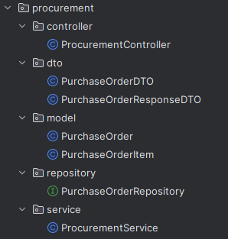

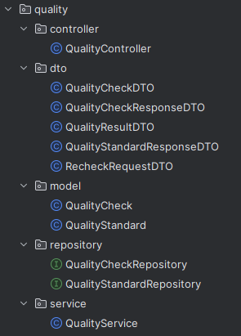

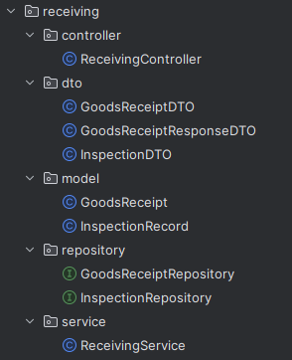

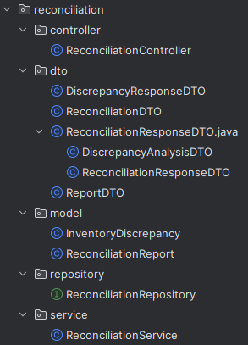

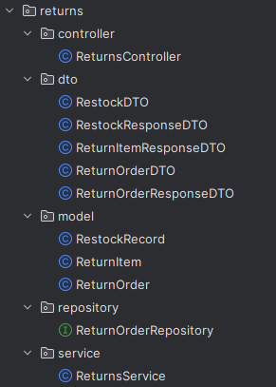

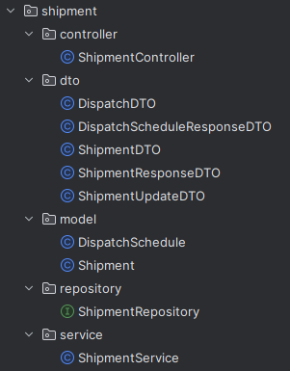

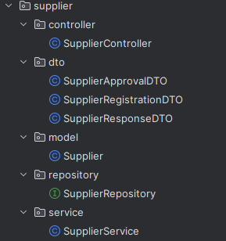

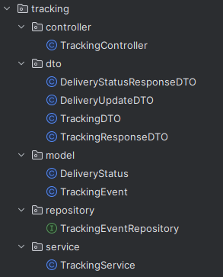

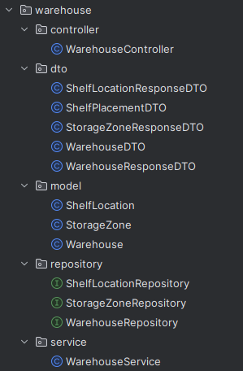

**Notes:**

* The controller package accepts HTTP requests and returns DTOs.
* service contains transactional business logic.
* model contains annotated JPA entities mapped to DB tables.
* dto decouples API contract from entities.
* repository uses Spring Data JPA for CRUD.
* exception centralizes error handling and maps exceptions to HTTP responses.

## Error Handling Strategy

### Global Exception Handling

#### **Custom Exception Hierarchy:**

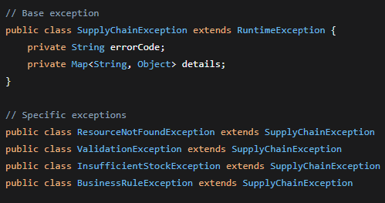

**

## Validation Strategy

#### **Request Validation:**

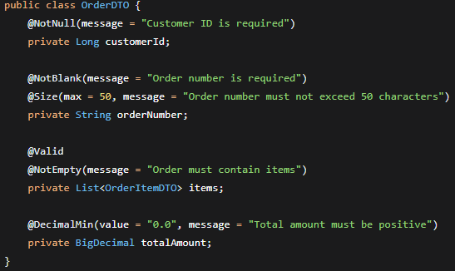

#### **Custom Validators:**

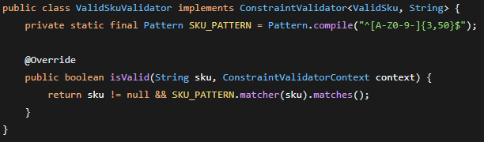

# **API Design & REST Conventions**

## REST Endpoint Design

### Consistent URL Patterns:

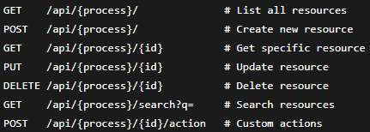

#### **Example Endpoints:**

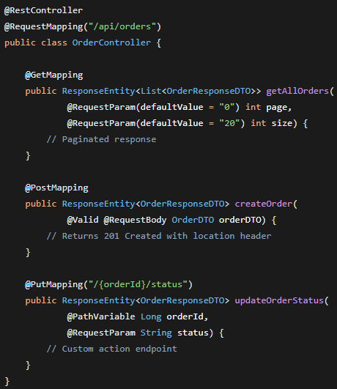

## Response Standardization

### Success Response Format:

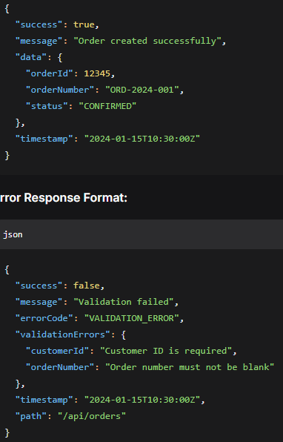

### Error Response Format:



# **Database transaction management**

## Database Design & Performance

### Indexing Strategy

**Critical Indexes Added:**

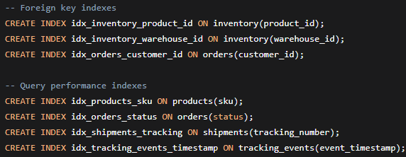

## Relationship Mapping

### One-to-Many Relationships:

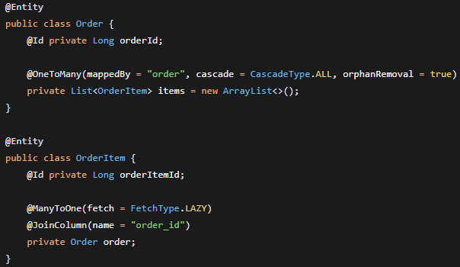

### Many-to-Many Relationships:

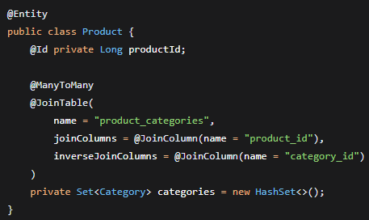

## ****Strategy:****

* Use Spring’s @Transactional annotation on service methods that perform multi-step operations touching multiple repositories. Example:
  + @Transactional on OrderService.createOrder() which:
    - checks inventory
    - reserves items (inventory decrement)
    - creates an Order
    - creates Shipment record
* **Propagation & isolation:**
  + Default propagation REQUIRED is sufficient for most operations.
  + Use REQUIRES_NEW for isolated sub-transactions that should commit independently (rare).
  + Keep isolation default (DB default), but for high concurrency consider REPEATABLE_READ or SERIALIZABLE on specific critical flows.

## ****Error handling within transactions:****

* Throw runtime exceptions to trigger rollback.
* For checked exceptions, configure rollback rules in @Transactional(rollbackFor = {CustomCheckedException.class}) if needed.

## ****Performance:****

* Keep transactions short: do not call external services (e.g., carrier APIs) inside a transaction; instead, persist state then call external API asynchronously.

# **e) Integration Documentation**

This section explains how the **15 business processes** integrate and shows key workflows (Order fulfillment, Inventory replenishment, Exception handling, Returns).

## 1. How all 15 processes integrate

* Processes are grouped by domain:
  + **Supplier / Procurement**: (1,2,3) Supplier onboarding, contract, procurement. → produce POs, expect receipts.
  + **Receiving & Quality**: (4,5,10) Goods receiving, stock entry, QC inspection → update inventory if passed.
  + **Inventory Management**: (6,7,8,15) Monitoring, forecasting, shelf placement, reconciliation → feed procurement decisions.
  + **Order Fulfillment & Logistics**: (9,11,12,13,14) Picking/packing, scheduling dispatch, tracking, exceptions, returns.
  + **Analytics & Reporting**: (15) Reconciliation & reporting draws data from all modules.

### ****Integration principles:****

* Each module communicates via **REST APIs** (internal service-to-service calls) and uses **event-like** actions (notifications) when async needed.
* Services expose two types of endpoints:
  + **Process API** (synchronous): create order, request inspection, schedule dispatch.
  + **Support API** (query): check stock, list shipments, get tracking status.
* Shared data models (DTOs) standardize communication (e.g., OrderDTO, ShipmentDTO, InventoryUpdateDTO).

## 2. Data flow between processes with arrows

* **Order → Inventory:** Order creation queries Inventory for availability.
* **Inventory → Procurement:** Low stock triggers procurement or creates PO.
* **Procurement → Receiving:** Supplier shipments create Goods Received Note (GRN).
* **Receiving → Quality:** All received goods go to QC; QC pass updates Inventory.
* **Order → Picking → Packing → Shipment:** Picking and packing create shipment linked to order.
* **Shipment → Tracking → Customer:** Shipment is scheduled and tracking ID is shared with customer via NotificationService.
* **Shipment Exceptions → Exception Handling → Resolution:** Exception updates status, triggers agent workflow, and notifies customer.
* **Returns → Receiving → QC → Inventory/Finance:** Returns feed back into receiving and QC; accepted returns update inventory and trigger refunds.

## 3. Inter-process dependencies

* **Quality Check (10)** is a hard dependency for Shipment Scheduling & Dispatch (11), shipment cannot go out without QC pass for items requiring inspection.
* **Inventory Monitoring (6)** directly influences **Procurement (3)**; inaccurate monitoring causes stockouts.
* **Order Picking (9)** depends on Inventory being up-to-date (from Stock entry & catalog update (5)), if stock not updated, orders may fail.
* **Shipment Tracking (12)** depends on Shipment creation (11) and updates status for Exception Handling (13).
* **Returns Processing (14)** affects Inventory (restock) and Finance (refunds).
* **Inventory Reconciliation (15)** periodically validates all records and triggers corrections or audits across other modules.

## 4. API call sequences (concrete examples for 3 major workflows)

### Order placement → fulfill → ship (API sequence)

1. POST /api/orders → body: OrderDTO  
   Response: 201 {order_id, status: "PENDING"}
2. GET /api/inventory/check?orderId=... → returns available: true|false
3. If available: POST /api/picking → body: {order_id} → 200 OK
4. POST /api/quality/inspect → body: InspectionDTO (if applicable)
   * If accepted: POST /api/shipments → body ShipmentDTO → 201 {shipment_id, tracking_id}
5. GET /api/tracking/{tracking_id} → fetch live status

### Low-stock alert → PO → receiving (API sequence)

1. GET /api/inventory/low-stock → returns list of SKUs below threshold
2. POST /api/procurement/po → body PO_DTO → 201 (po_id)
3. Supplier confirmation (external) → POST /api/receiving/receive?poId={po_id} → 200
4. POST /api/quality/inspect → if pass: PUT /api/inventory/{sku}/increase?qty=...

### Exception handling (API sequence)

1. Carrier webhook or POST /api/tracking/{id}/exception → body {reason}
2. POST /api/exceptions → create exception ticket
3. PUT /api/exceptions/{id}/assign → assigns agent
4. Agent resolves: PUT /api/exceptions/{id}/resolve → update shipment status → notify customer POST /api/notifications

# **f) Postman Collection:**

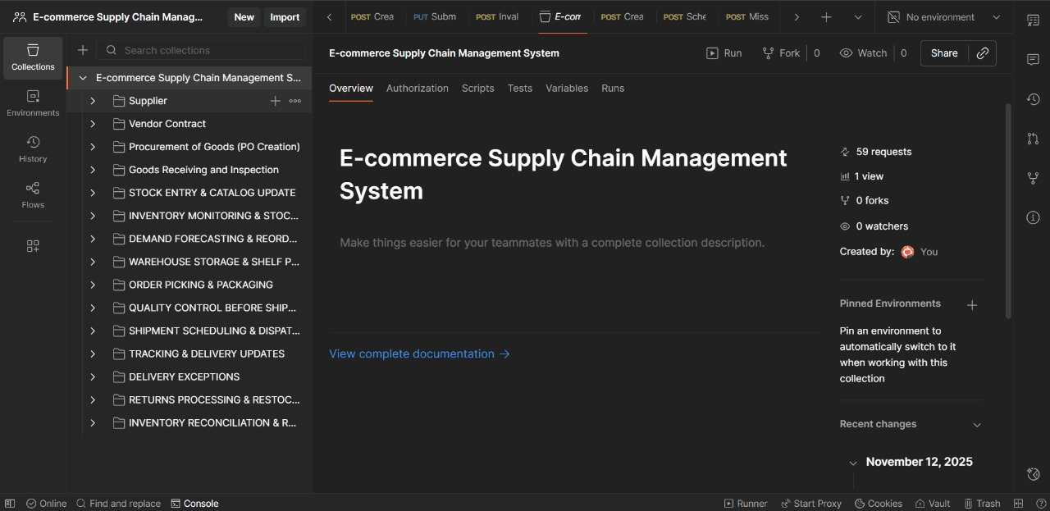

# **g) API and Error Testing and Results of 15 Processes:**

Process#01**: Supplier Management:  
API:1.1: Register New Supplier** 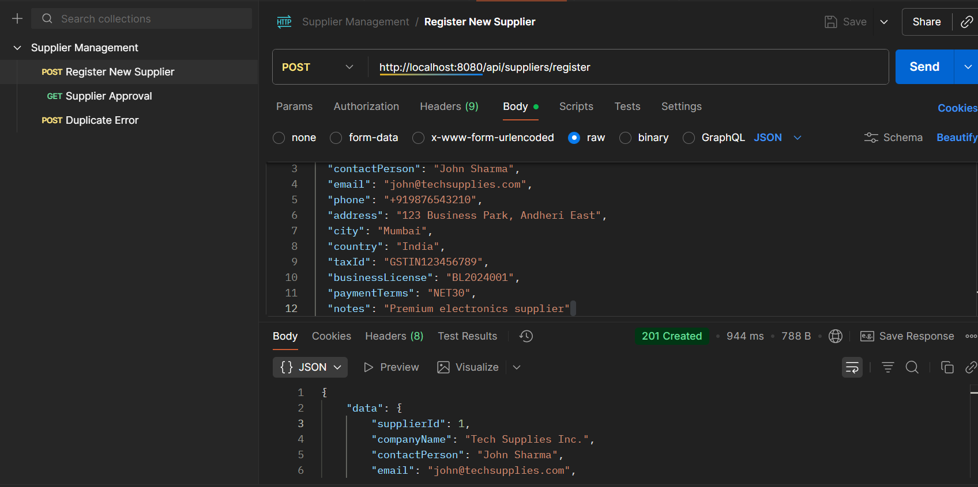

* **API Name: Register New Supplier**
* **Endpoint: http://localhost:8080/api/suppliers/register**
* **Method: POST**
* **Description: Creates a new supplier in the system and registers their details. The supplier is initially created with a PENDING status.**
* **Request Body:**

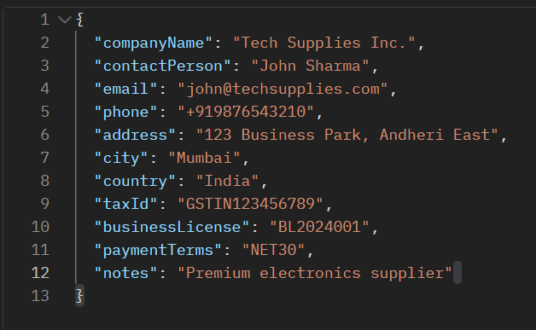

* **Respond Body:**

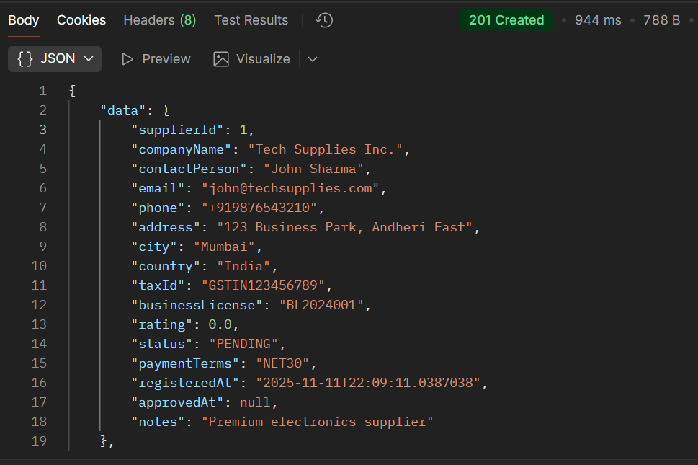

**API:1.2:**

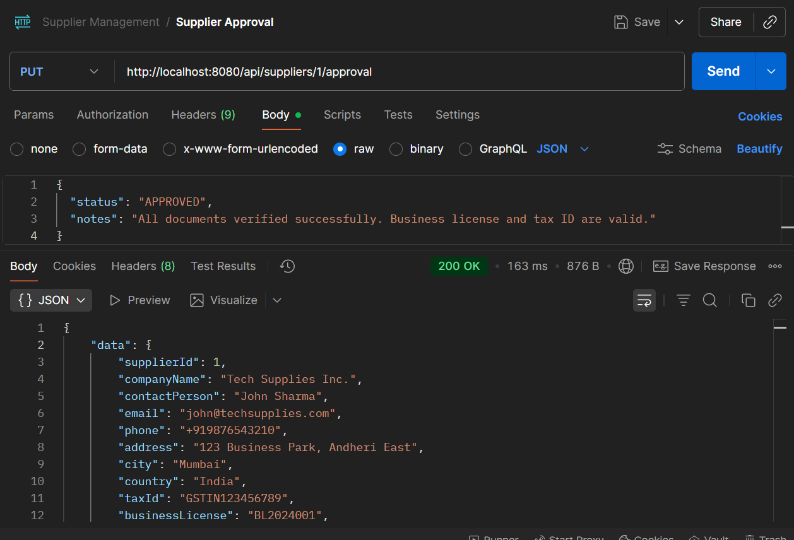

* **API Name: Update Supplier Approval Status**
* **Endpoint: http://localhost:8080/api/suppliers/1/approval**
* **Method: PUT**
* **Description: Updates the approval status and related information for a specific supplier. The {1} in the endpoint is a path parameter representing the supplierId.**
* **Request Body:**

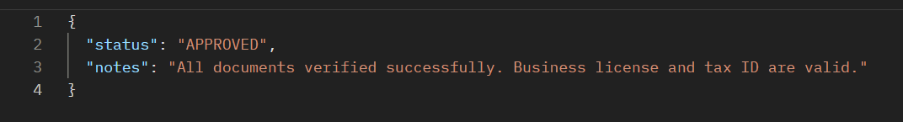

* **Respond Body:  
  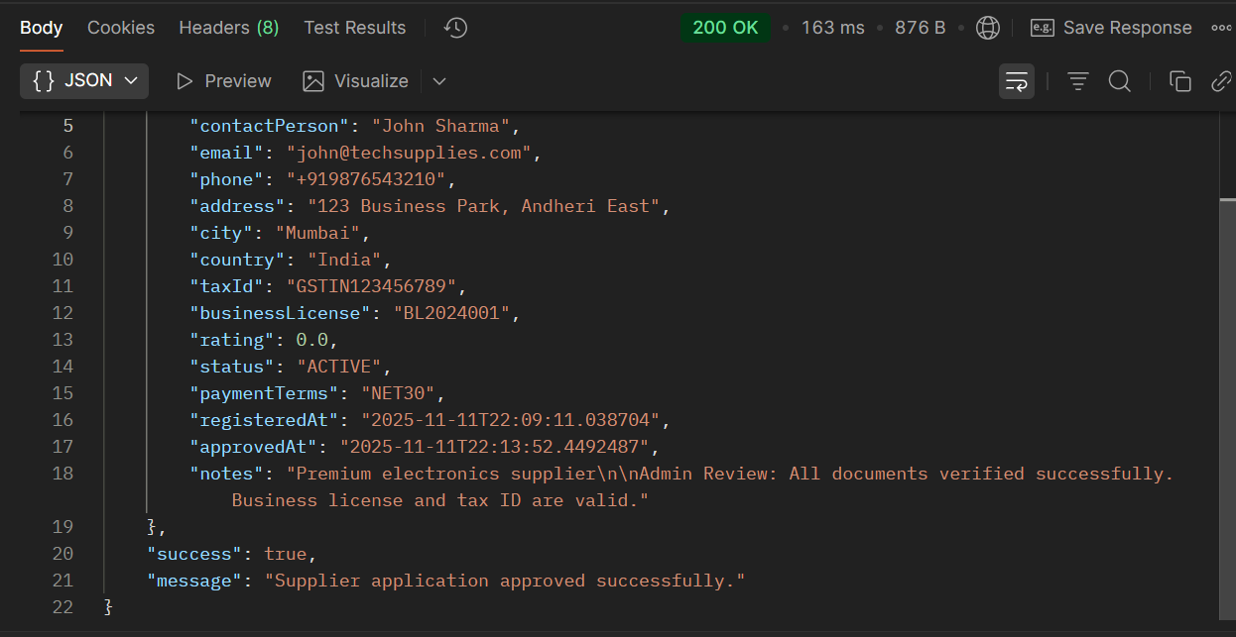**

### Error TESTING SCENARIOS For Process 1:

**Error 1: Missing Required Fields:**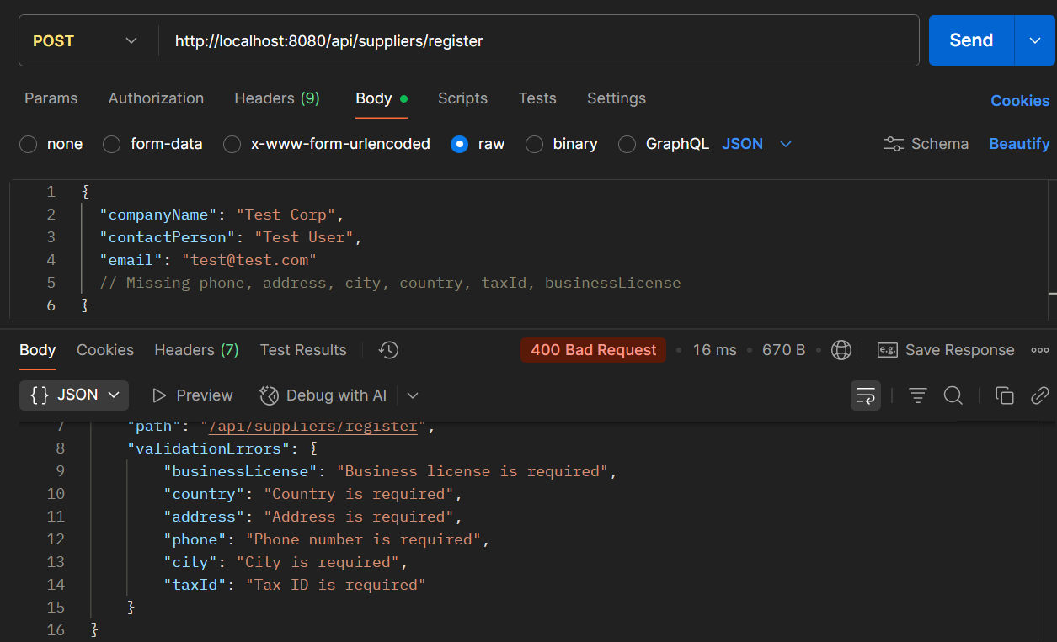

**2. Invalid Data Types:**

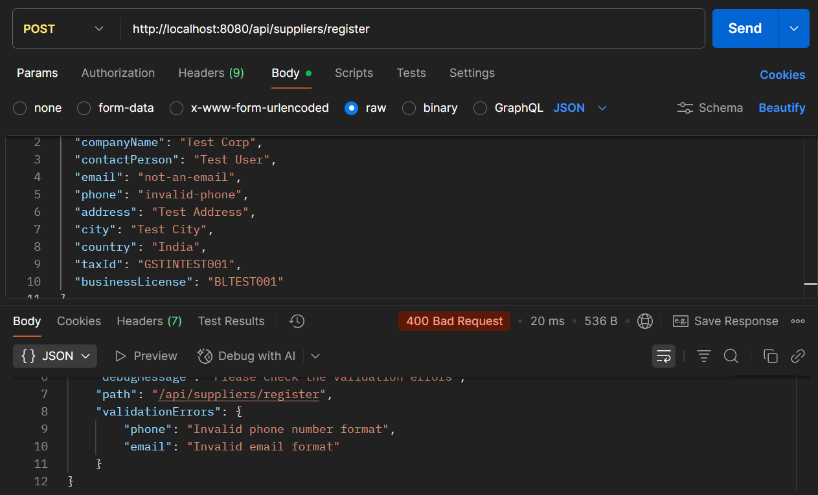

**3. Duplicate Entries:**

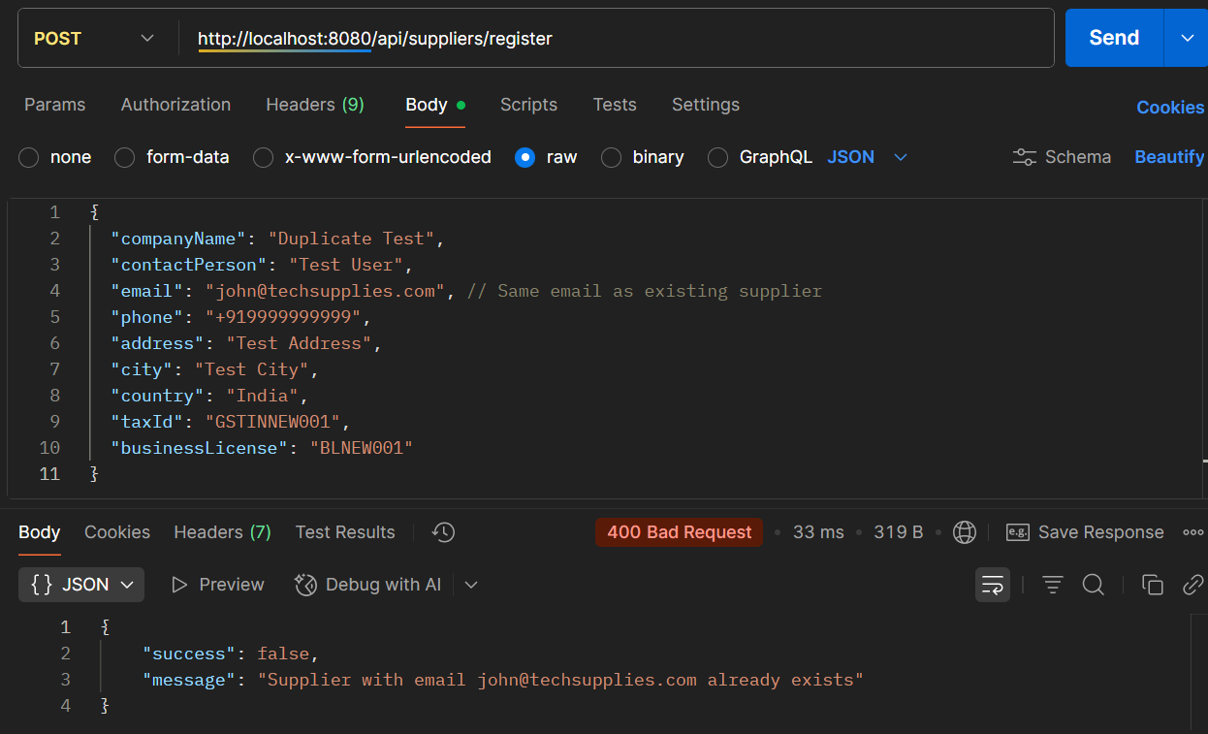

PROCESS 2: **VENDOR CONTRACT MANAGEMENT**

**API 2.1: Create Contract**

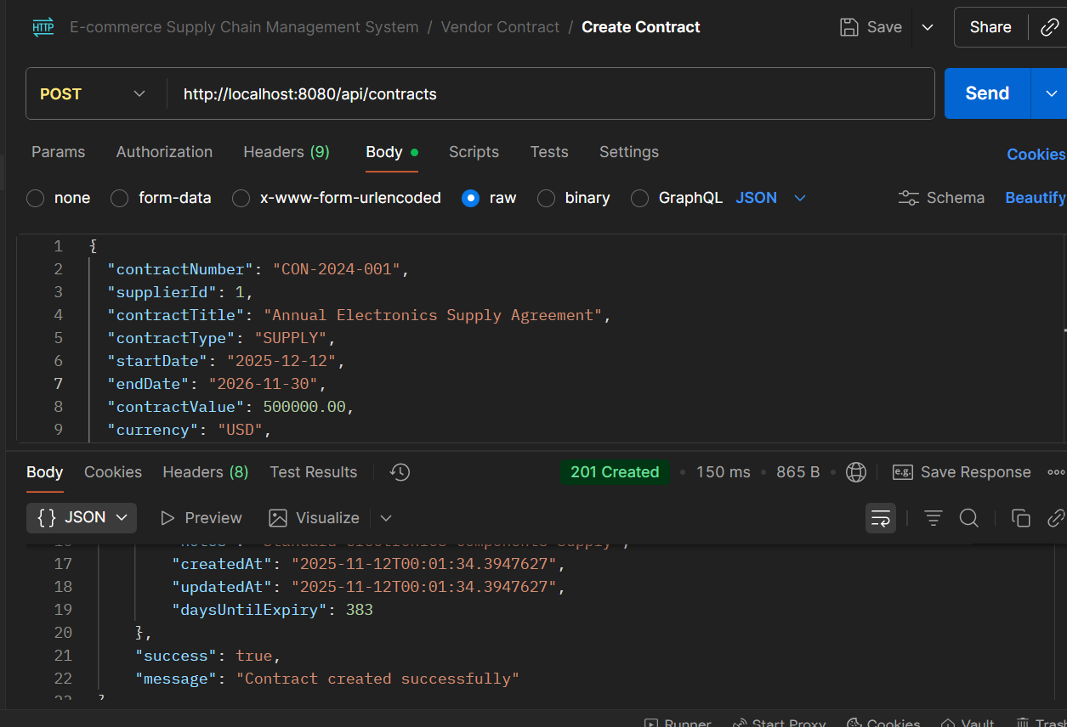

* **API Name: Create Contract**
* **Endpoint:**[**http://localhost:8080/api/contracts**](http://localhost:8080/api/contracts)
* **Method: POST**
* **Description: Creates a new contract, linking it to a specific supplier and defining its terms, value, and duration.**
* **Request Body:**

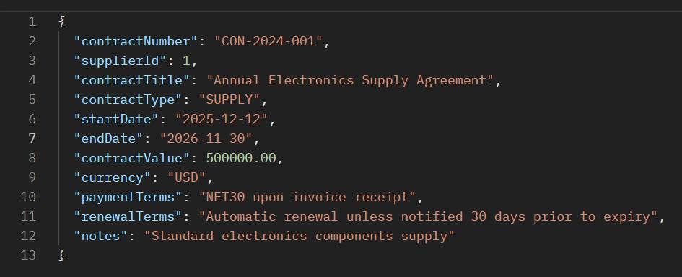

* **Respond Body:**

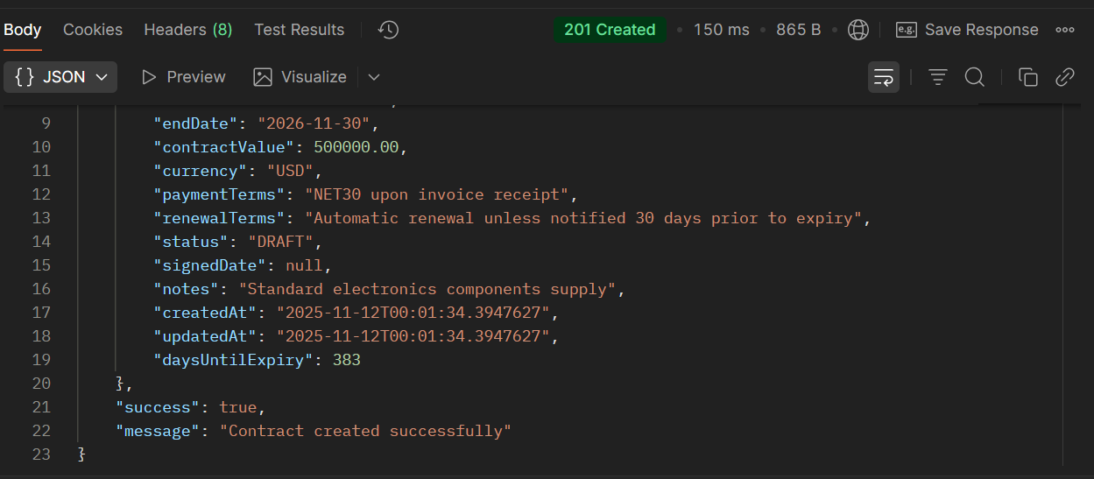

**API 2.2: Add SLA to Contract**

**First, create a contract using API 2.1 success case to get contractId**

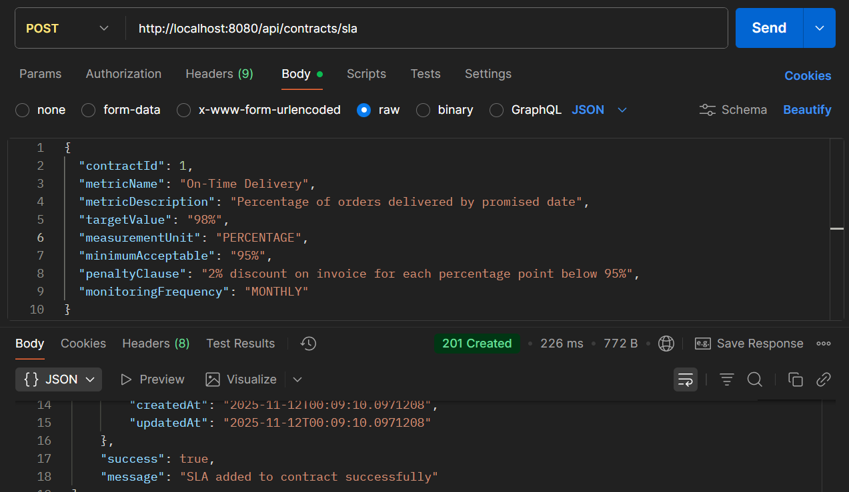

* **API Name: Add SLA to Contract**
* **Endpoint: http://localhost:8080/api/contracts/sla**
* **Method: POST**
* **Description:**Adds a Service Level Agreement (SLA) metric to an existing contract, defining performance targets, measurement units, and penalties for non-compliance.
* **Example Request Body:**

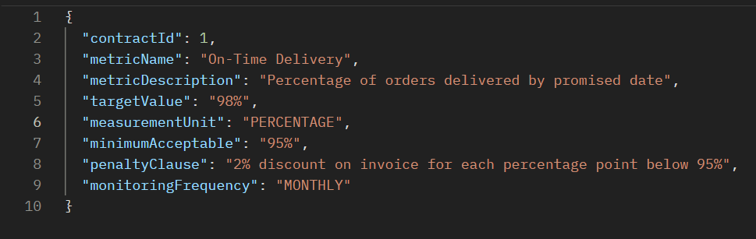

* **Respond Body:**

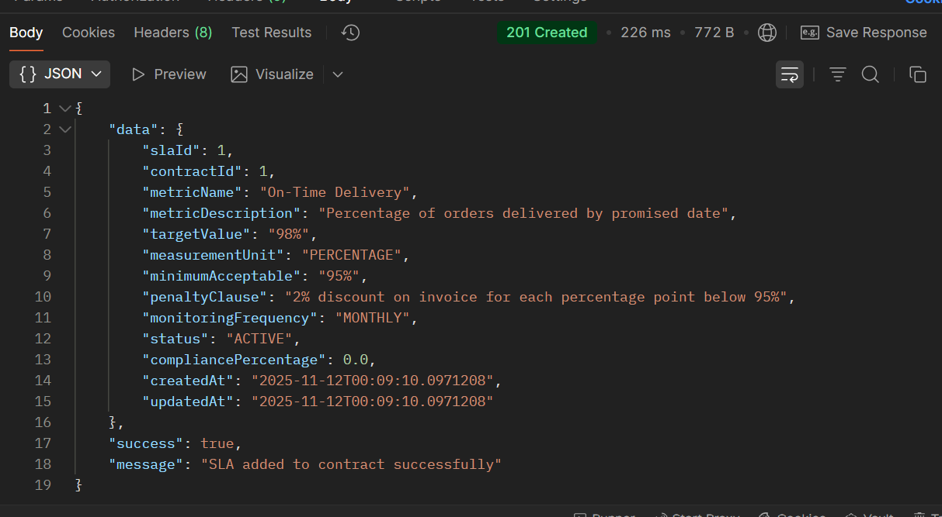

### Error Testing Scenarios For Process 2:

**Error 1: Missing Required Payment Terms Field**

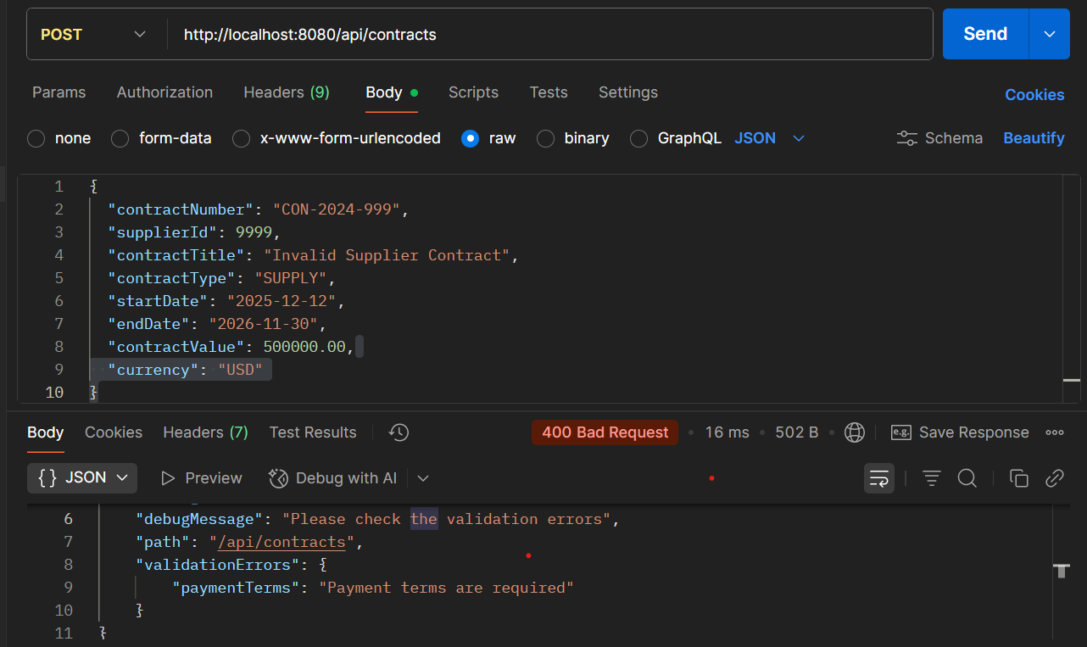

PROCESS 3: **PROCUREMENT OF GOODS**

**API 3.1: Create Purchase Order**

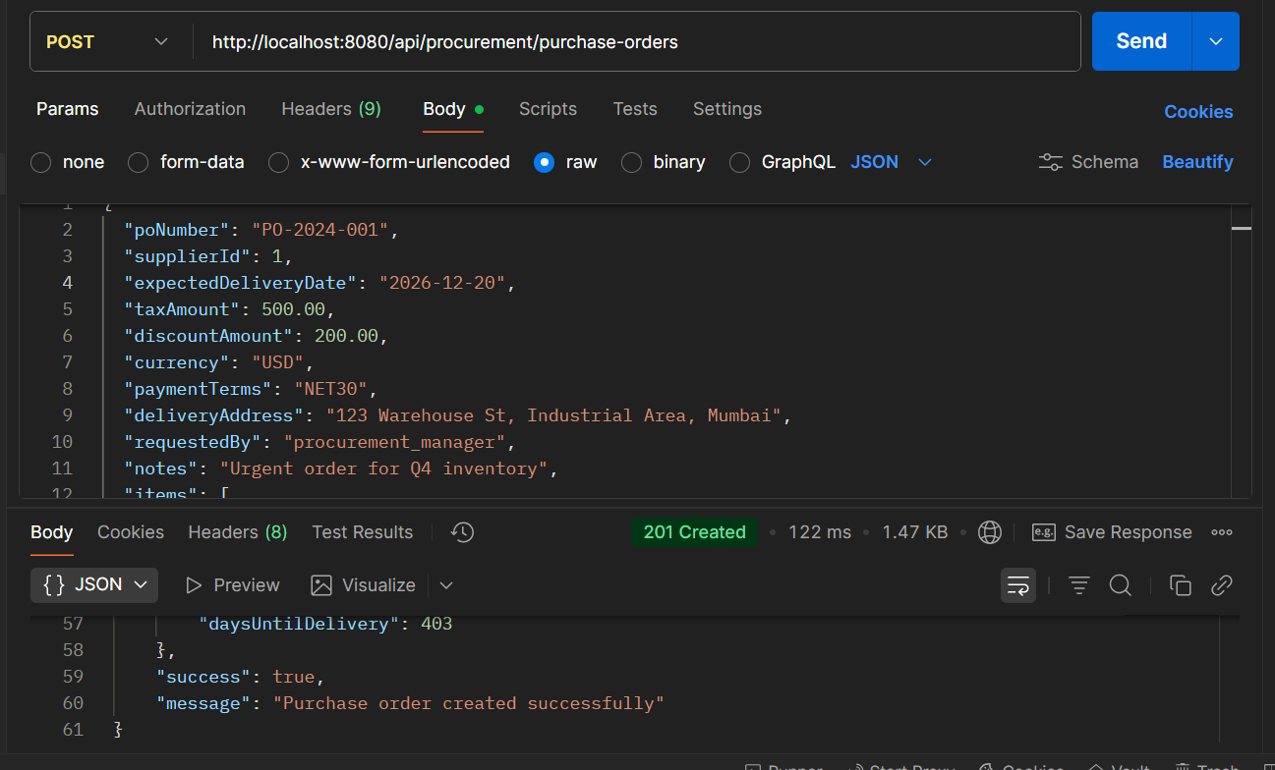

* **API Name: Create Purchase Order**
* **Endpoint:**[**http://localhost:8080/api/procurement/purchase-orders**](http://localhost:8080/api/procurement/purchase-orders)
* **Method: POST**
* **Description:**Creates a new purchase order for procurement, including header information and line items.
* **Request Body:**

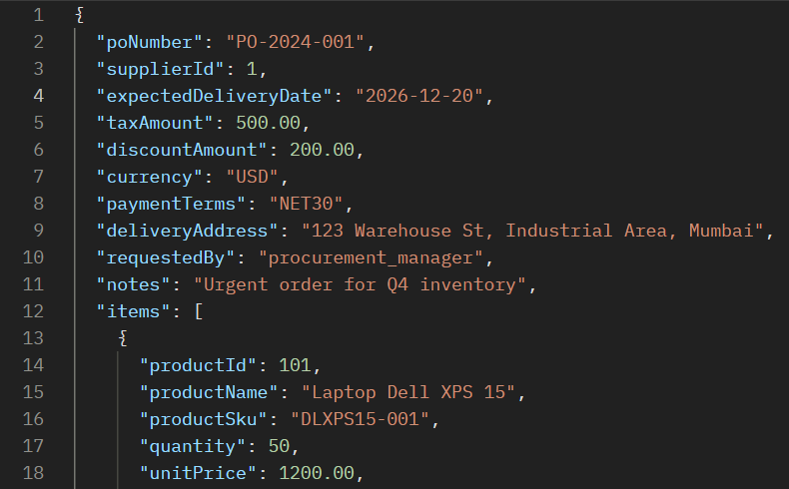

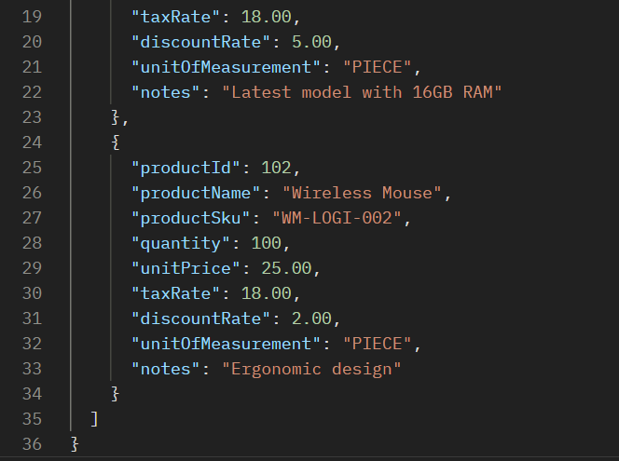

* **Response Body:**

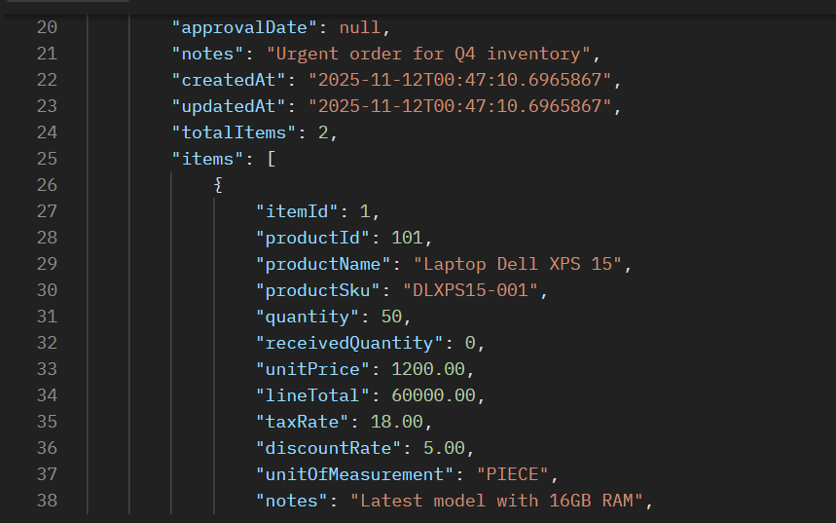 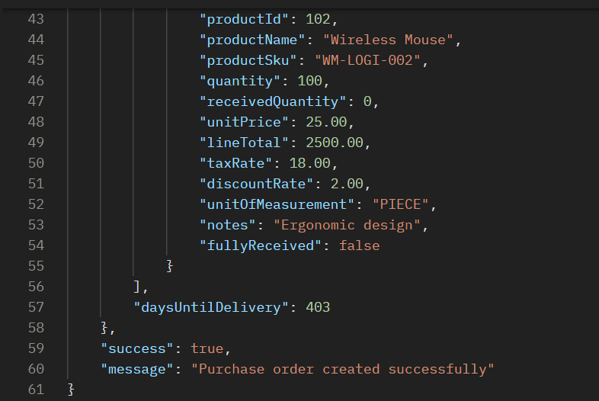

**API 3.2: Approve Purchase Order**

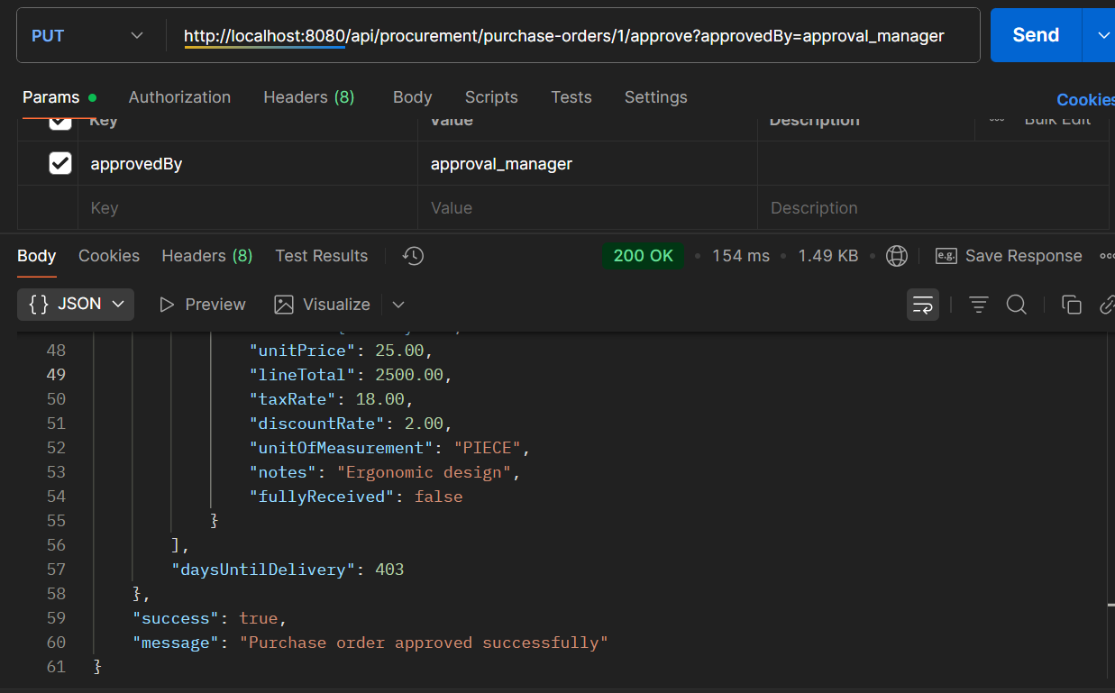

* **API Name: Approve Purchase Order**
* **Endpoint:**[**http://localhost:8080/api/procurement/purchase-orders/1/approve?approvedBy=approval_manager**](http://localhost:8080/api/procurement/purchase-orders/1/approve?approvedBy=approval_manager)
* **Method: PUT**
* **Description: Approves an existing purchase order. The {1} in the endpoint is a path parameter for the purchaseOrderId, and it requires a approvedBy query parameter to specify who is approving the order.**
* **Example Request Body:  
  *This endpoint likely doesn't require a request body, as all necessary data (PO ID and approver) is passed via the URL.***
* **Example Response Body:**

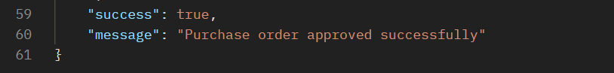

### Error Testing Scenarios for Process 3:

**Error 1: Duplicate PO Number**

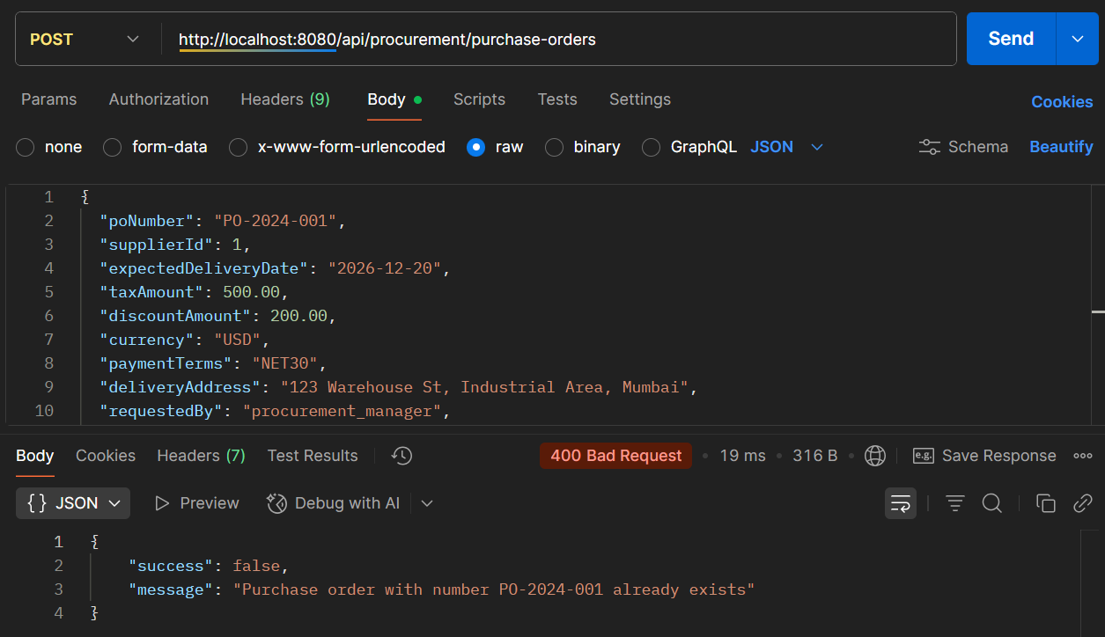

PROCESS 4: **GOODS RECEIVING & INSPECTION**

**API 4.1: Create Goods Receipt**

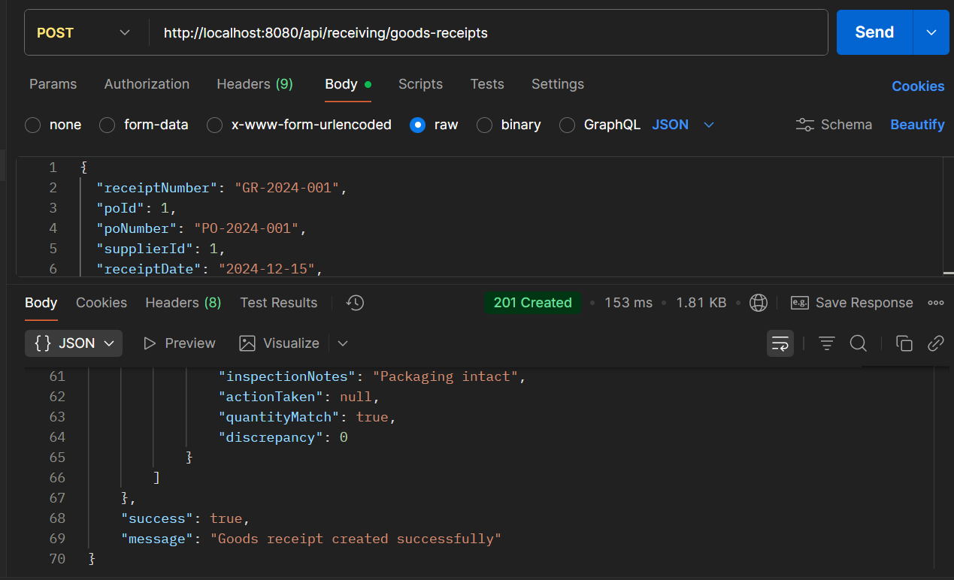

* **API Name: Create Goods Receipt**
* **Endpoint:**[**http://localhost:8080/api/receiving/goods-receipts**](http://localhost:8080/api/receiving/goods-receipts)
* **Method: POST**
* **Description:**Creates a goods receipt notice for received inventory against a purchase order, including inspection details and quantity verification.
* **Request Body:**

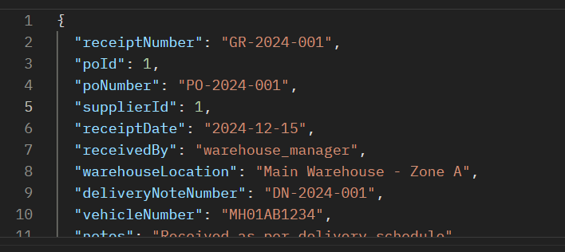

* **Respond Body:**

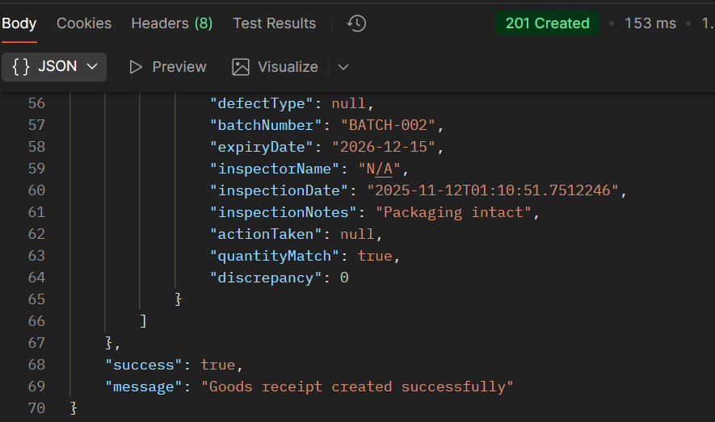

**API 4.2: Perform Quality Inspection:**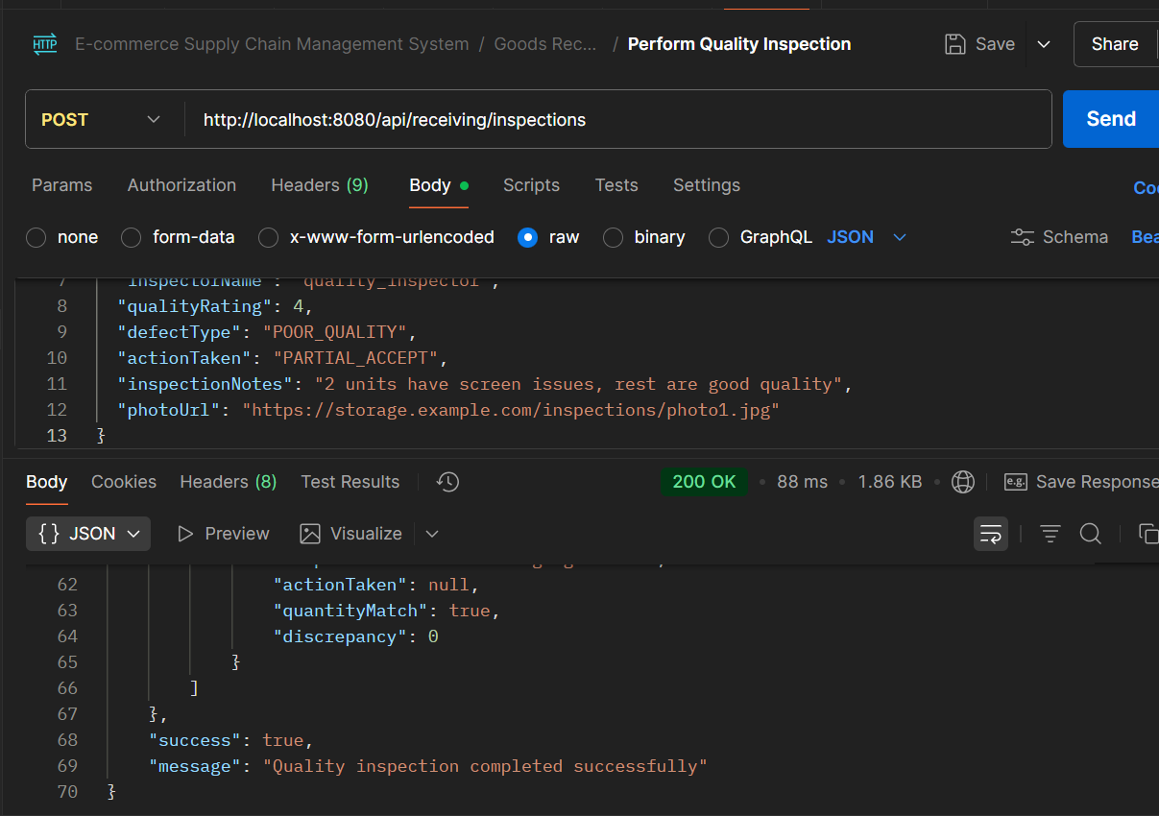

* **API Name: Create Quality Inspection**
* **Endpoint:**[**http://localhost:8080/api/receiving/inspections**](http://localhost:8080/api/receiving/inspections)
* **Method: POST**
* **Description:**Records quality inspection results for received goods, including defect classification, quality ratings, and actions taken.
* **Request Body:**

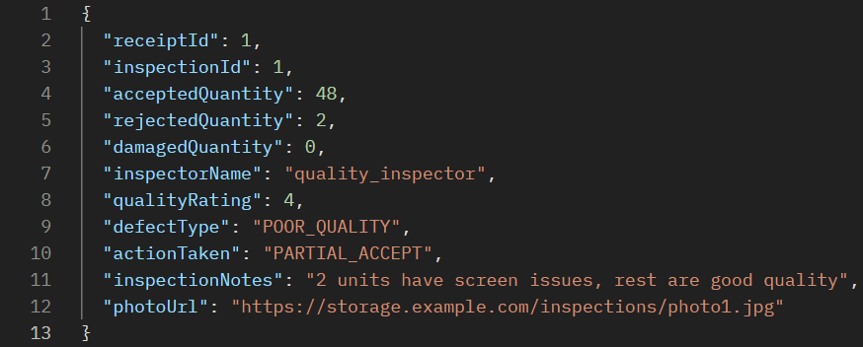

* **Respond Body:**

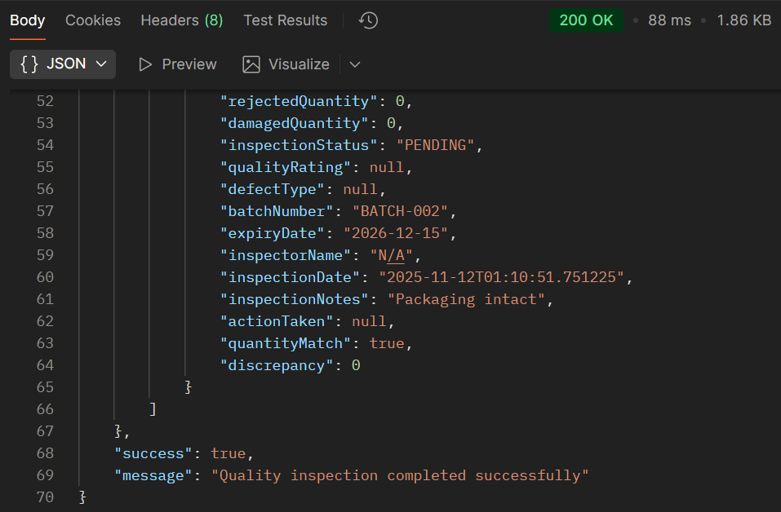

### ERROR Testing SCENARIOS FOR PROCESS 4

**Error 1: Invalid Action Taken**

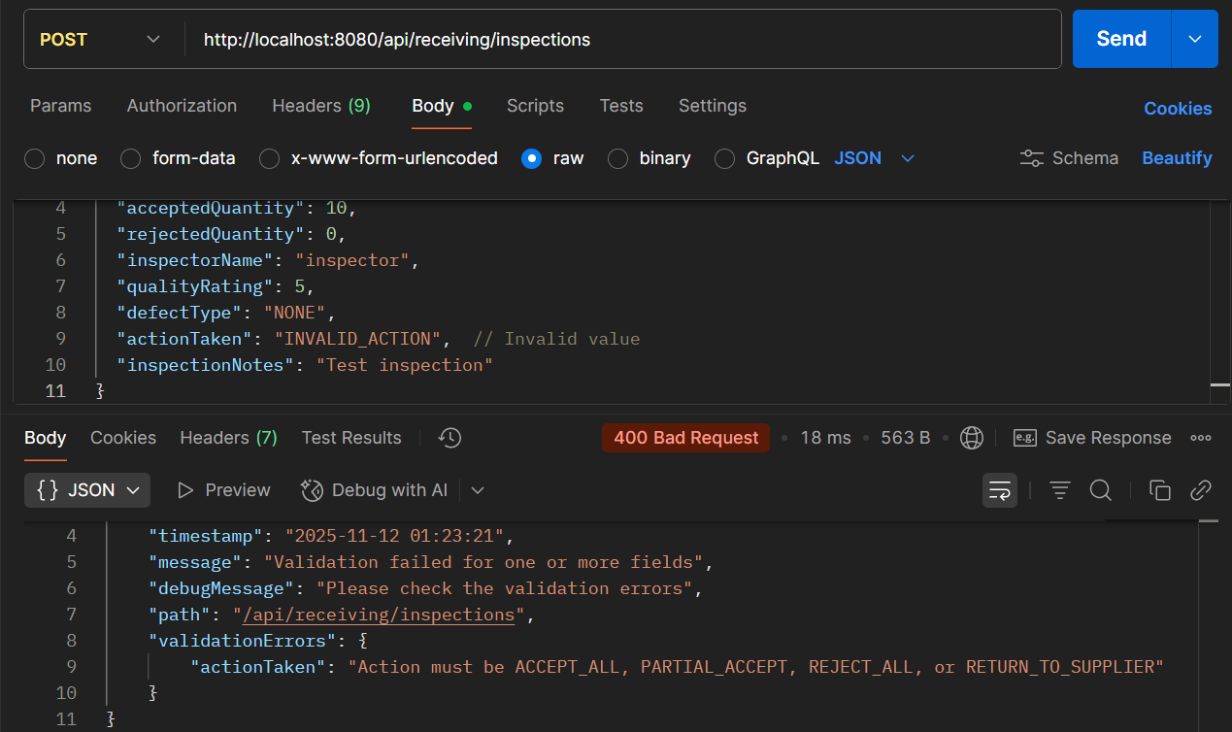

PROCESS 5: **STOCK ENTRY & CATALOG UPDATE**

**API 5.1: Add Product to Catalog**

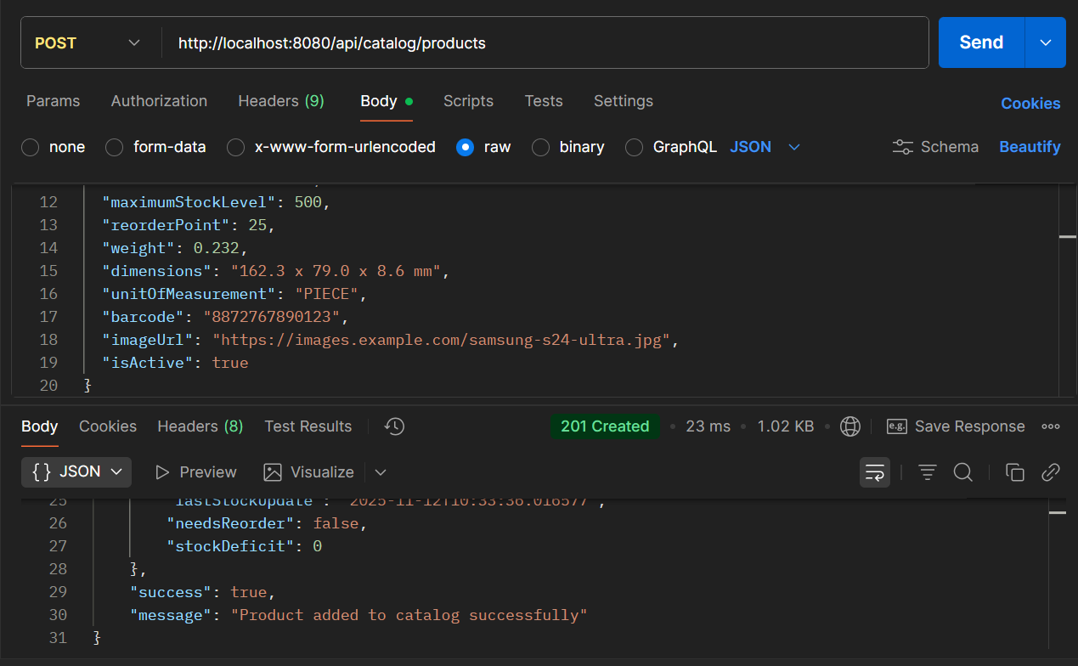

* **API Name: Add Product to Catalog**
* **Endpoint:**[**http://localhost:8080/api/catalog/products**](http://localhost:8080/api/catalog/products)
* **Method: POST**
* **Description: Adds a new product to the inventory catalog with comprehensive product details, stock management parameters, and product information.**
* **Request Body:**

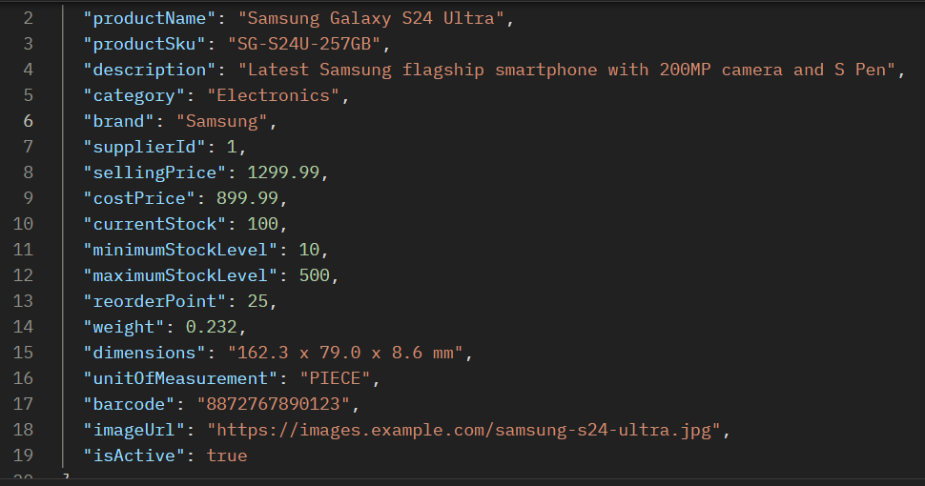

* **Respond Body:**

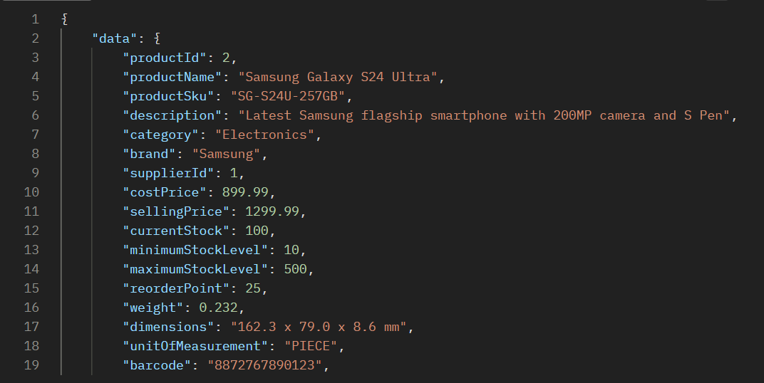

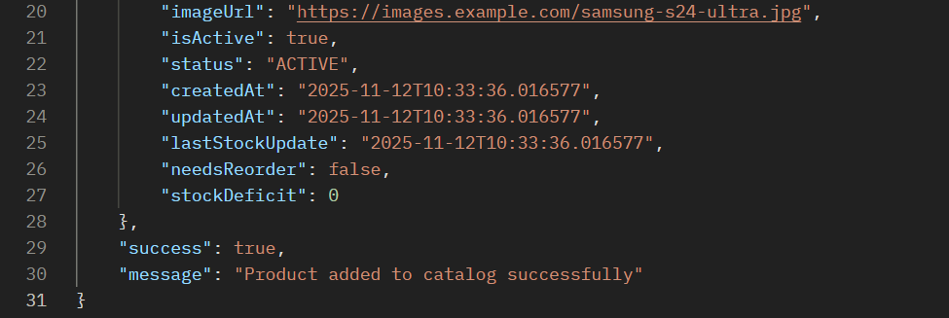

**API 5.2: Update Product Stock**

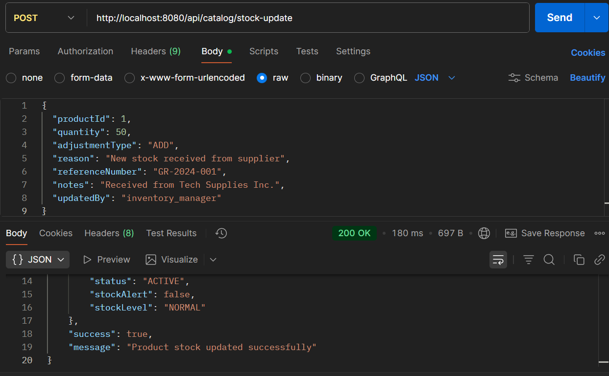

* **API Name: Generate Inventory Report**
* **Endpoint:**[**http://localhost:8080/api/reconciliation/inventory-report?warehouseId=1&reportType=SYSTEM_AUDIT**](http://localhost:8080/api/reconciliation/inventory-report?warehouseId=1&reportType=SYSTEM_AUDIT)
* **Method: POST**
* **Description: Generates comprehensive inventory reports with accuracy grading, performance ratings, and discrepancy analysis for specific warehouses and report types.**
* **Request Body:**

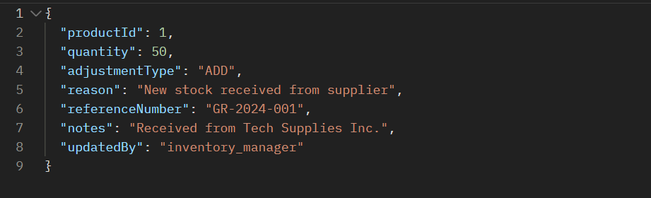

* **Response Body:**

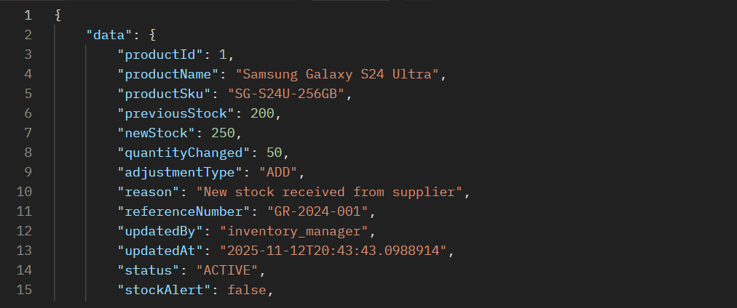

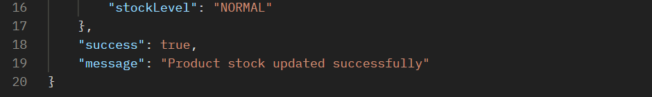

### Error Scenarios for Process 5

**Error 1: Duplicate Product SKU**

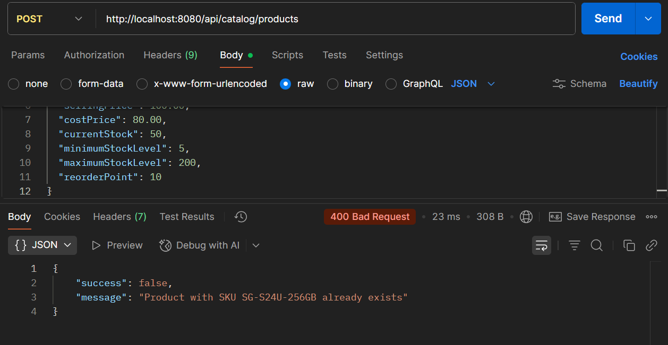

**Error 2: Invalid Adjustment Type**

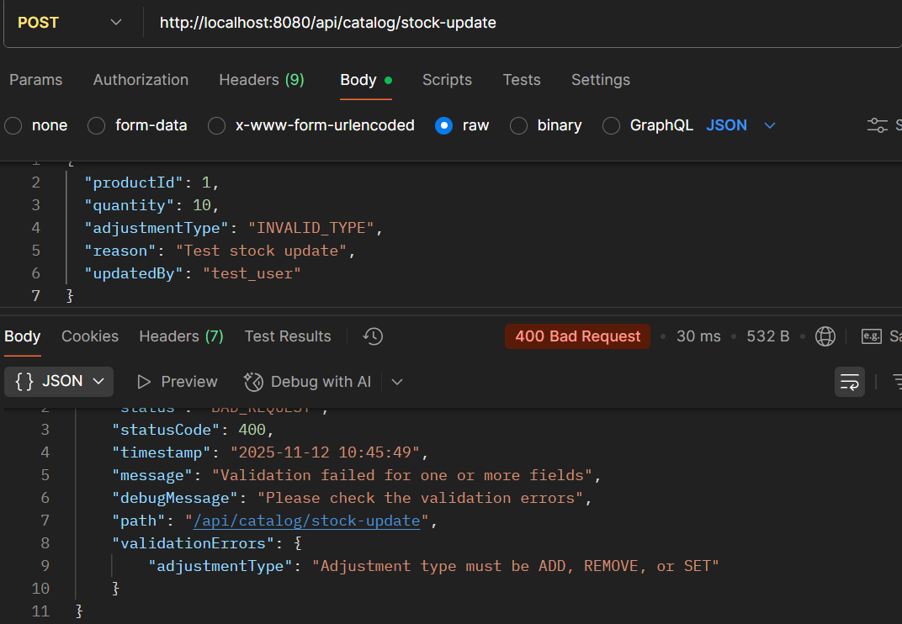

**Error 3: Non existing ID**

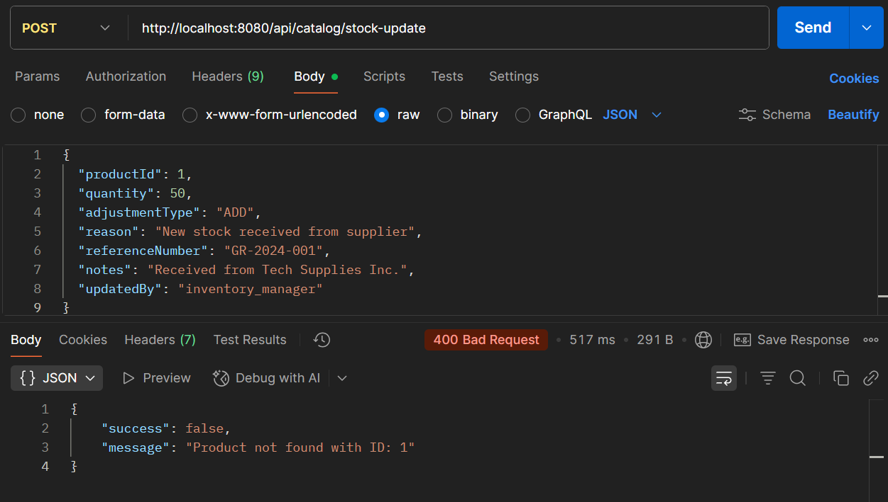

PROCESS 6: **INVENTORY MONITORING & STOCK ALERTS**

**API 6.1: Add to Inventory Monitoring**

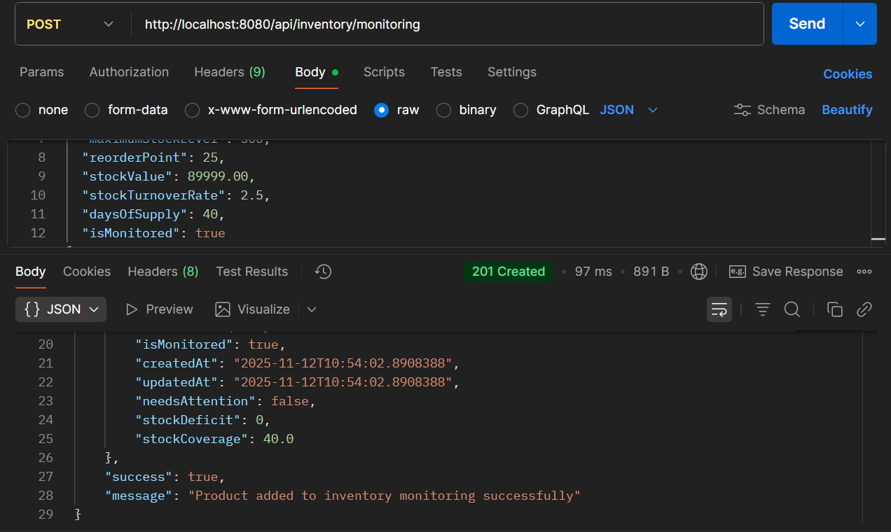

* **API Name: Add Product to Inventory Monitoring**
* **Endpoint:**[**http://localhost:8080/api/inventory/monitoring**](http://localhost:8080/api/inventory/monitoring)
* **Method: POST**
* **Description: Adds a product to inventory monitoring system with advanced inventory metrics, stock performance tracking, and automated alerting capabilities.**
* **Request Body:**

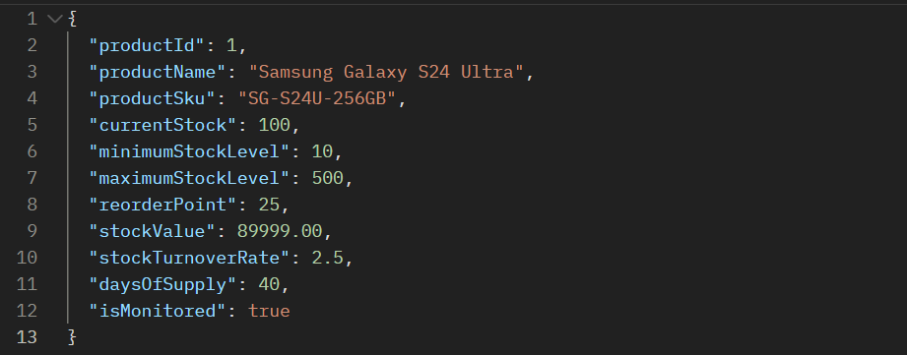

**Respond Body:**

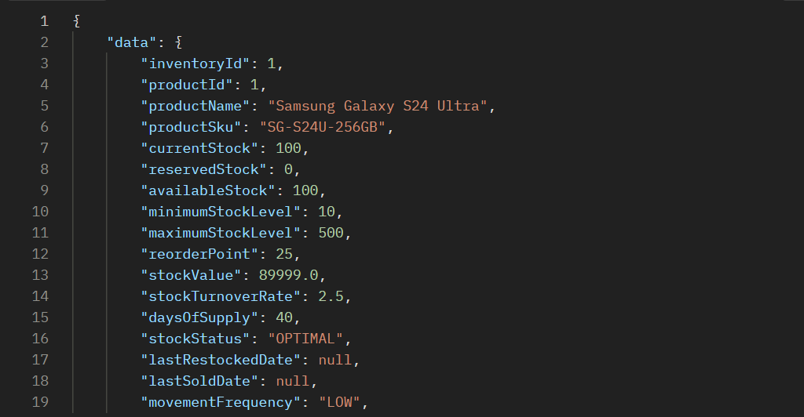

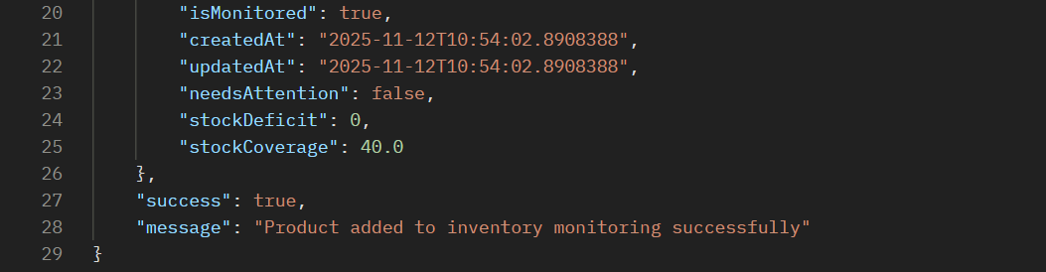

**API 6.2: Update Stock Alert**

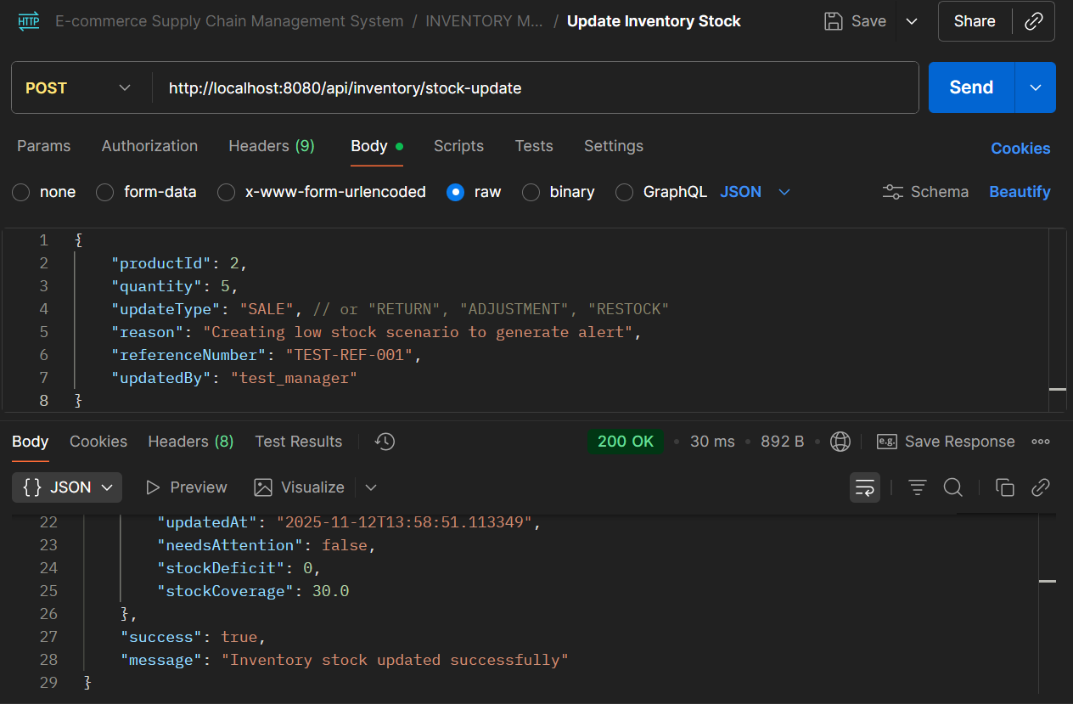

* **API Name: Update Inventory Stock**
* **Endpoint:**[**http://localhost:8080/api/inventory/stock-update**](http://localhost:8080/api/inventory/stock-update)
* **Method: POST**
* **Description: Updates inventory stock levels with different transaction types (sales, returns, adjustments, restock) and maintains audit trail for inventory movements.**
* **Request Body:**

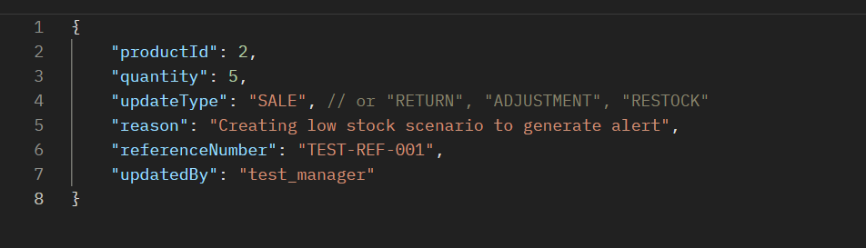

* **Respond Body:**

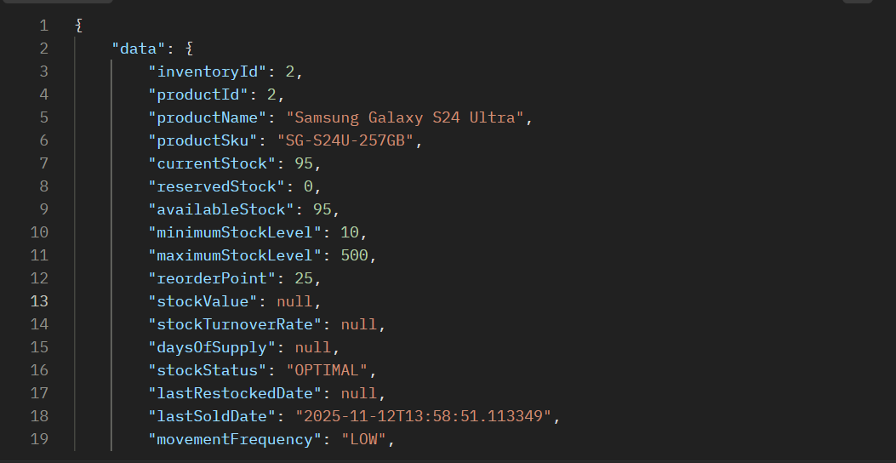

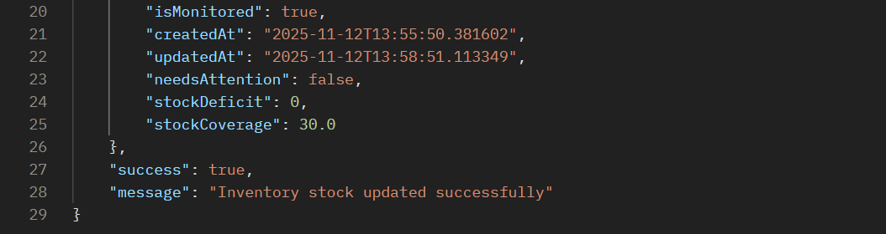

API TO TEST LOW STOCK ALERT **Step 1: Set Stock BELOW Reorder Point**

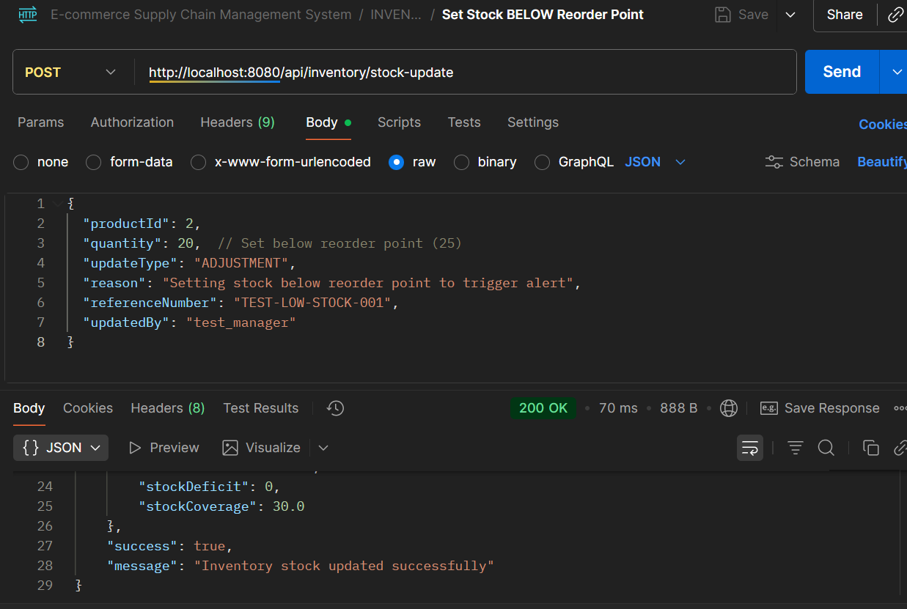

* **API Name: Update Inventory Stock**
* **Endpoint:**[**http://localhost:8080/api/inventory/stock-update**](http://localhost:8080/api/inventory/stock-update)
* **Method: POST**
* **Description: Updates inventory stock levels with different transaction types and maintains comprehensive inventory tracking and alerting system.**
* **Request Body:**

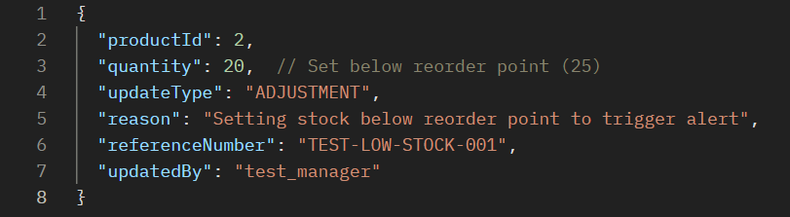

* **Respond Body:**

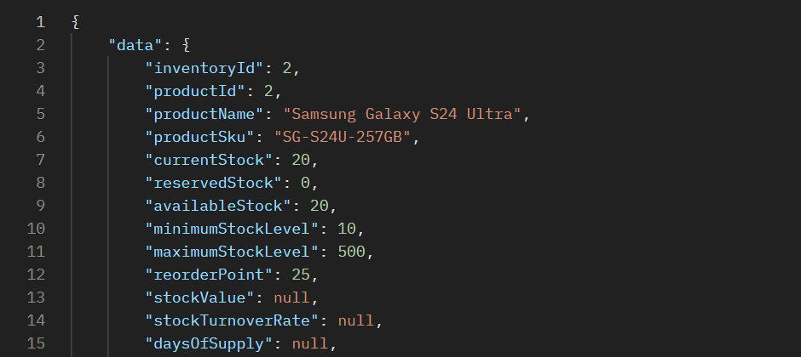

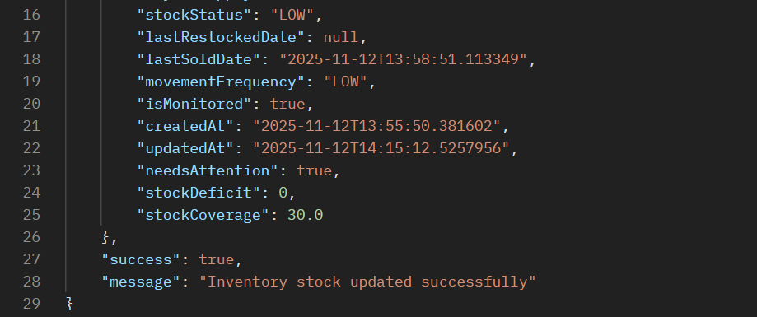

**Step 2: Run Health Check to Generate Alert**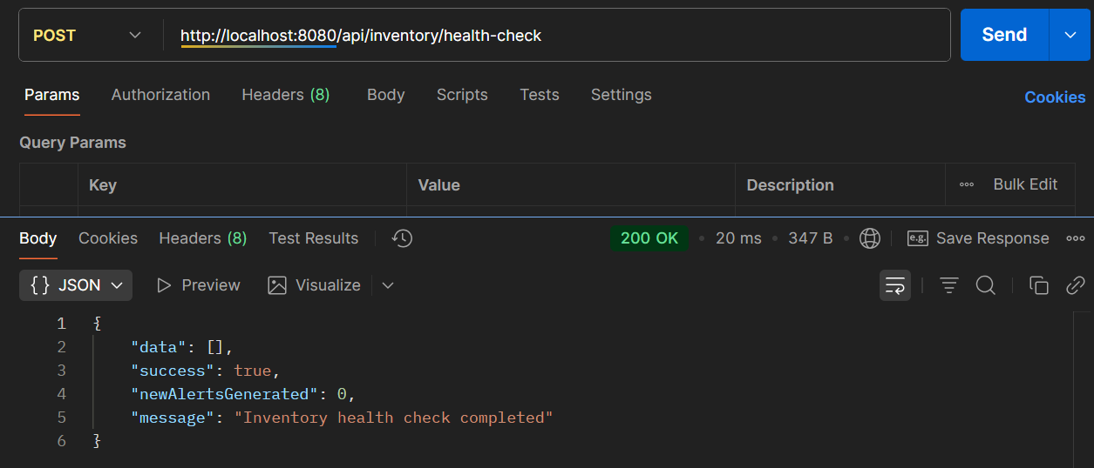

* **API Name: Inventory Health Check**
* **Endpoint:**[**http://localhost:8080/api/inventory/health-check**](http://localhost:8080/api/inventory/health-check)
* **Method: POST**
* **Description: Performs a system-wide inventory health check to identify stock issues, generate alerts for low stock, overstock, and other inventory anomalies.**
* **Example Request Body:**

***(NO BODY)***

* **Example Response Body:**

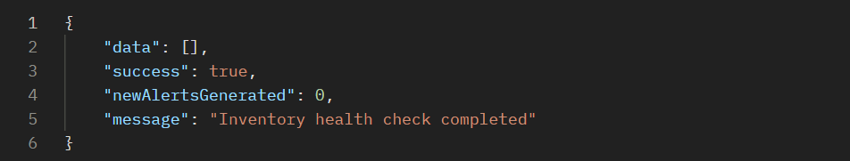

**Step 3: Get Active Alerts**

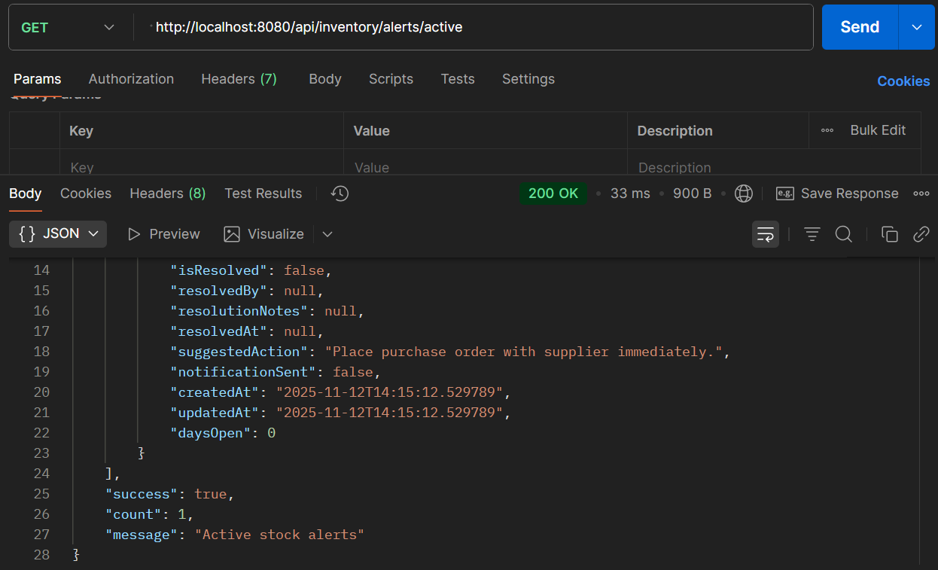

* **API Name: Get Active Inventory Alerts**
* **Endpoint:**[**http://localhost:8080/api/inventory/alerts/active**](http://localhost:8080/api/inventory/alerts/active)
* **Method: GET**
* **Description: Retrieves all active (unresolved) inventory alerts with detailed information including suggested actions and alert status.**
* **Example Request Body:  
  *This is a GET endpoint and does not require a request body.***
* **Example Response Body:**

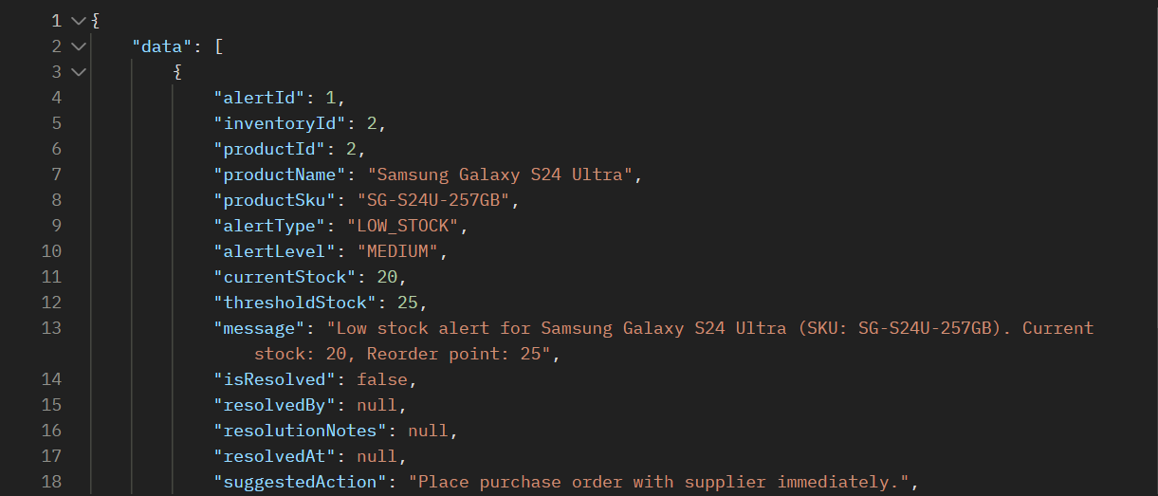

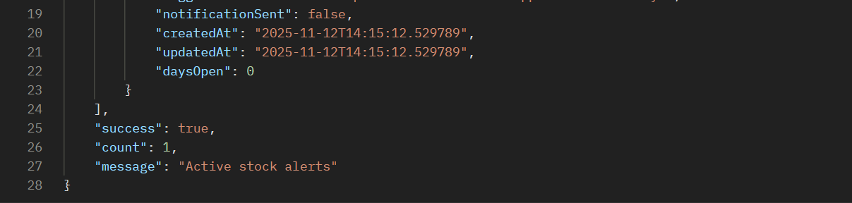

**Step 4: Low Stock Resolved**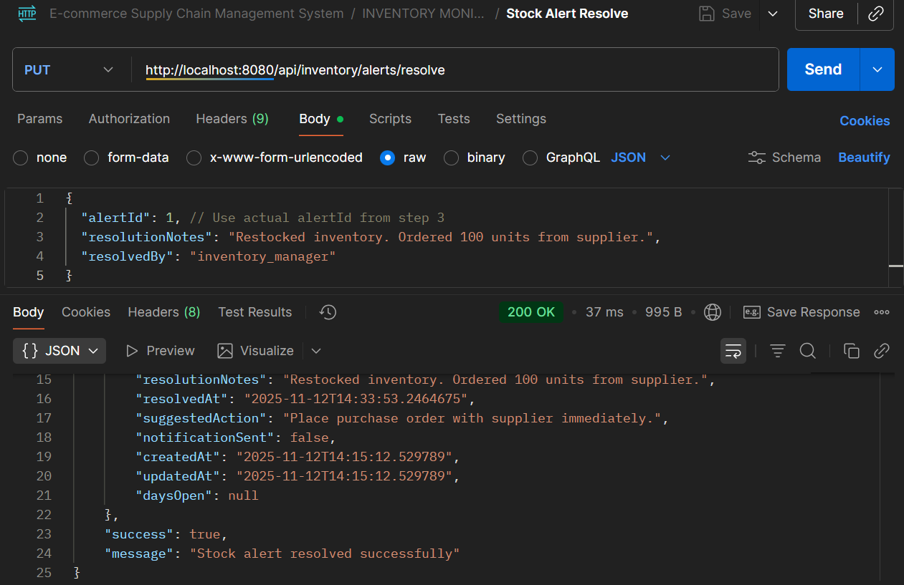

* **API Name: Resolve Inventory Alert**
* **Endpoint:**[**http://localhost:8080/api/inventory/alerts/resolve**](http://localhost:8080/api/inventory/alerts/resolve)
* **Method: PUT**
* **Description: Marks an active inventory alert as resolved with resolution details and audit trail.**
* **Request Body:**

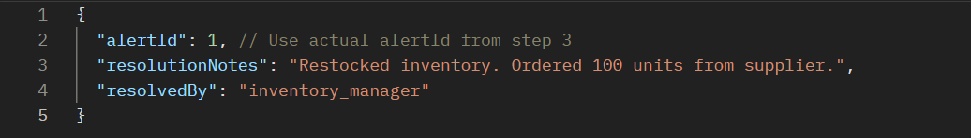

* **Respond Body:**

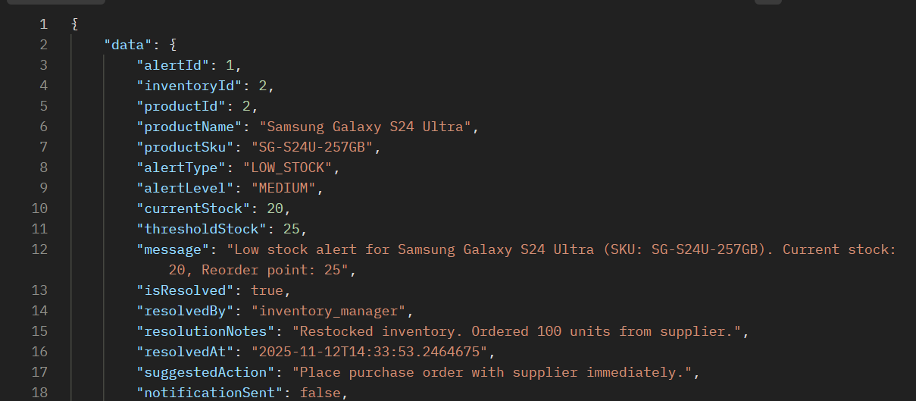

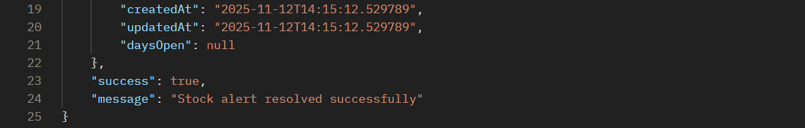

**NOTE:**

This API completes the inventory alert lifecycle by allowing users to resolve alerts with detailed resolution notes and tracking who resolved them and when. The system updates the resolvedAt timestamp and marks isResolved as true.

PROCESS 7: **DEMAND FORECASTING & REORDER PLANNING**

**API 7.1: Generate Demand Forecast**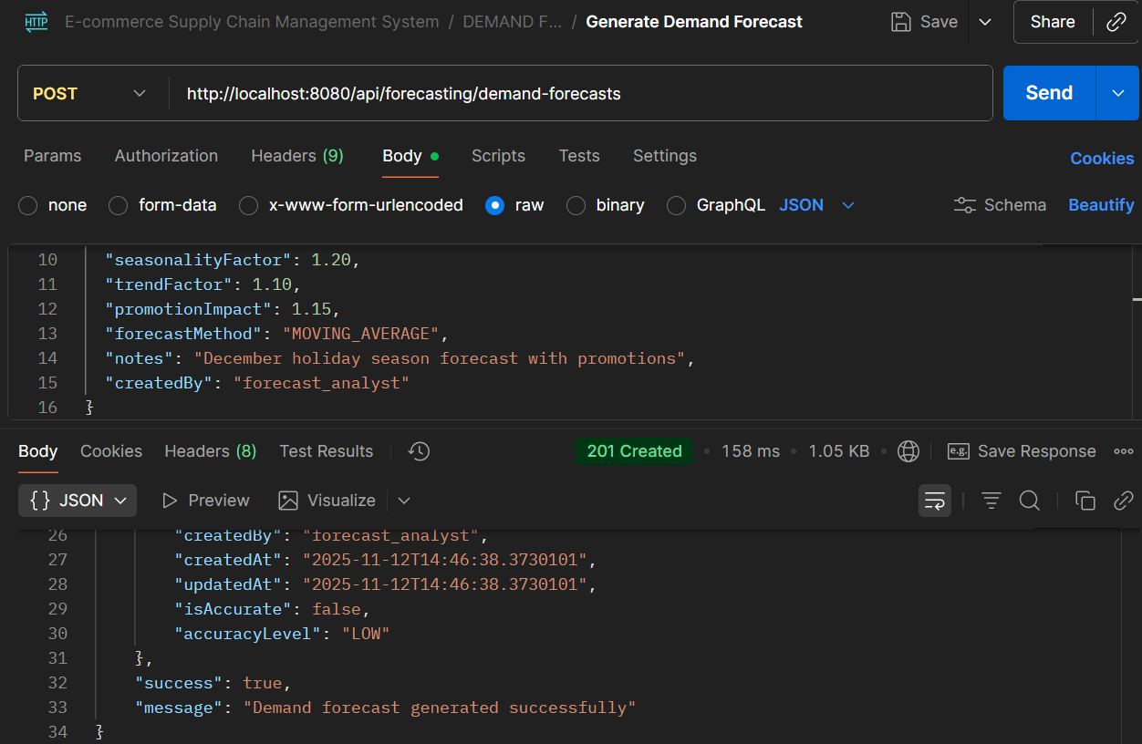

* **API Name: Generate Demand Forecast**
* **Endpoint:**[**http://localhost:8080/api/forecasting/demand-forecasts**](http://localhost:8080/api/forecasting/demand-forecasts)
* **Method: POST**
* **Description: Generates demand forecasts for products using various forecasting methods and factors like seasonality, trends, and promotions.**
* **Request Body:**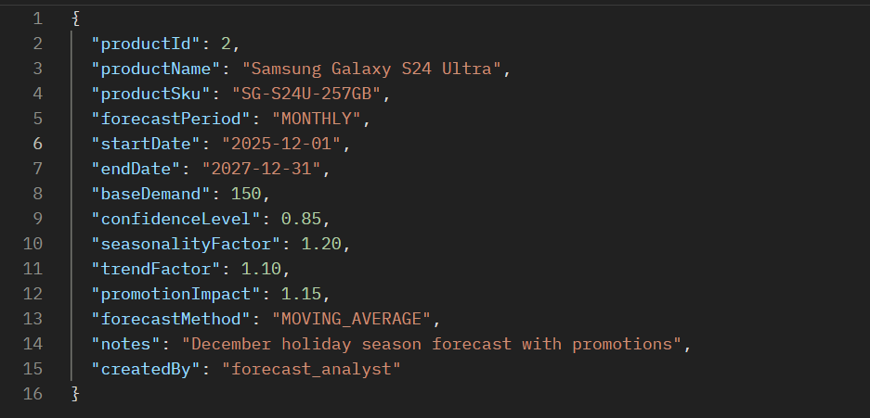
* **Respond Body:**

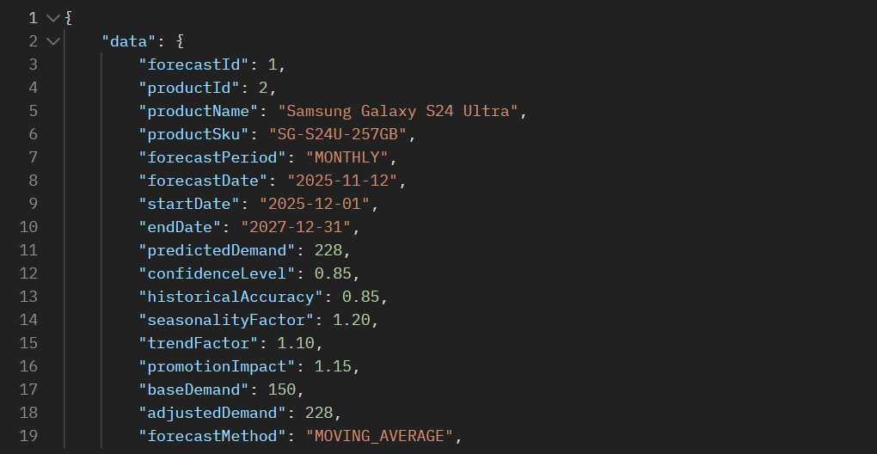

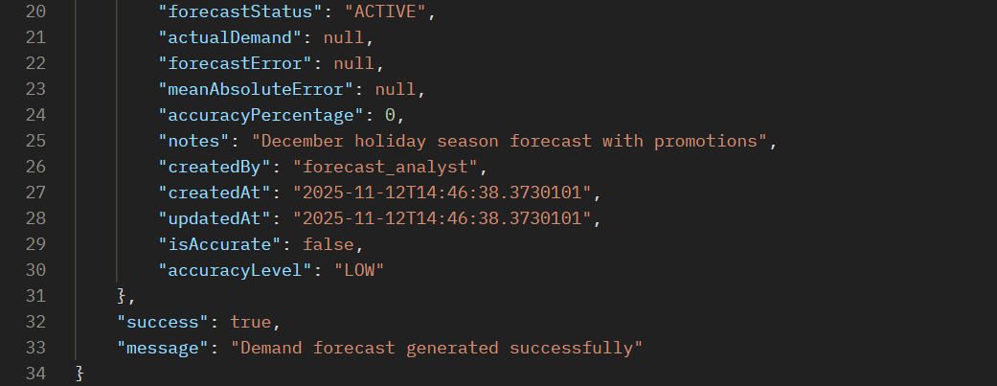

**API 7.2: Generate Reorder Plan**

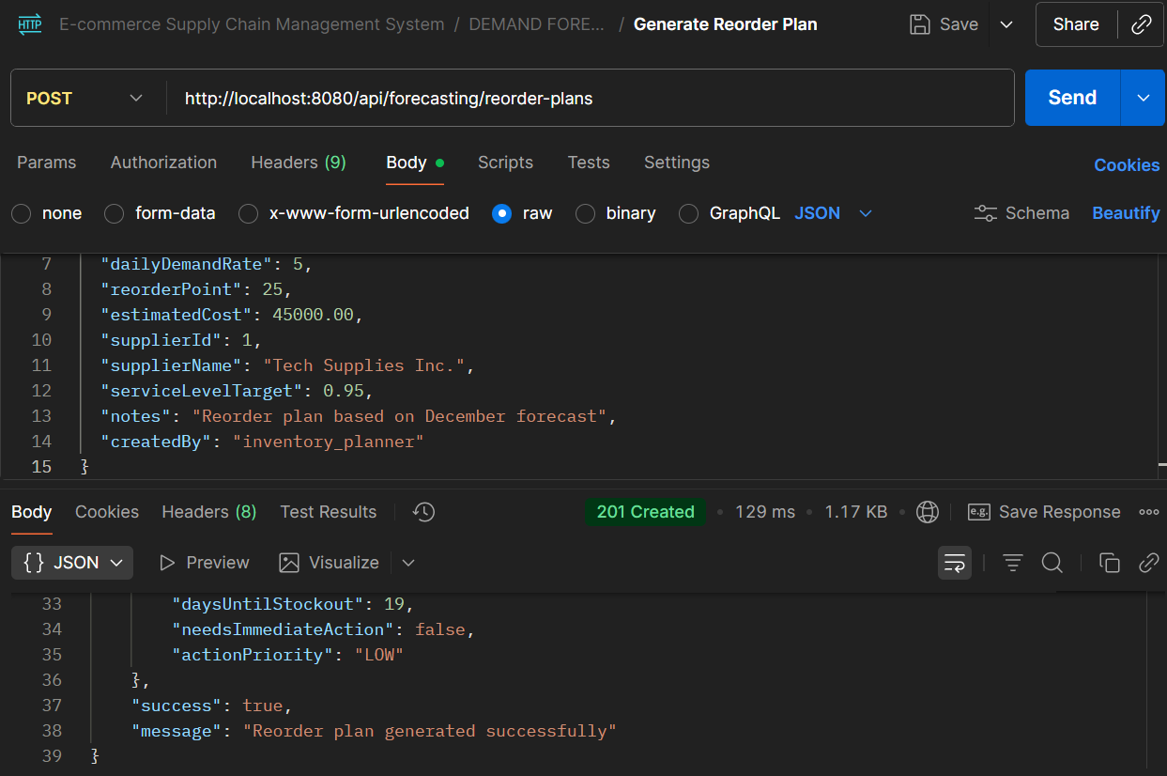

* **API Name: Generate Demand Forecast**
* **Endpoint:**[**http://localhost:8080/api/forecasting/demand-forecasts**](http://localhost:8080/api/forecasting/demand-forecasts)
* **Method: POST**
* **Description: Generates demand forecasts for products using various forecasting methods and factors like seasonality, trends, and promotions.**
* **Request Body:**

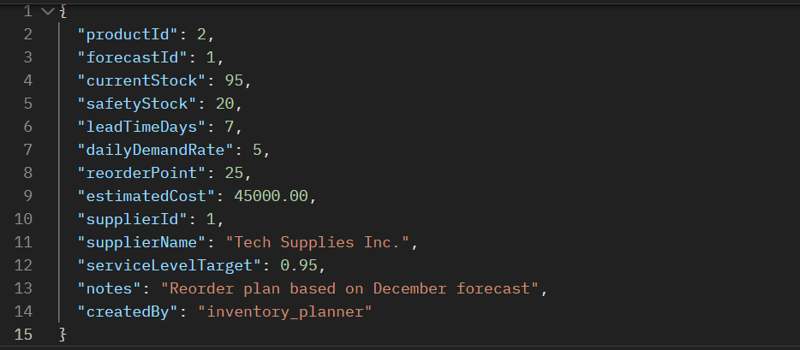

* **Respond Body:**

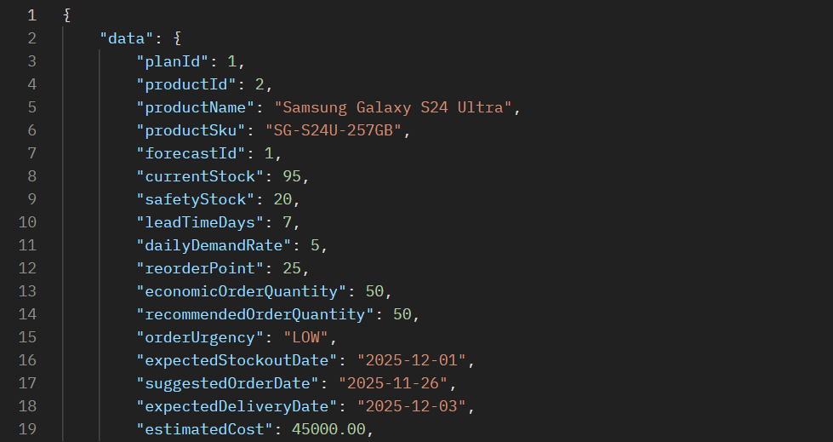

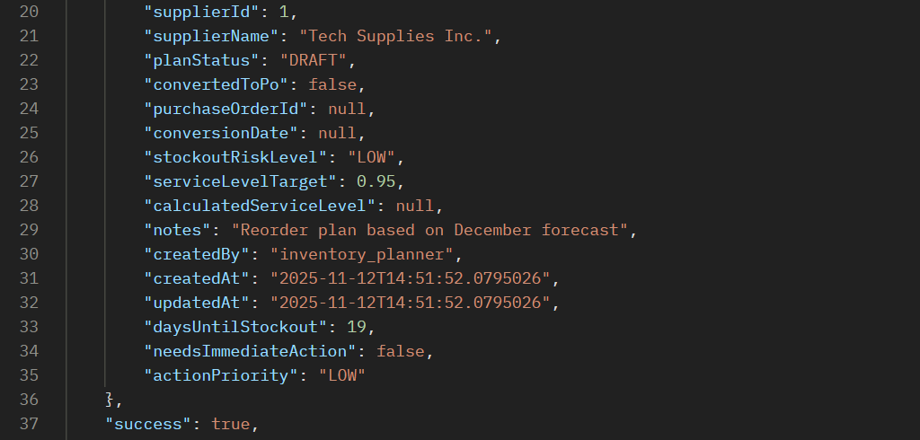



### ERROR SCENARIOS FOR PROCESS 7

**Error 1: Invalid Forecast Period & Invalid Forecast Method**

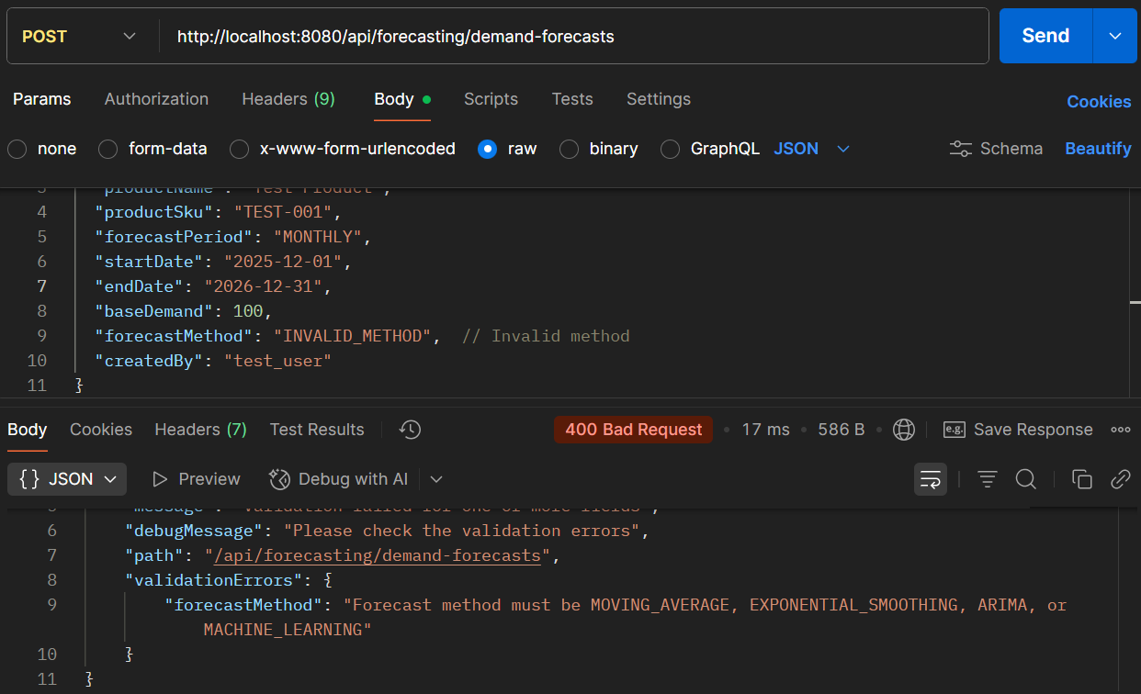

**Error 2: Invalid Forecast Period**

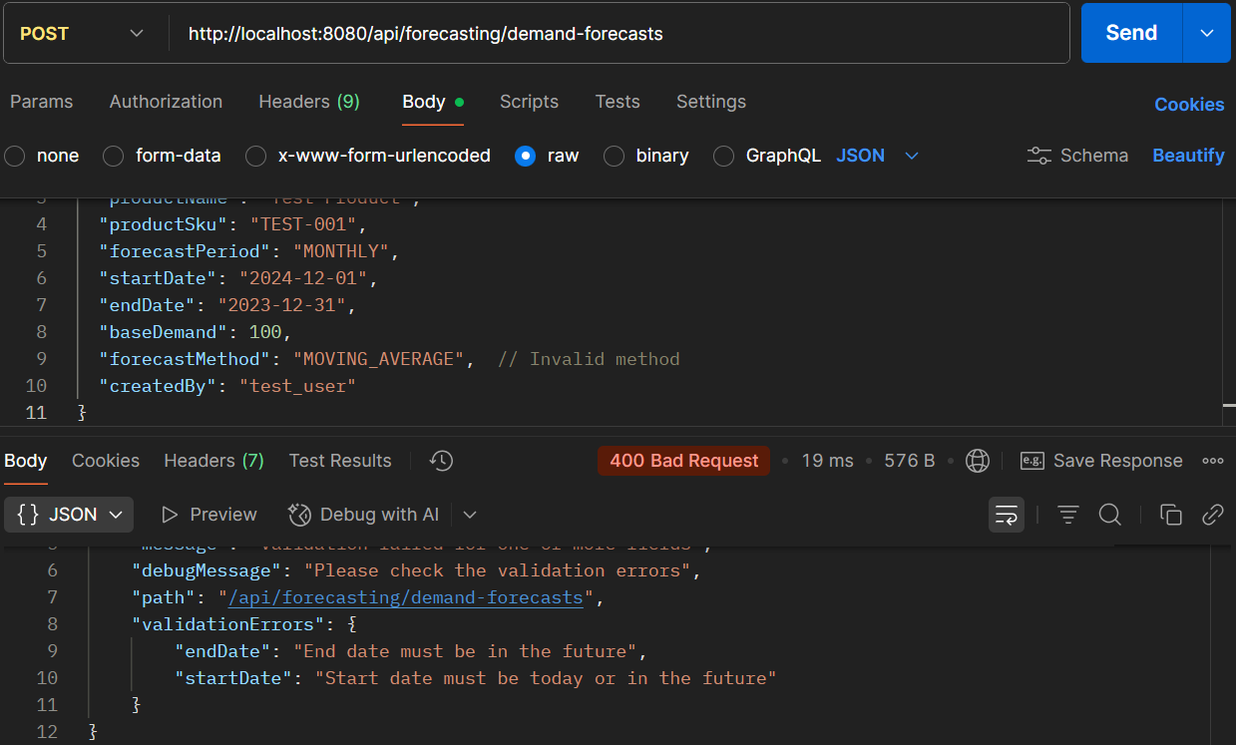

PROCESS 8: **WAREHOUSE STORAGE & SHELF PLACEMENT**

**API 8.1: Create Warehouse**

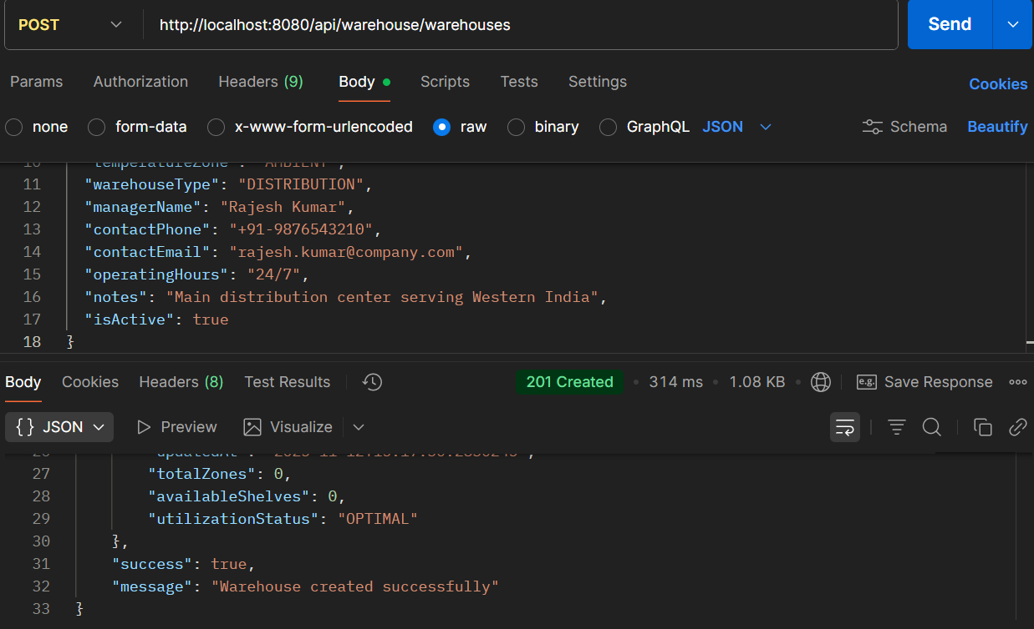

* **API Name: Create Warehouse**
* **Endpoint:**[**http://localhost:8080/api/warehouse/warehouses**](http://localhost:8080/api/warehouse/warehouses)
* **Method: POST**
* **Description: Creates a new warehouse facility with comprehensive details including location, capacity, contact information, and operational parameters.**
* **Request Body:**

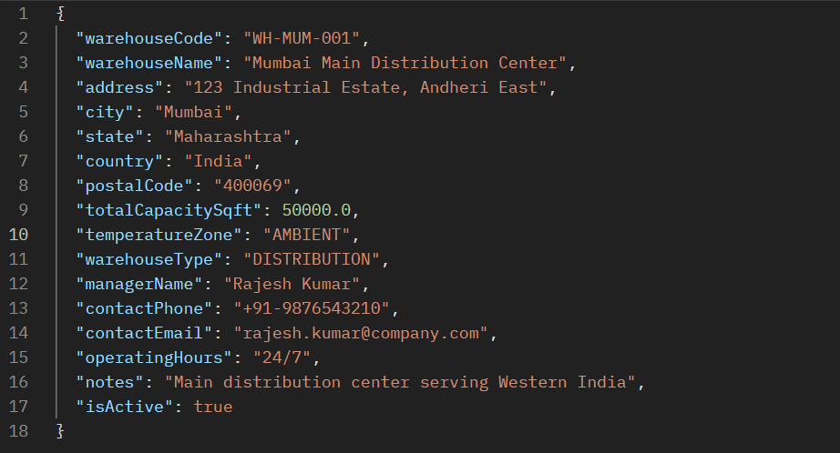

* **Respond Body:**

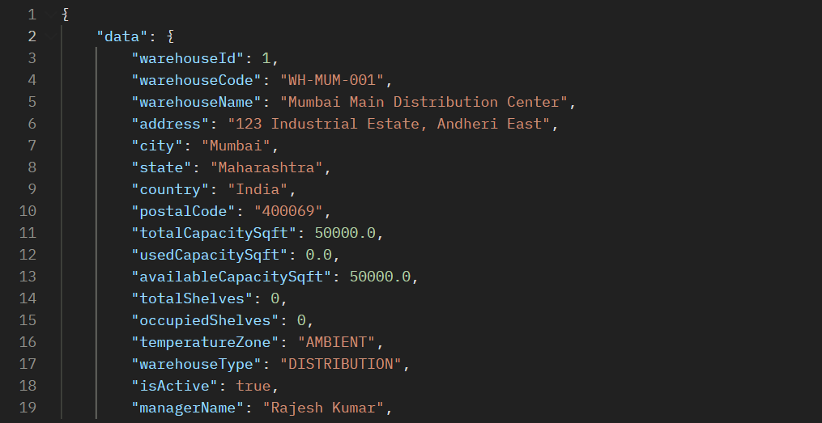

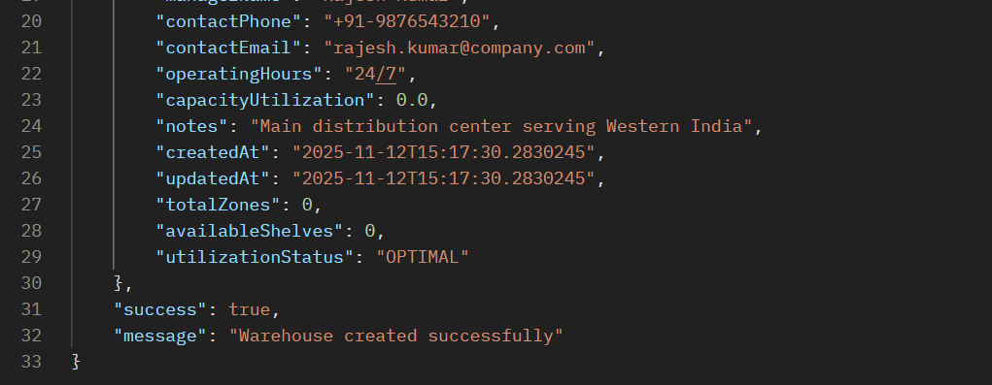

**API 8.2: Warehouses with Available Capacity**

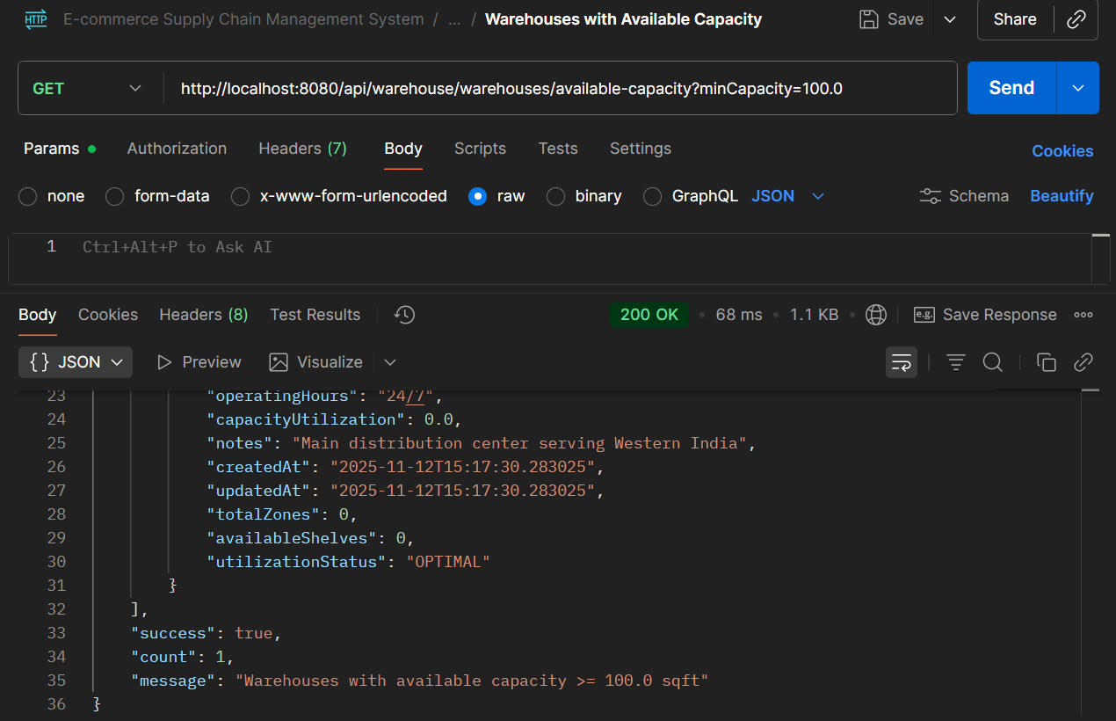

* **API Name: Get Warehouses with Available Capacity**
* **Endpoint:** [**http://localhost:8080/api/warehouse/warehouses/available-capacity?minCapacity=100.0**](http://localhost:8080/api/warehouse/warehouses/available-capacity?minCapacity=100.0)
* **Method: GET**
* **Description: Retrieves warehouses that have available capacity meeting specified criteria, used for inventory allocation and storage planning.**
* **Request Body:  
  *This is a GET endpoint and does not require a request body. It likely uses query parameters like*minCapacity=100*.***
* **Response Body:**

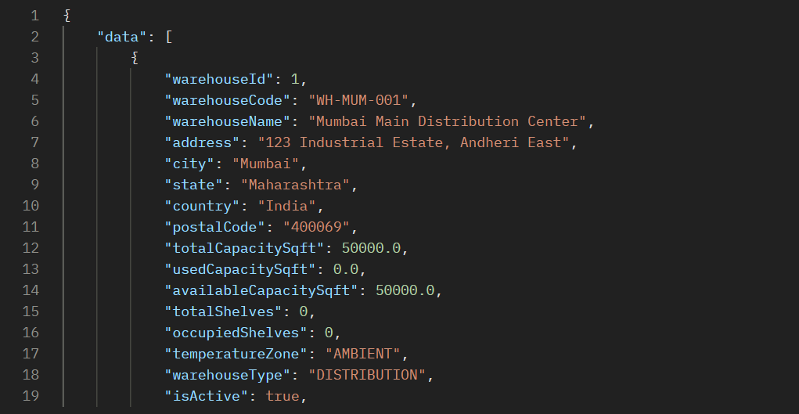

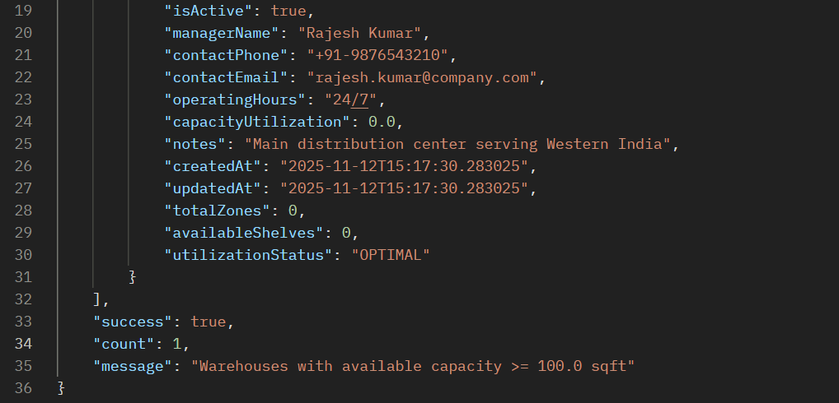

### ERROR SCENARIOS FOR PROCESS 8

**Error 1: Invalid Warehouse Type**

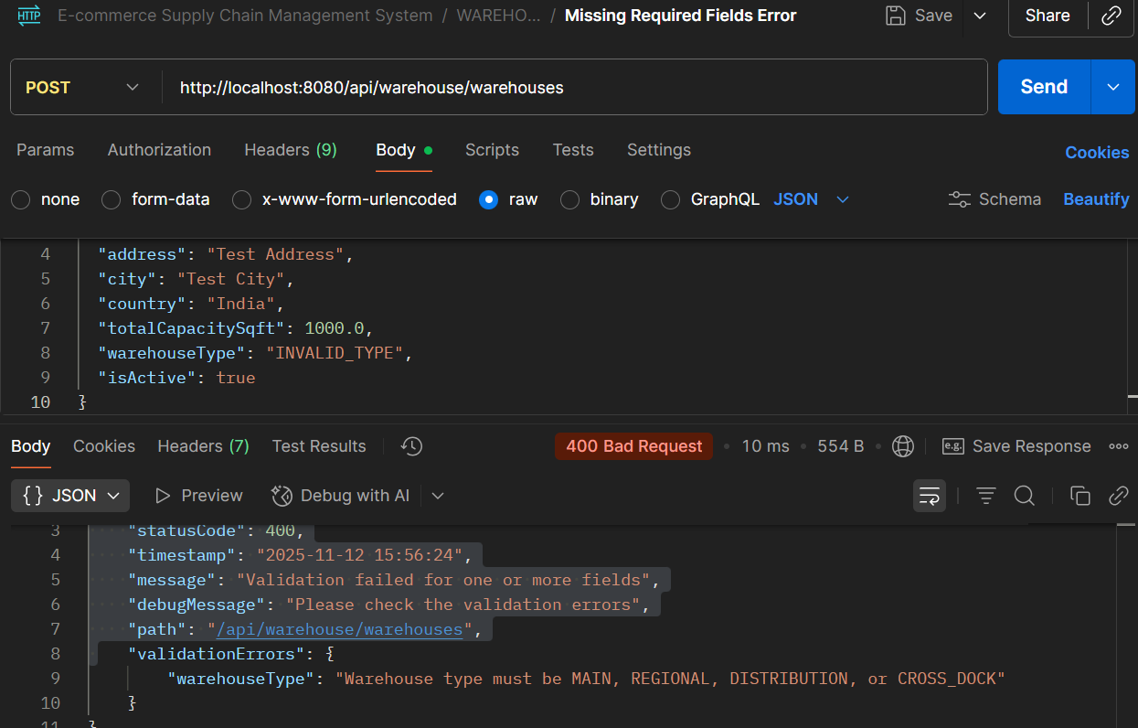

**Error 2: Missing Required Fields Error**

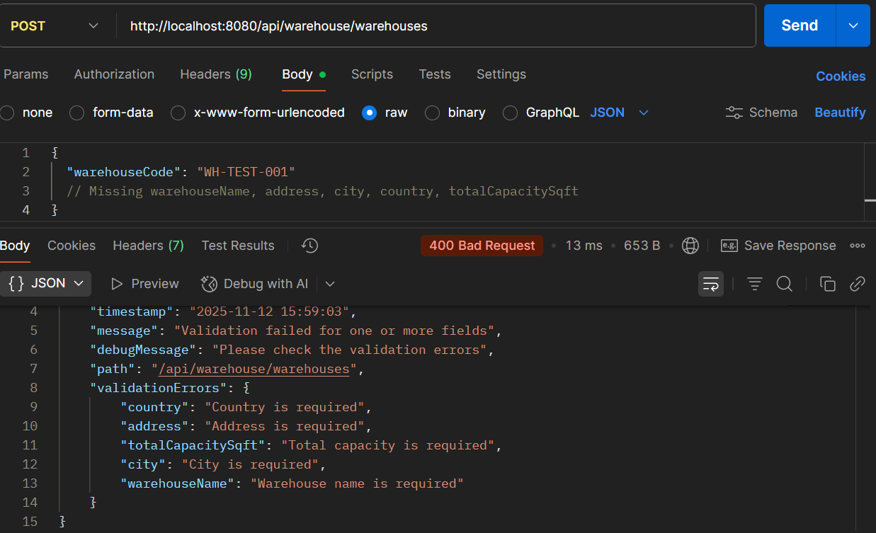

PROCESS 9: **ORDER PICKING & PACKAGING**

**API 9.1: Create Pick List**

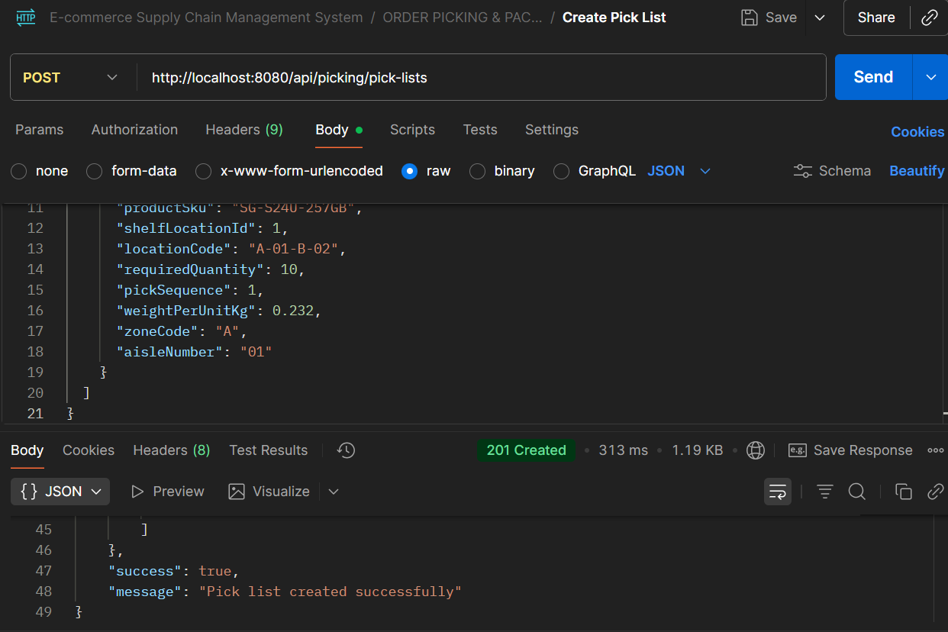

* **API Name: Create Pick List**
* **Endpoint:**[**http://localhost:8080/api/picking/pick-lists**](http://localhost:8080/api/picking/pick-lists)
* **Method: POST**
* **Description: Generates a pick list for warehouse order fulfillment with optimized picking sequence, location details, and product information.**
* **Request Body:**

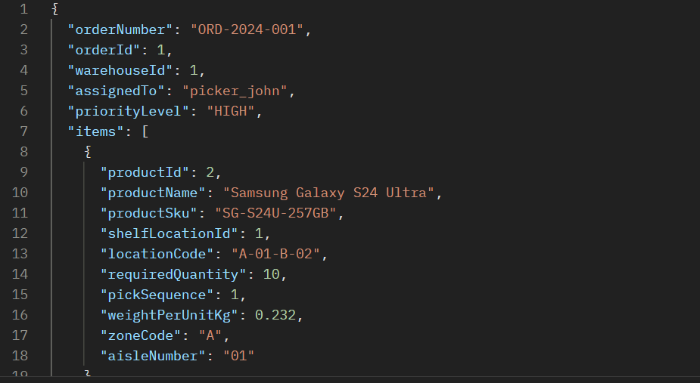

* **Respond Body:**

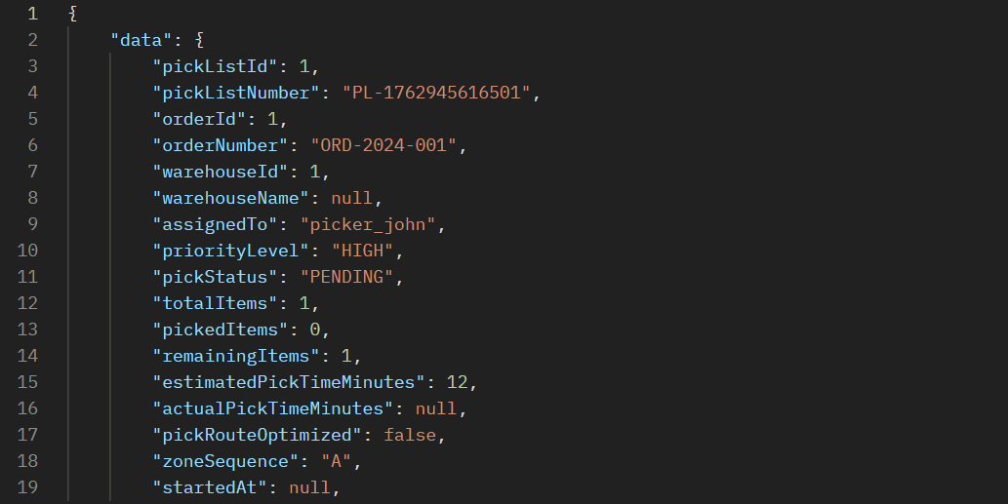

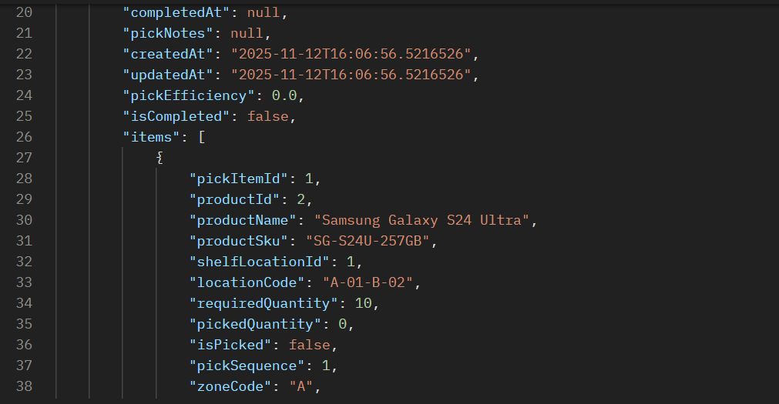

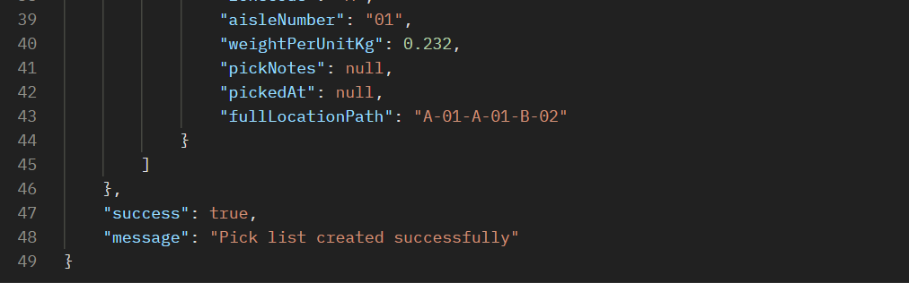

**API 9.2: Create Package**

**Step 1: Update Pick Item Status**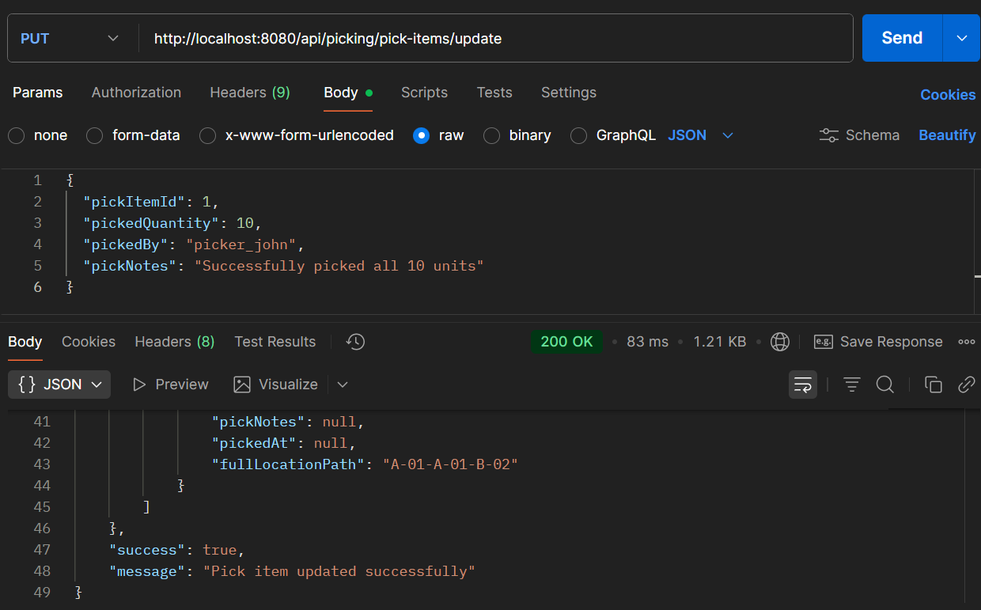

**Step 2: Then Create Package**

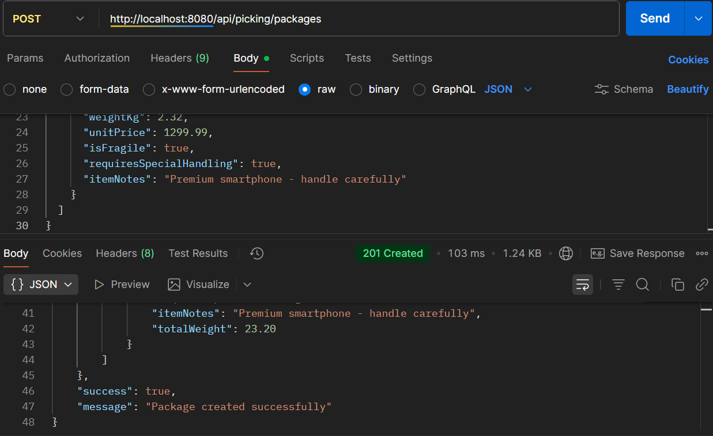

### ERROR SCENARIOS FOR PROCESS 9

**ERROR 1: Invalid Package Type**

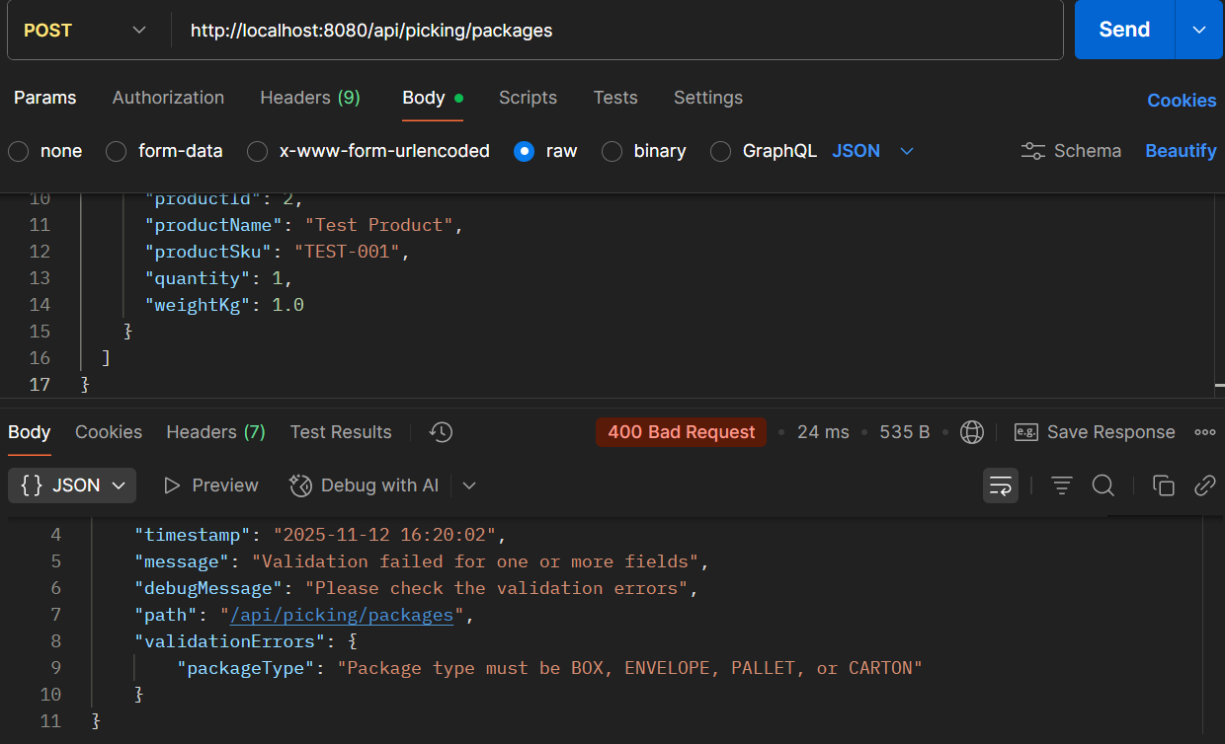

**ERROR 2: Zero Quantity in Pick List**

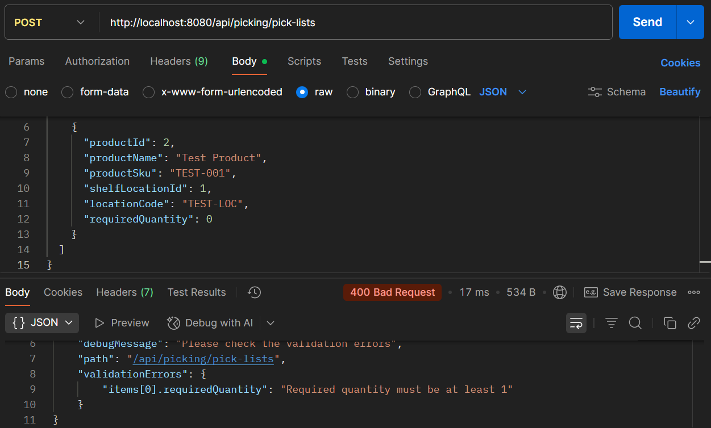

PROCESS 10: **QUALITY CONTROL BEFORE SHIPMENT**

**API 10.1: Create Quality Check**

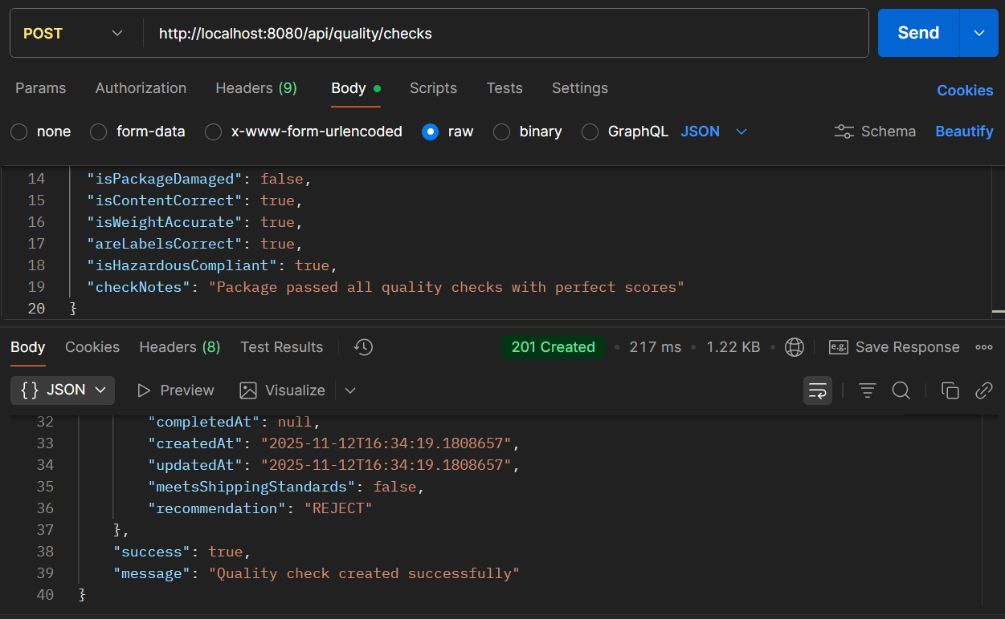

* **API Name: Create Quality Check**
* **Endpoint: http://localhost:8080/api/quality/checks**
* **Method: POST**
* **Description: Performs comprehensive quality checks on products/packages before shipping, evaluating multiple quality dimensions and providing recommendations.**
* **Request Body:**

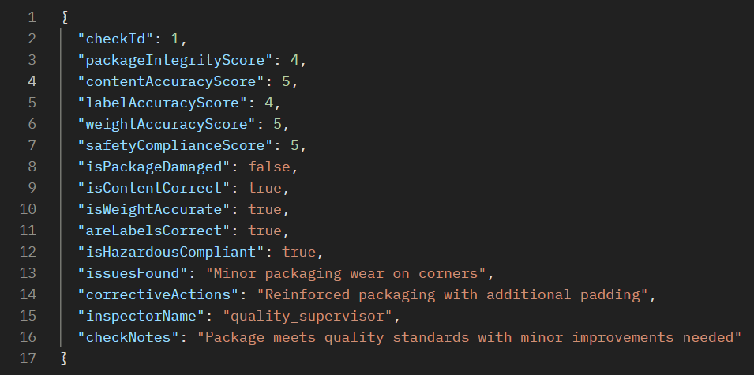

* **Respond Body**

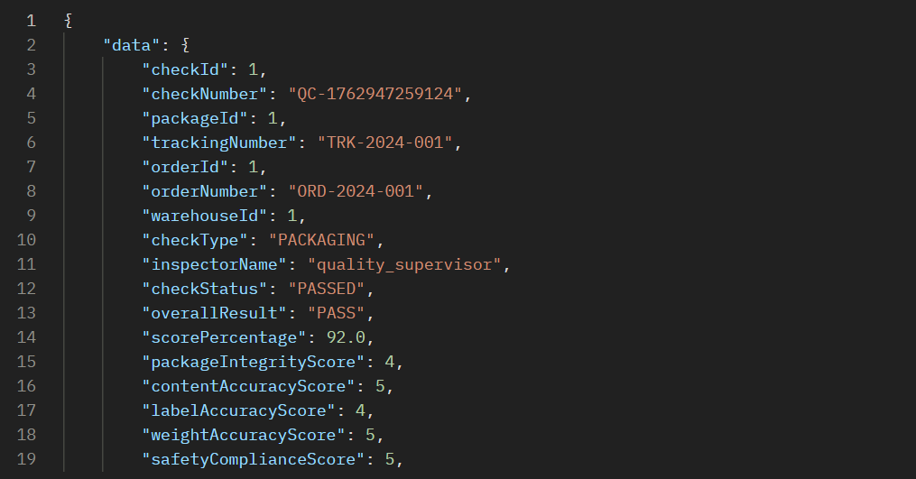

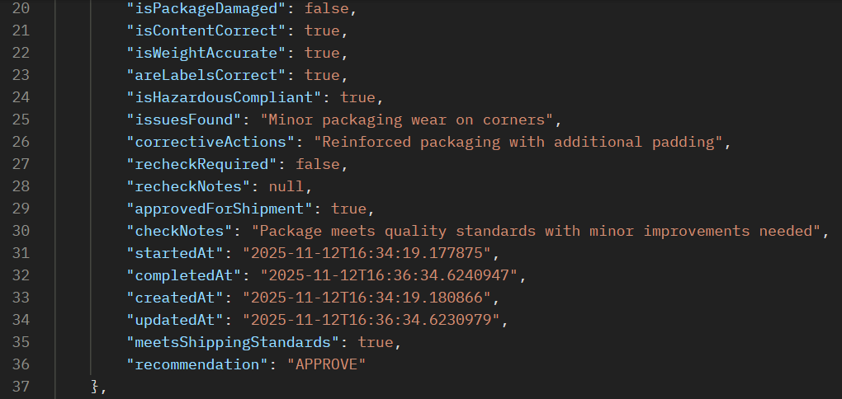



**API 10.2: Submit Quality Results**

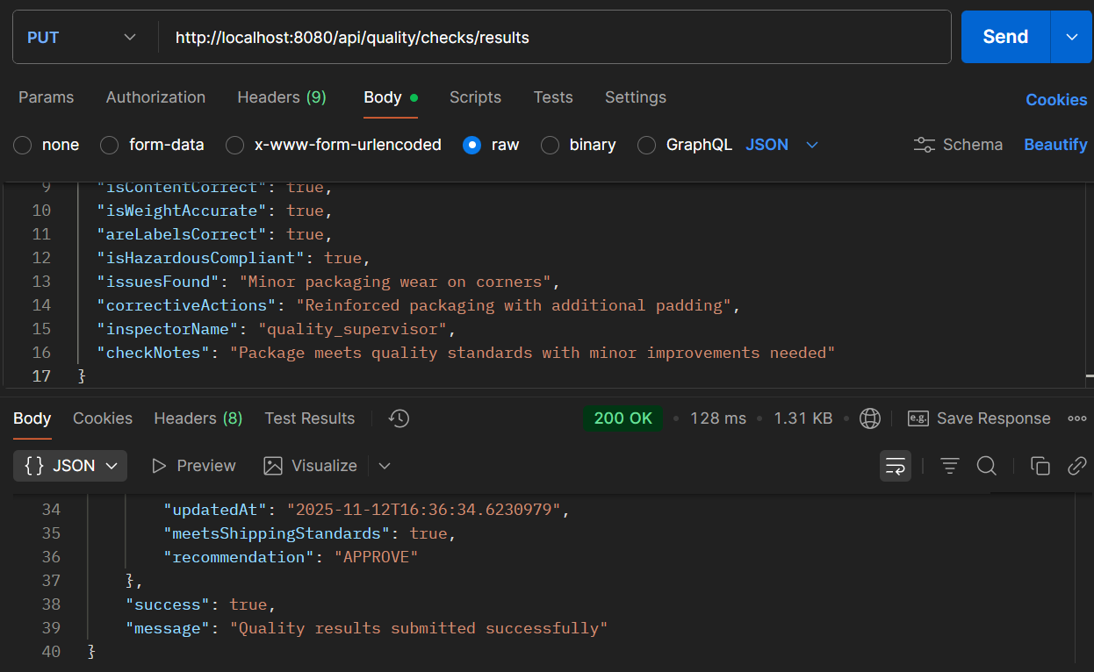

* **API Name: Submit Quality Check Results**
* **Endpoint: http://localhost:8080/api/quality/checks/results**
* **Method: PUT**
* **Description: Substitutes or updates quality check results with detailed issue tracking, corrective actions, and final recommendations for shipment approval.**
* **Request Body:**

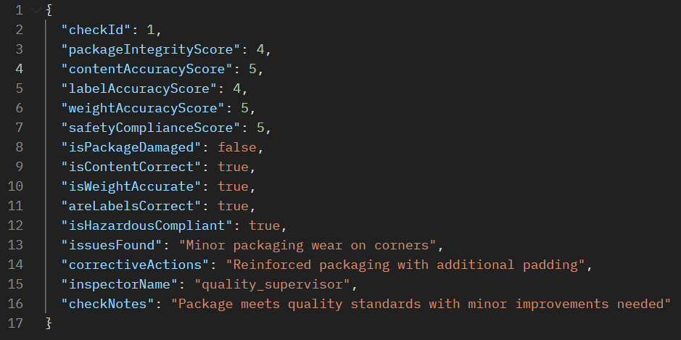

* **Respond Body:**

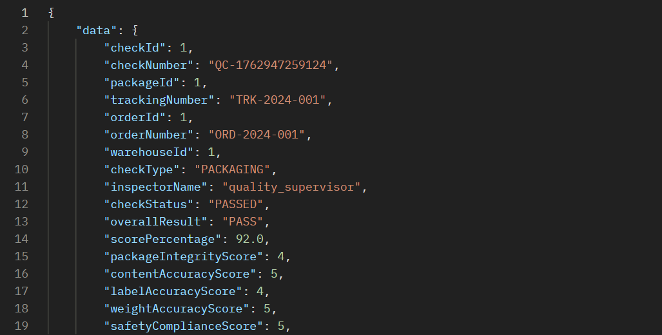

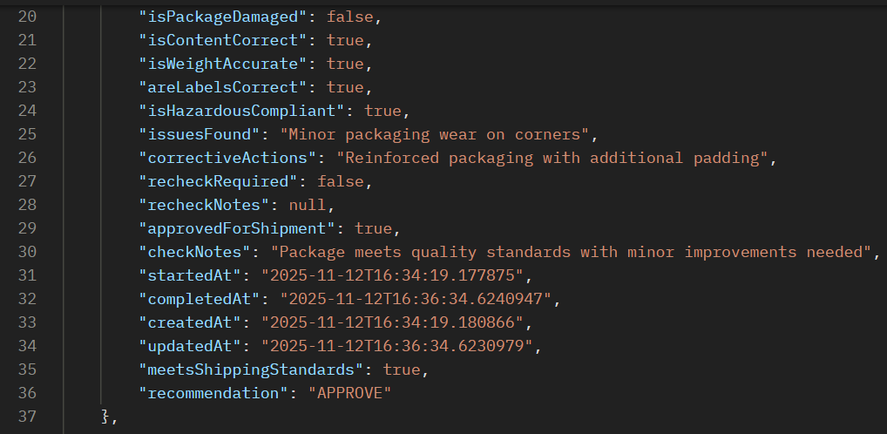



### ERROR SCENARIOS FOR PROCESS 10

**Error 1: Invalid Check Type**

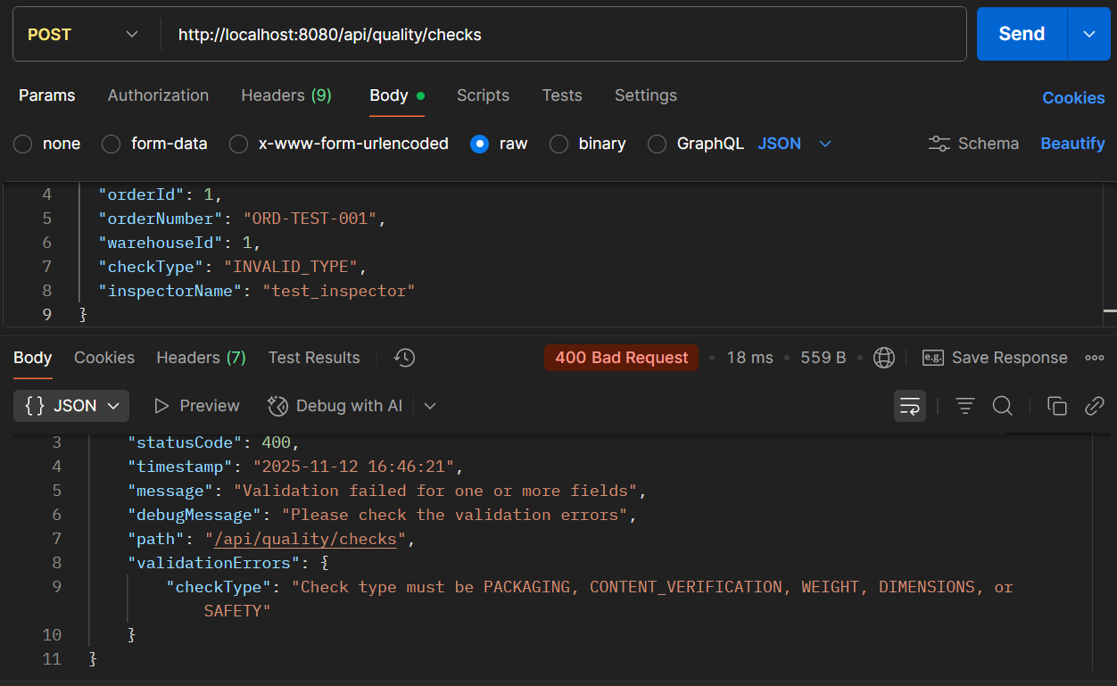

**ERROR 2: Missing Required Boolean Fields**

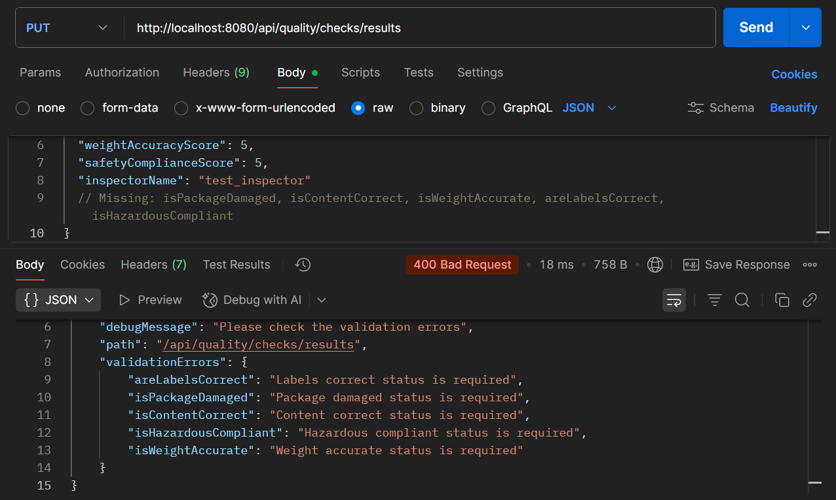

PROCESS 11**: SHIPMENT SCHEDULING & DISPATCHING**

**API 11.1: Create Shipment**

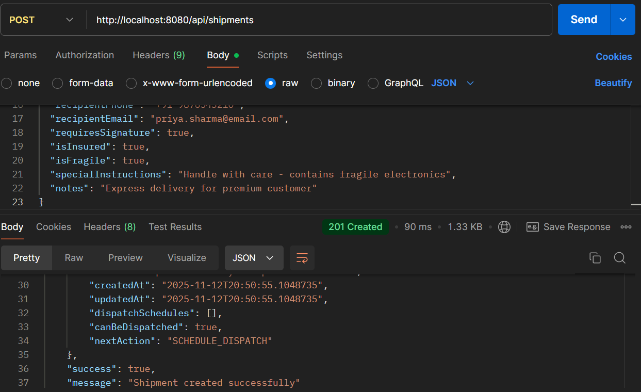

* **API Name: Create Shipment**
* **Endpoint:**[**http://localhost:8080/api/shipments**](http://localhost:8080/api/shipments)
* **Method: POST**
* **Description: Creates a new shipment with comprehensive delivery details, customer information, shipping preferences, and special handling instructions.**
* **Request Body:**

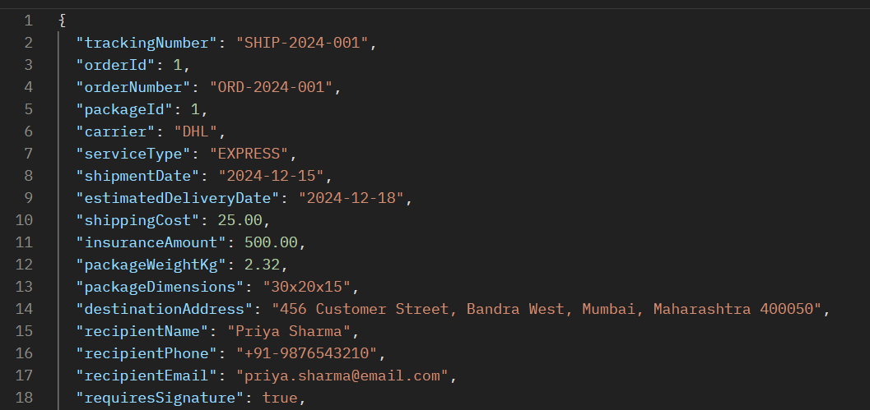

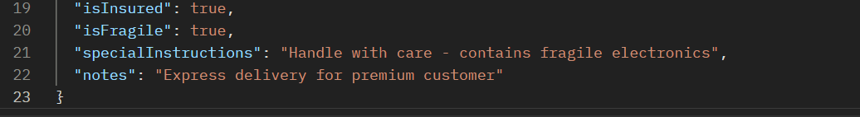

* **Respond Body:**

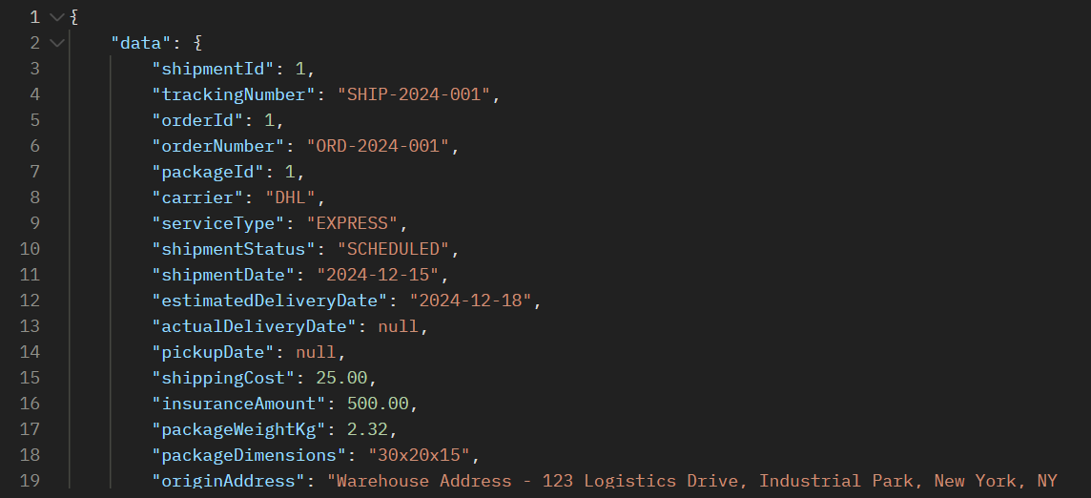

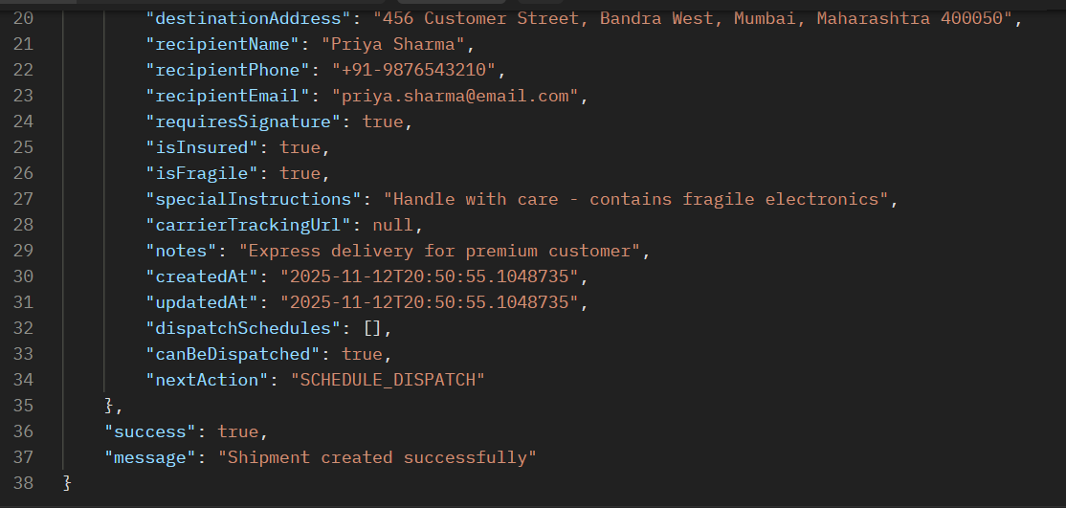

**API 11.2: Schedule Dispatch**

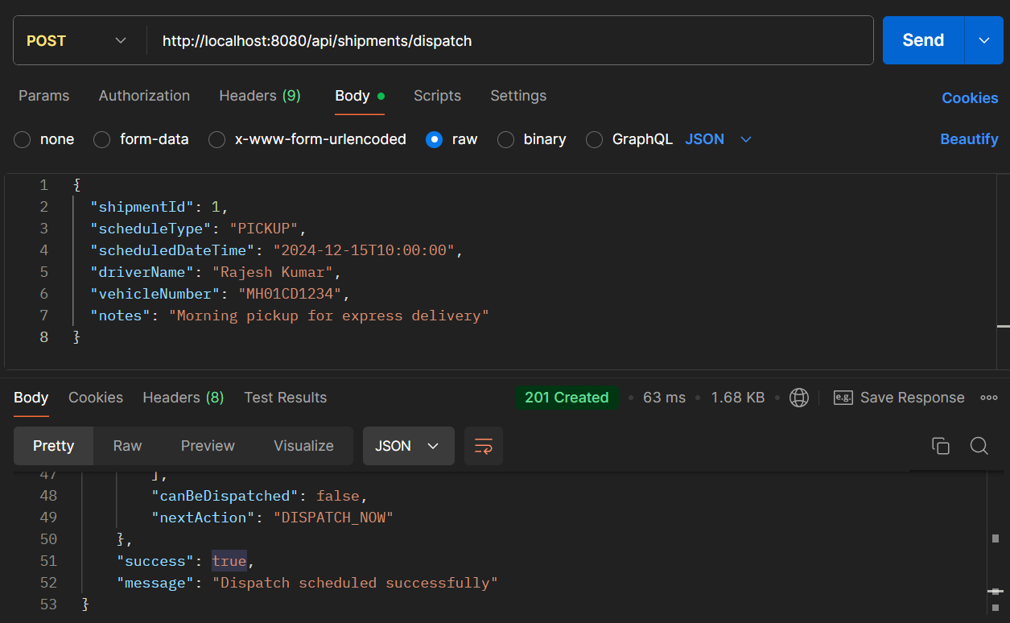

* **API Name: Schedule Shipment Dispatch**
* **Endpoint:**[**http://localhost:8080/api/shipments/dispatch**](http://localhost:8080/api/shipments/dispatch)
* **Method: POST**
* **Description: Schedules the dispatch of a shipment with pickup/delivery details, driver information, and vehicle assignment.**
* **Request Body:**

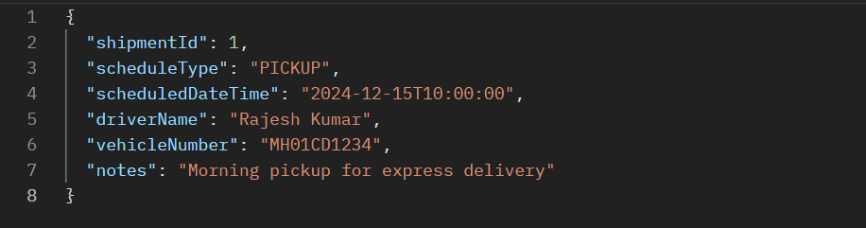

* **Respond Body:**

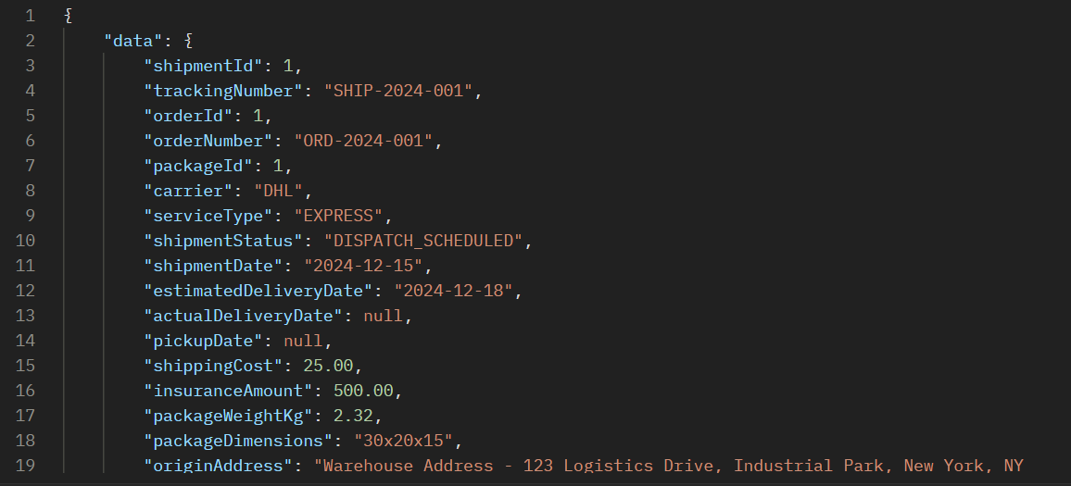

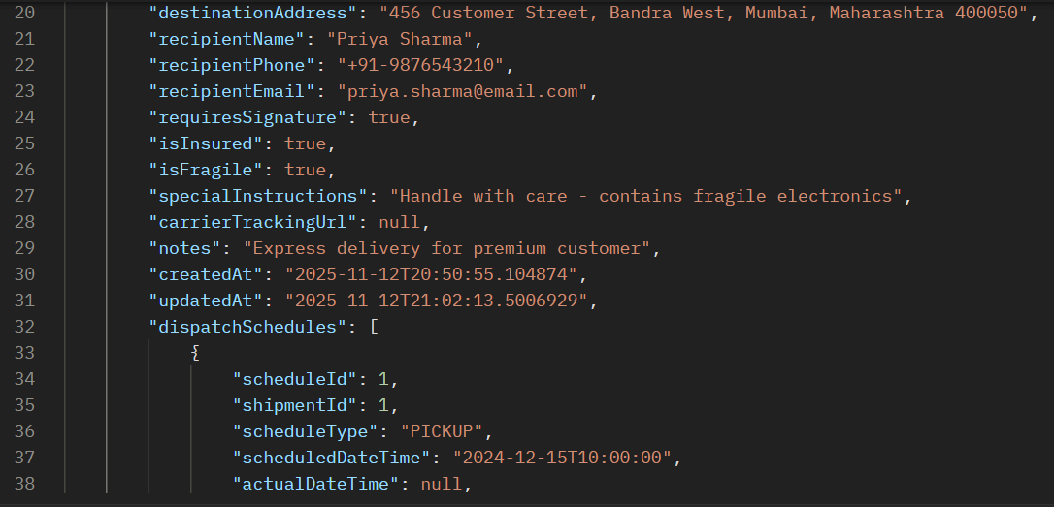

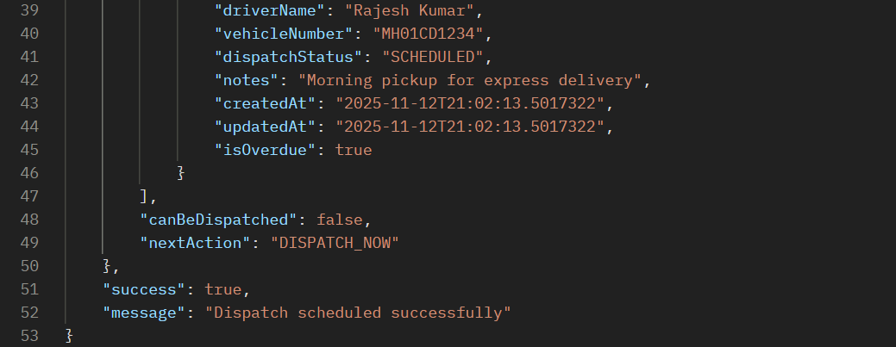

### ERROR SCENARIOS FOR PROCESS 11

**Error 1: Missing Required Fields in Shipment**

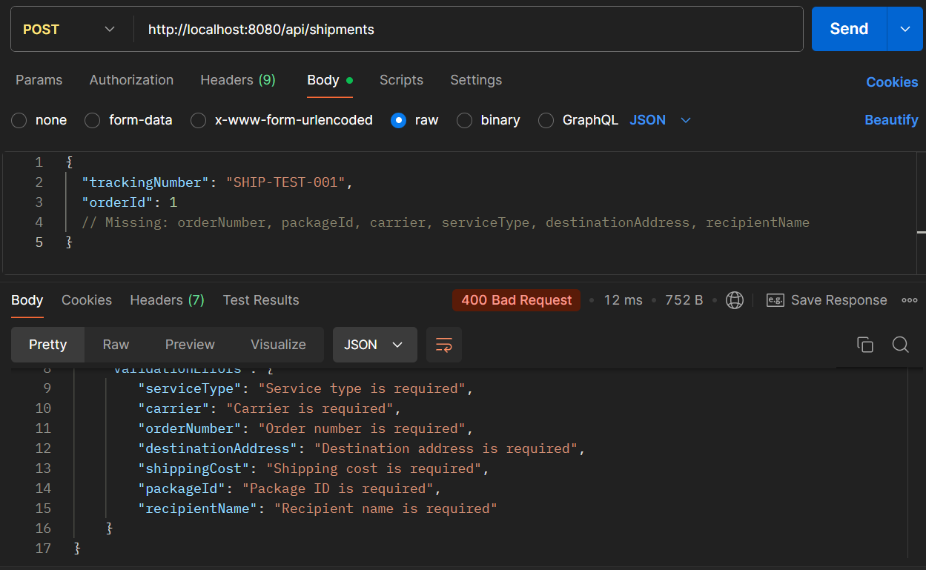

**Error 2: Invalid Dispatch**

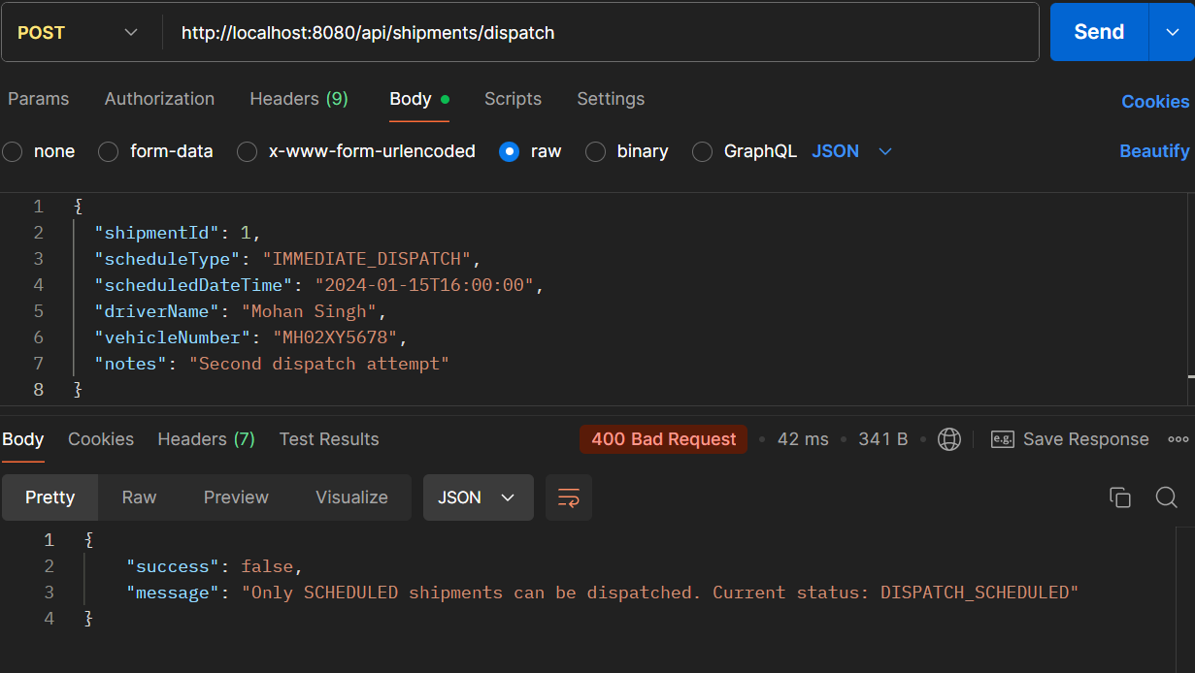

PROCESS 12: **TRACKING & DELIVERY UPDATES**

**API 12.1: Add Tracking Event**

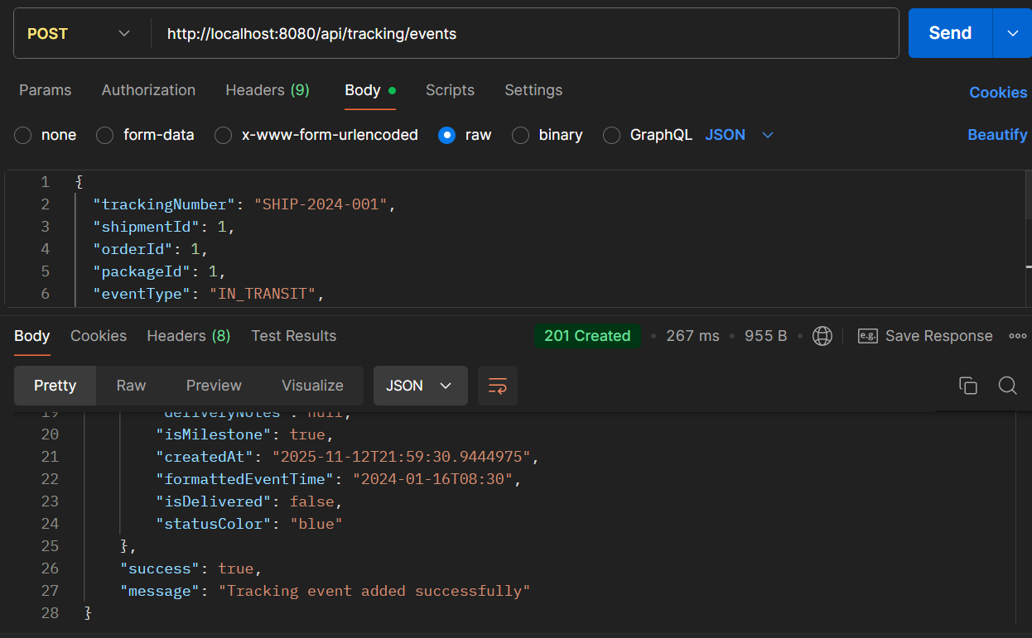

* **API Name: Add Tracking Event**
* **Endpoint:**[**http://localhost:8080/api/tracking/events**](http://localhost:8080/api/tracking/events)
* **Method: POST**
* **Description: Adds real-time tracking events to shipments, updating their status and providing visibility into the delivery progress.**
* **Example Request Body:**

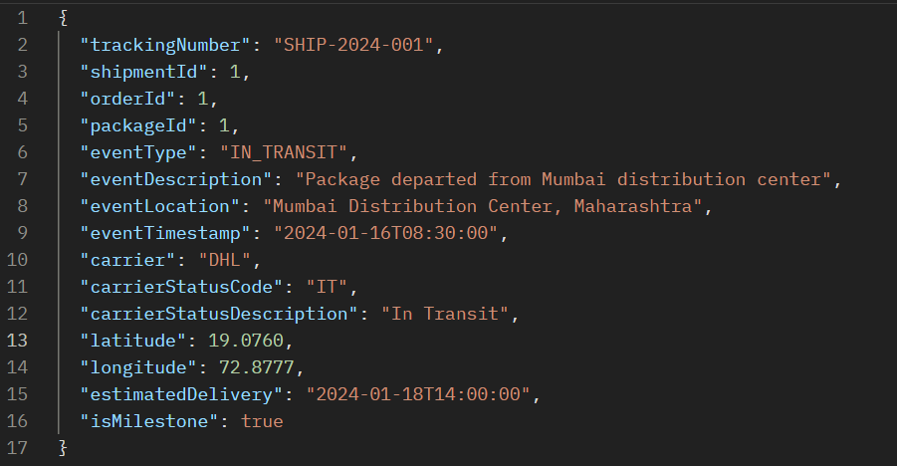

* **Respond Body:**

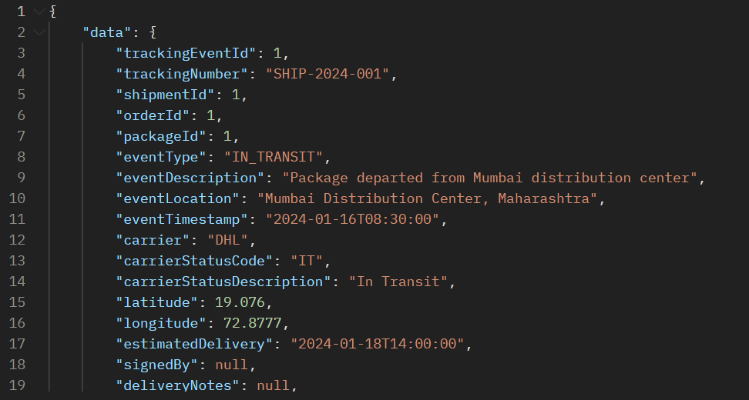

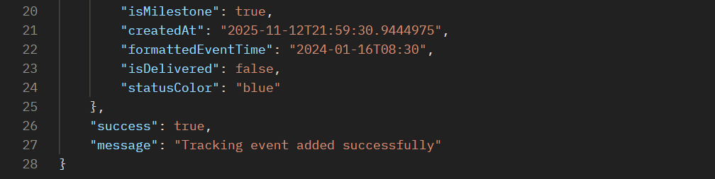

**API 12.2: Get Tracking Status**

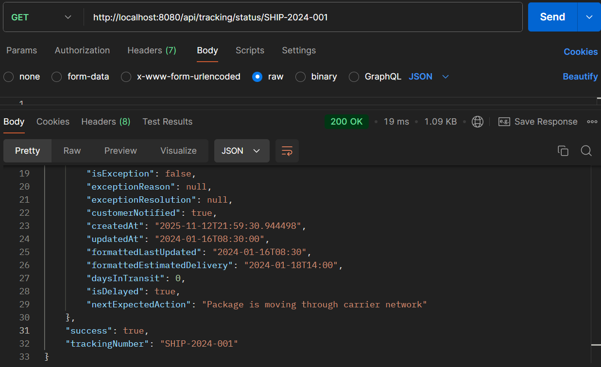

* **API Name: Get Tracking Status**
* **Endpoint:**[**http://localhost:8080/api/tracking/status/SHIP-2024-001**](http://localhost:8080/api/tracking/status/SHIP-2024-001)
* **Method: GET**
* **Description: Retrieves the current status and comprehensive tracking information for a specific shipment using its tracking number.**
* **Example Request Body:  
  *This is a GET endpoint and does not require a request body. The tracking number is passed as a path parameter.***
* **Example Response Body:**

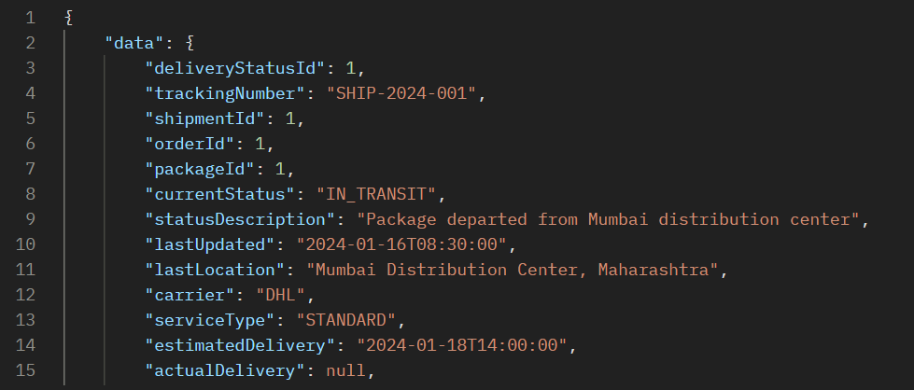

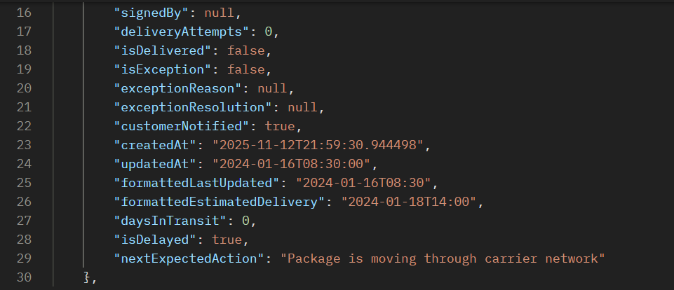



### ERROR SCENARIOS FOR PROCESS 12

**Error 1: Invalid Event Type**

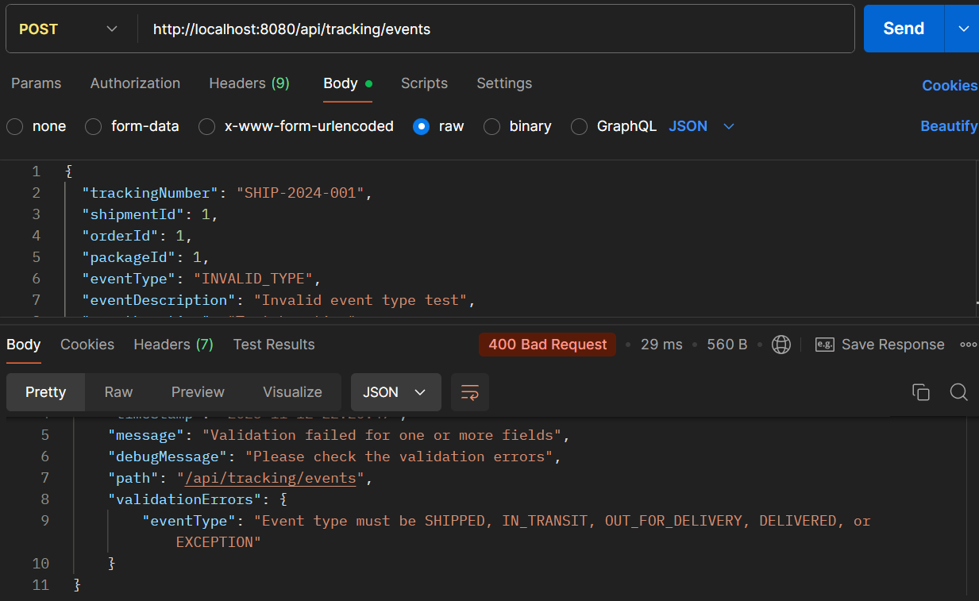

**Error 2: Get Status for Non-existent Tracking**

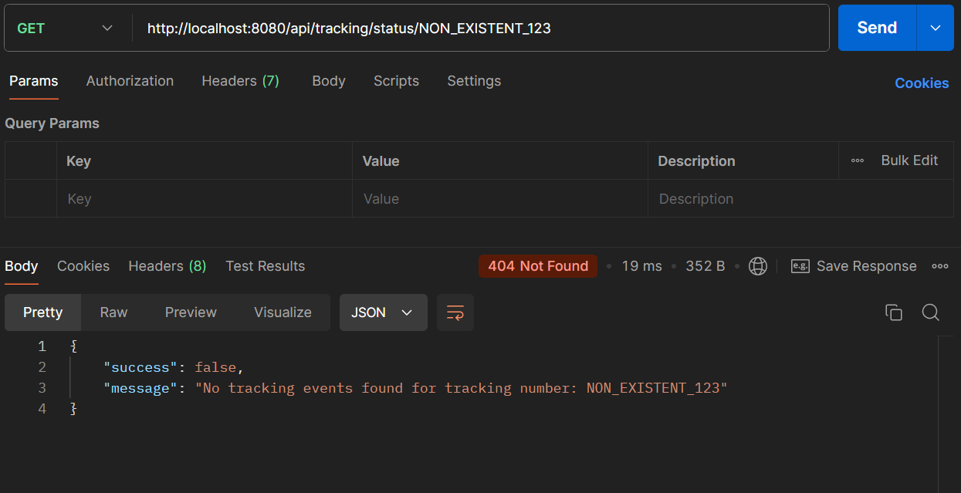

PROCESS 13**: DELIVERY EXCEPTIONS**

**API 13.1: Create Delivery Exception**

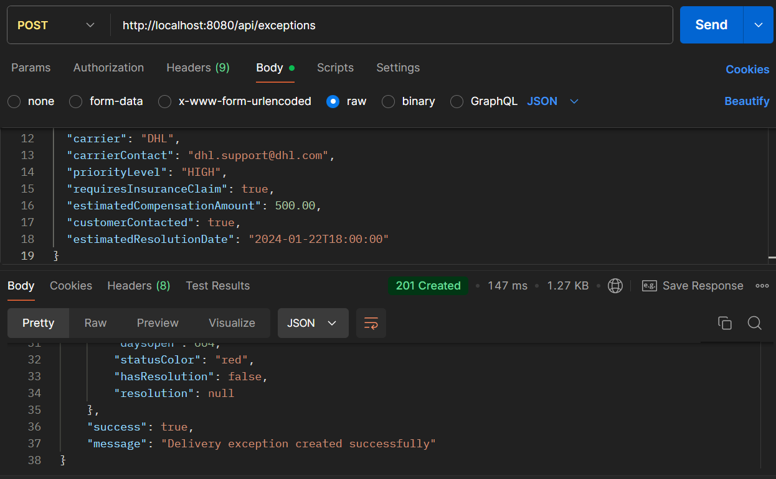

* **API Name: Create Exception**
* **Endpoint:**[**http://localhost:8080/api/exceptions**](http://localhost:8080/api/exceptions)
* **Method: POST**
* **Description: Logs and manages supply chain exceptions with comprehensive incident details, impact assessment, and resolution tracking.**
* **Request Body:**

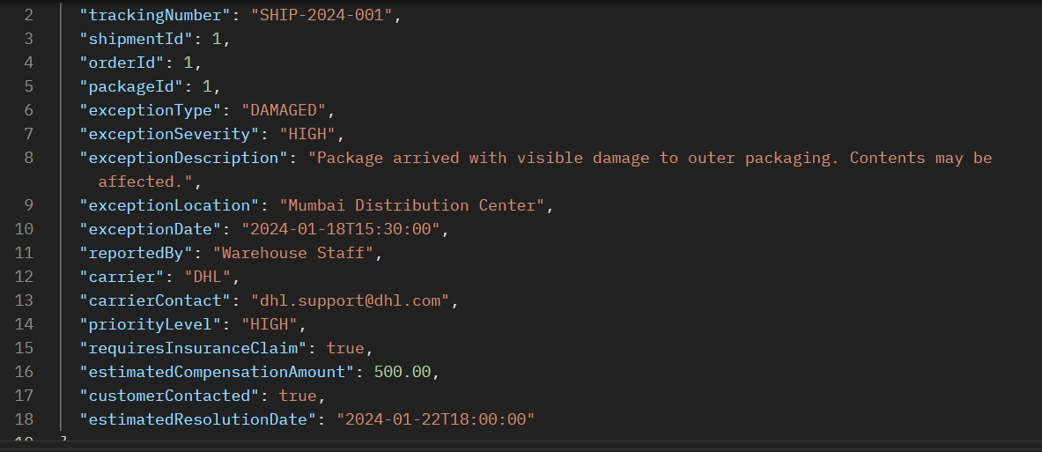

* **Respond Body:**

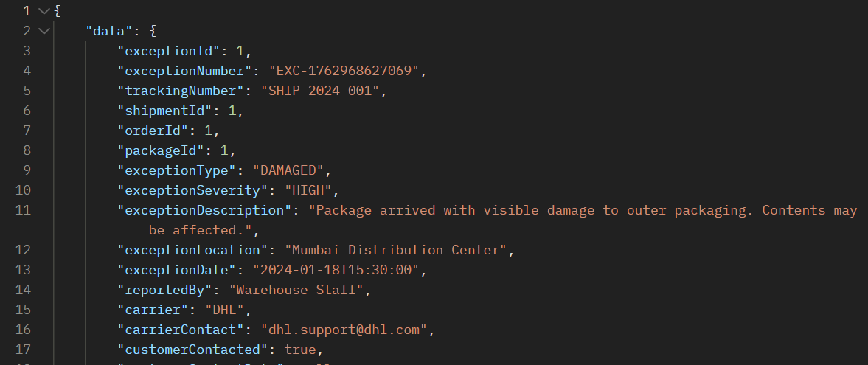

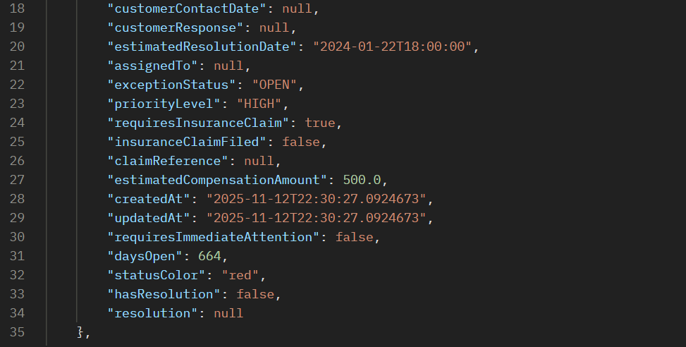



**API 13.2: Resolve Delivery Exception**

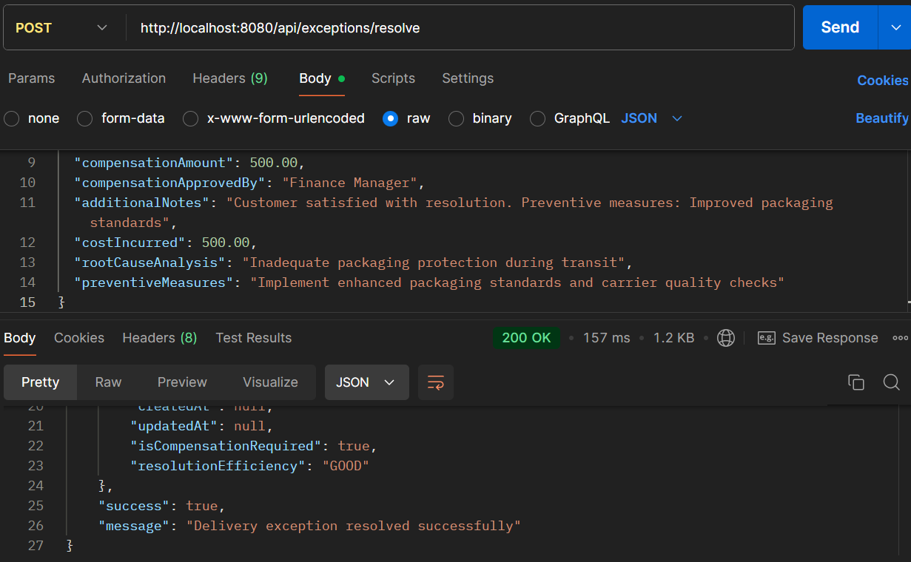

* **API Name: Resolve Exception**
* **Endpoint:**[**http://localhost:8080/api/exceptions/resolve**](http://localhost:8080/api/exceptions/resolve)
* **Method: POST**
* **Description: Resolves supply chain exceptions with comprehensive resolution details, financial compensation, root cause analysis, and preventive measures.**
* **Example Request Body:**

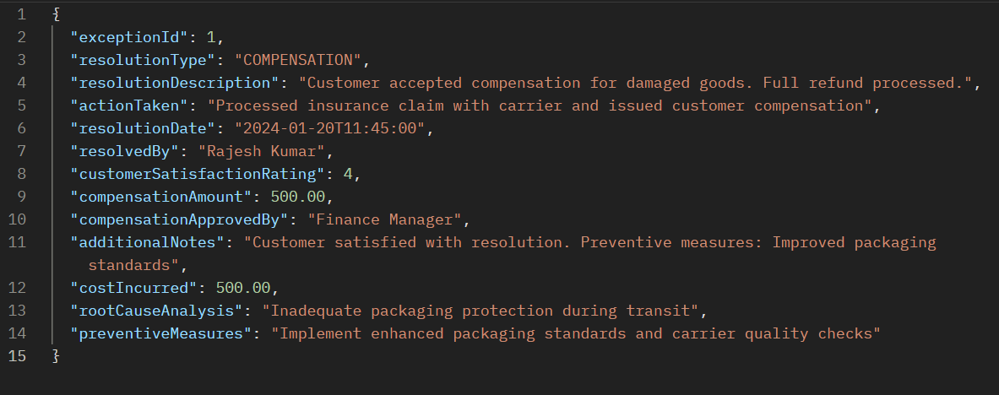

* **Respond Body:**

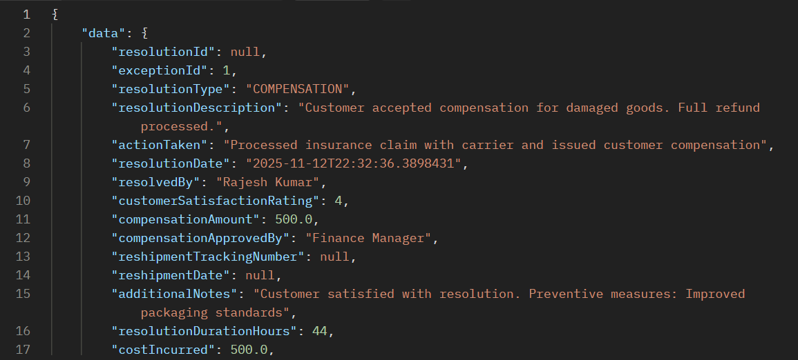

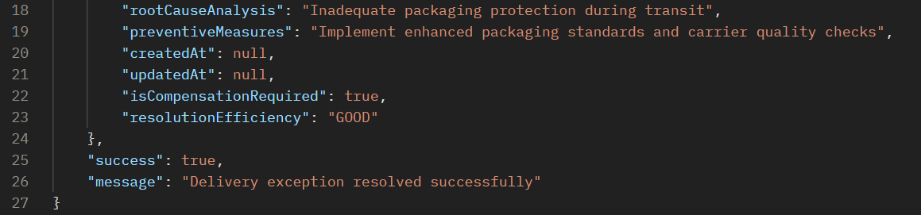

### ERROR SCENARIOS FOR PROCESS 13

**Error 1: Invalid Exception Type**

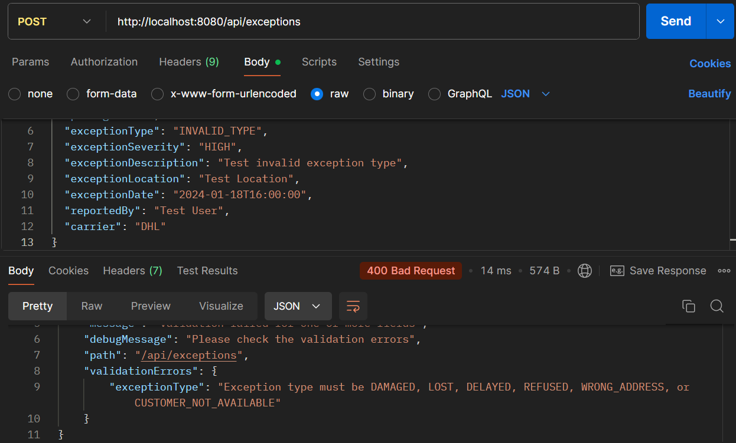

**Error 2: Resolve Non-existent Exception**

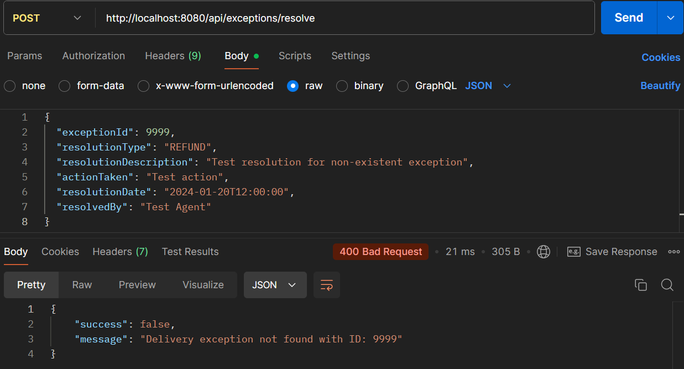

PROCESS 14: **RETURNS PROCESSING & RESTOCKING**

**API 14.1: Create Return Order**

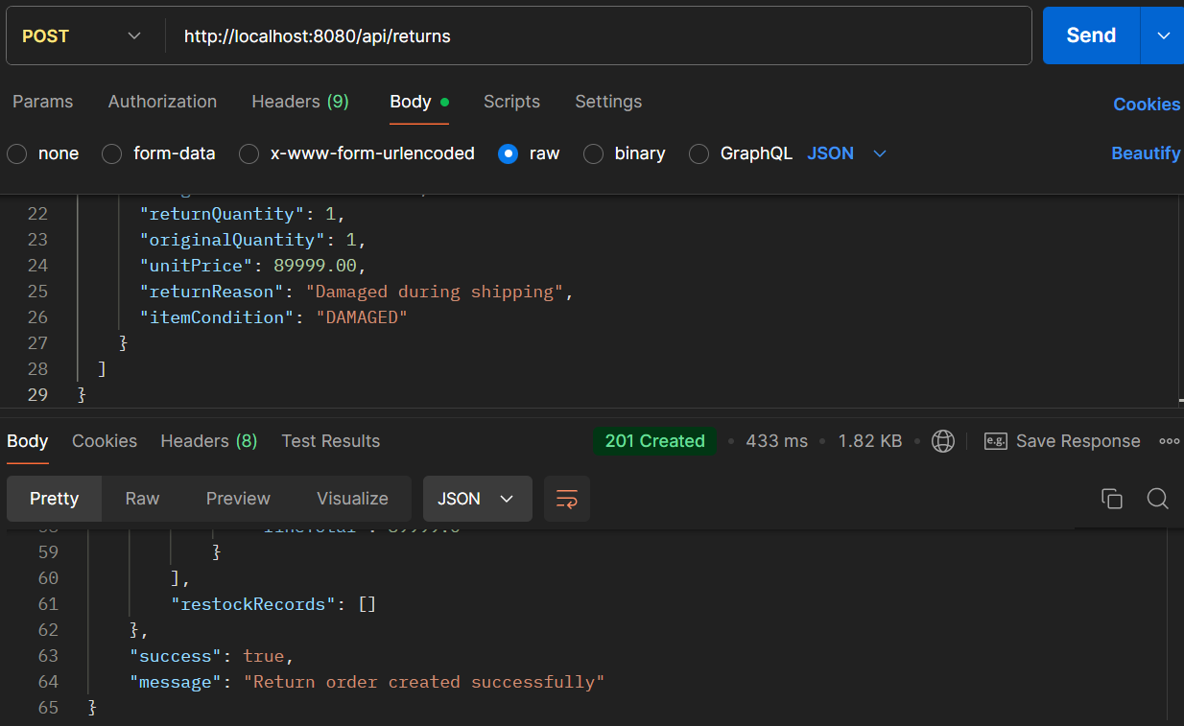

* **API Name: Create Return Order**
* **Endpoint: http://localhost:8080/api/returns**
* **Method: POST**
* **Description: Creates a return order for products being returned by customers, including return reasons, item conditions, and restocking details.**
* **Request Body:**

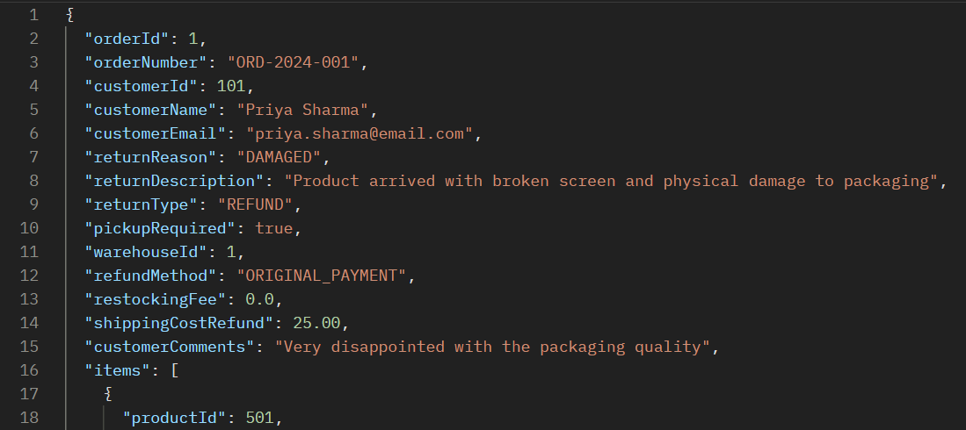

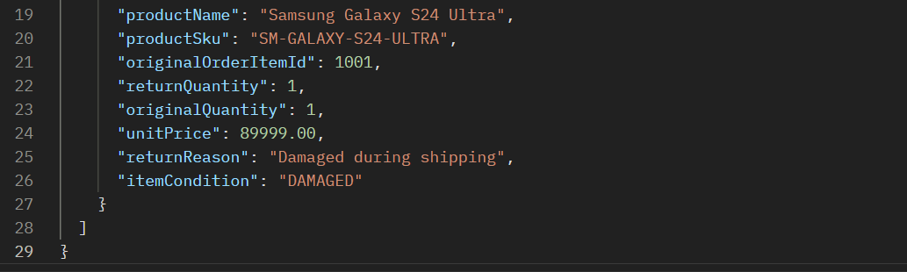

* **Respond Body:**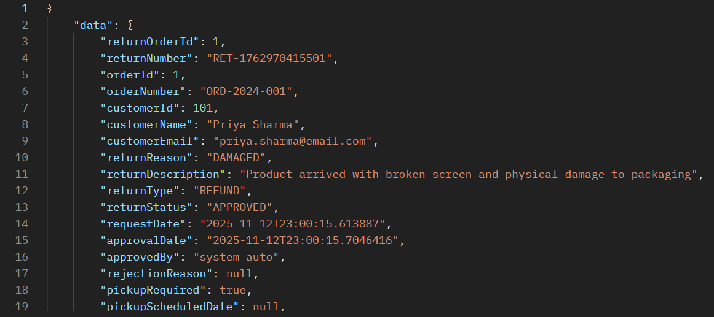

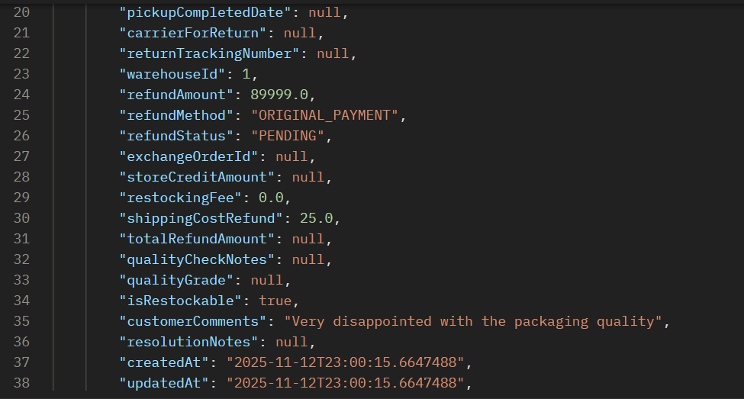

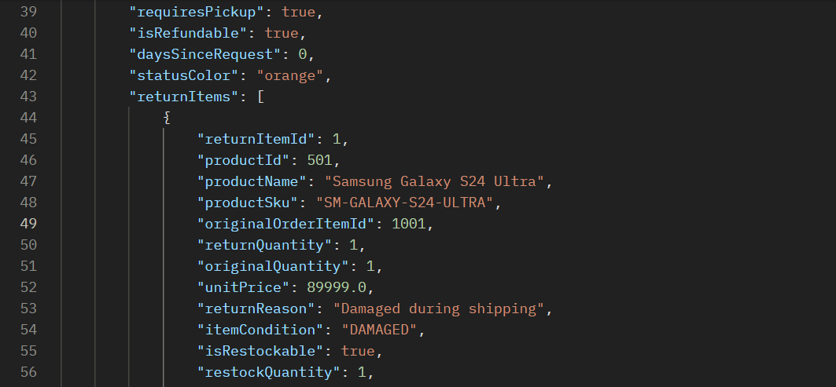

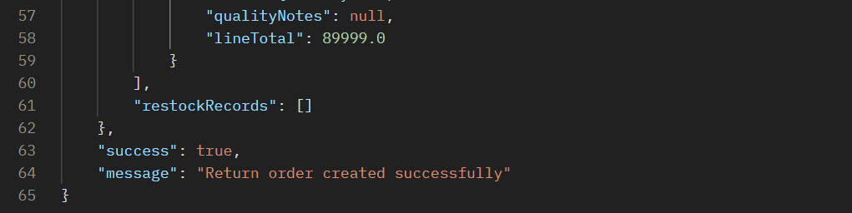

**API 14.2: Approval Return Order**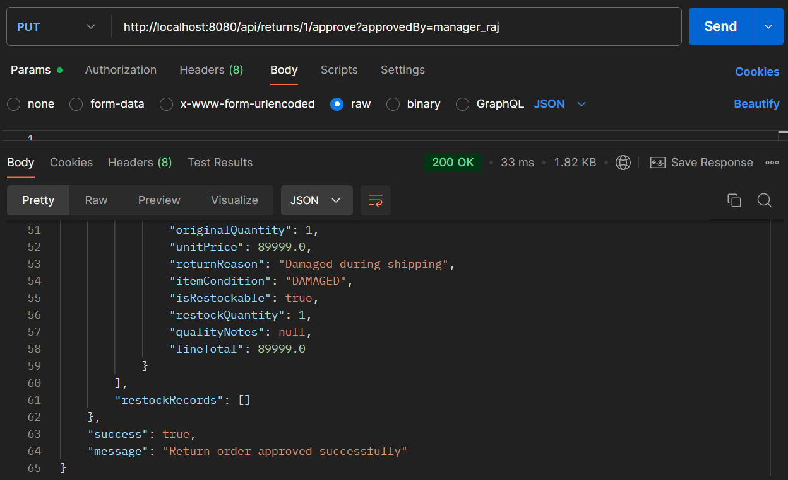

* **API Name: Approve Return Order**
* **Endpoint:**[**http://localhost:8080/api/returns/1/approve?approvedBy=manager_raj**](http://localhost:8080/api/returns/1/approve?approvedBy=manager_raj)
* **Method: PUT**
* **Description: Approves a return order, authorizing refunds, pickup arrangements, and restocking processes. The {1} in the endpoint is a path parameter for the returnId, and it requires an approvedBy query parameter.**
* **Example Request Body:  
  *This endpoint likely doesn't require a request body, as the approval decision and approver information are passed via the URL.***
* **Example Response Body:**

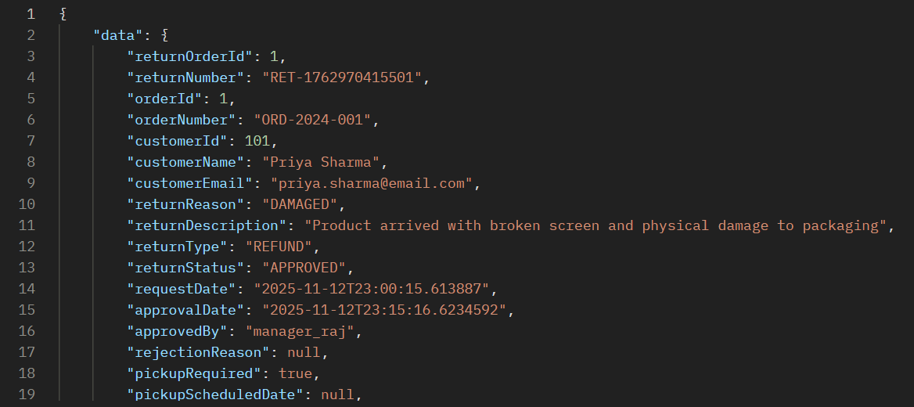

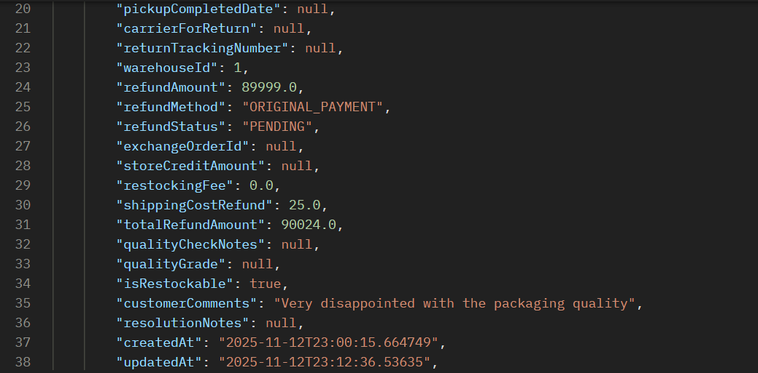

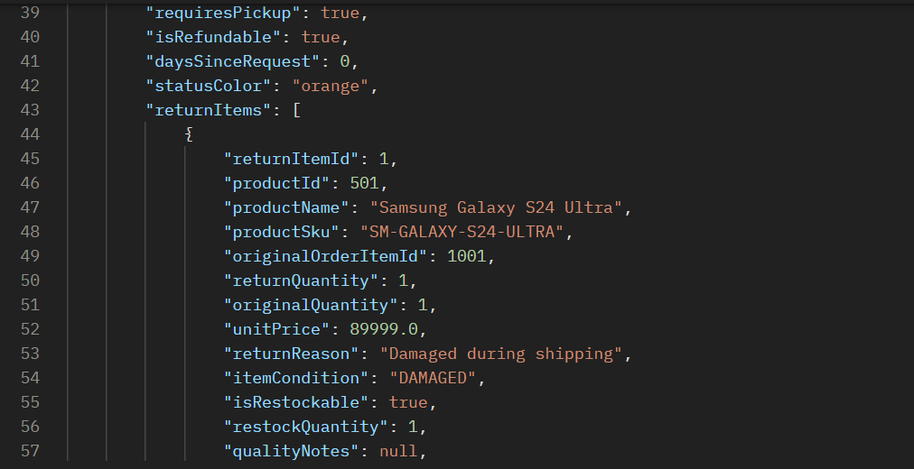

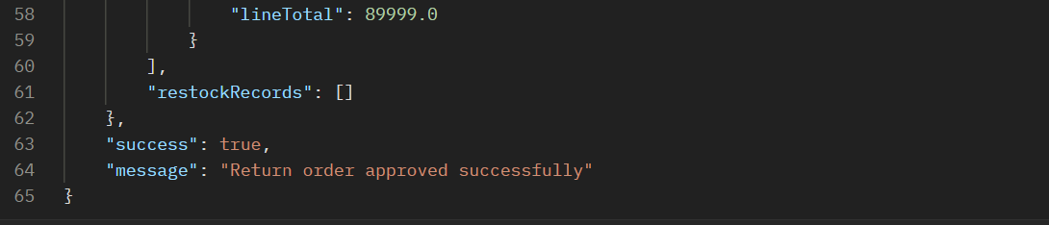

### ERROR SCENARIOS FOR PROCESS 14

**Error 1: Invalid Return Order Status Error**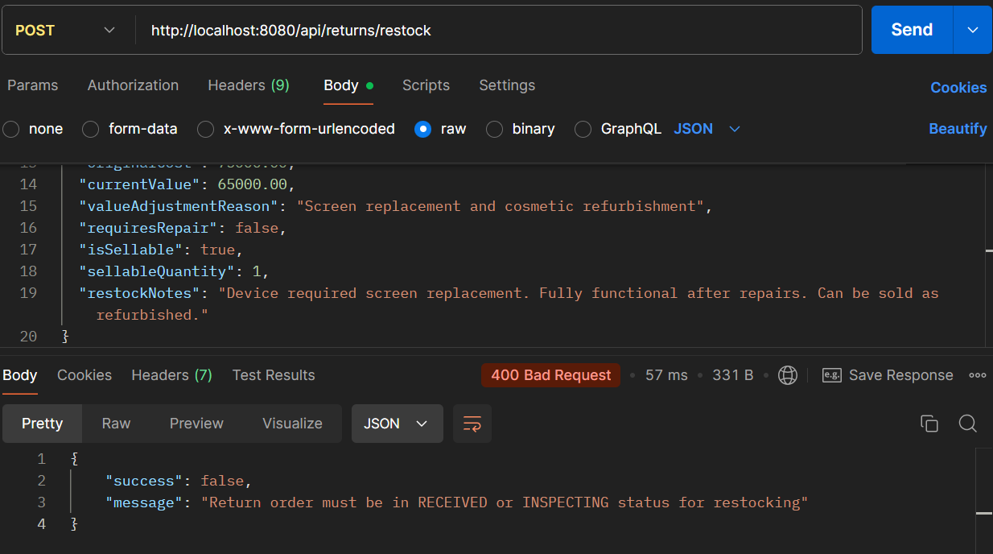

**Error 2: Invalid Restock Quantity**

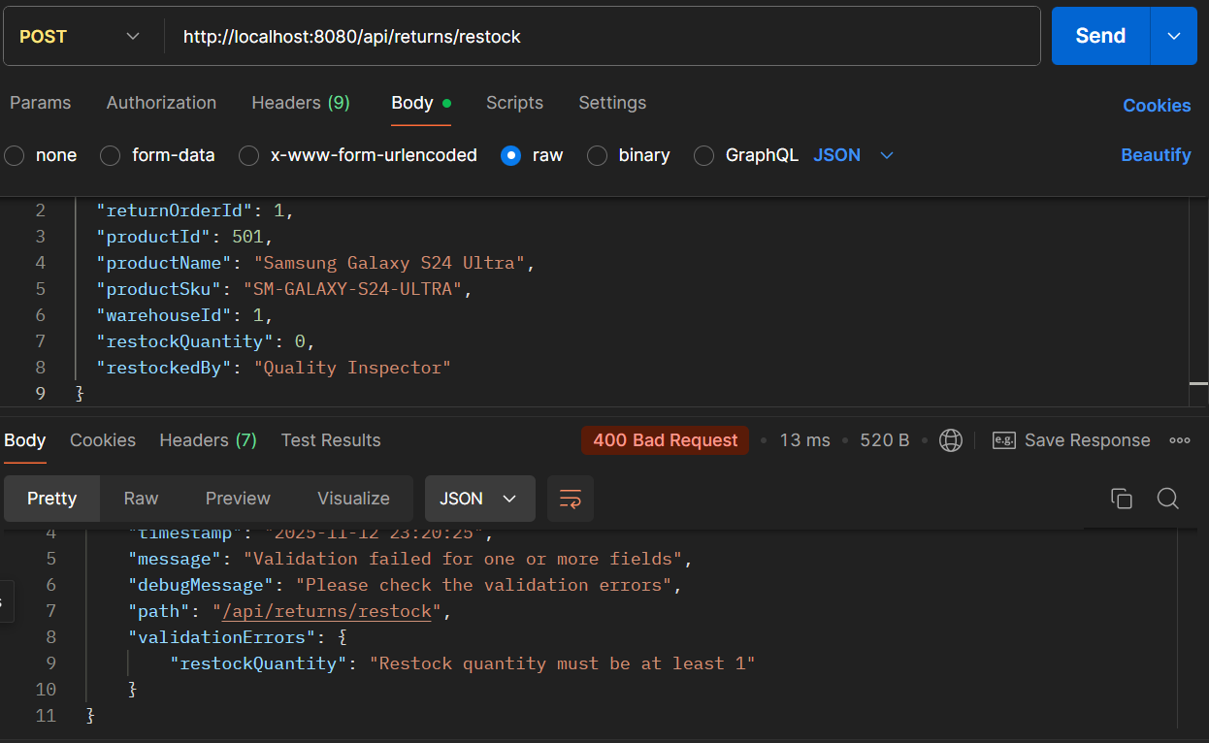

PROCESS 15: **INVENTORY RECONCILIATION & REPORTING**

**API 15.1: Create Reconciliation Report**

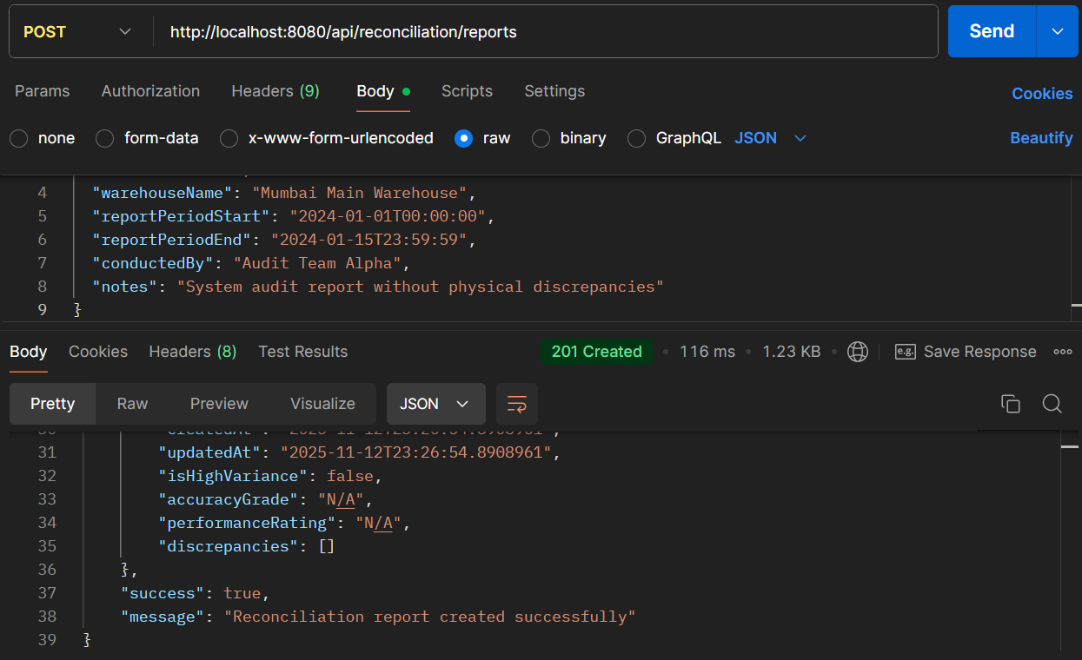

* **API Name: Create Reconciliation Report**
* **Endpoint: http://localhost:8080/api/reconciliation/reports**
* **Method: POST**
* **Description: Generates inventory reconciliation reports comparing system records with physical counts, identifying discrepancies and providing accuracy assessments.**
* **Request Body:**

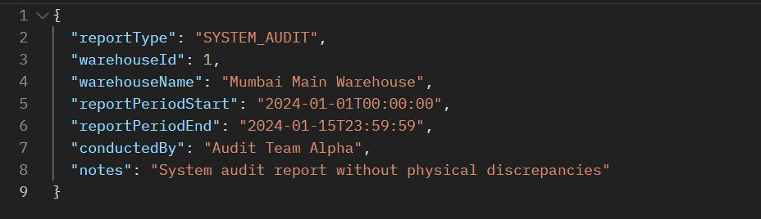

* **Respond Body:**

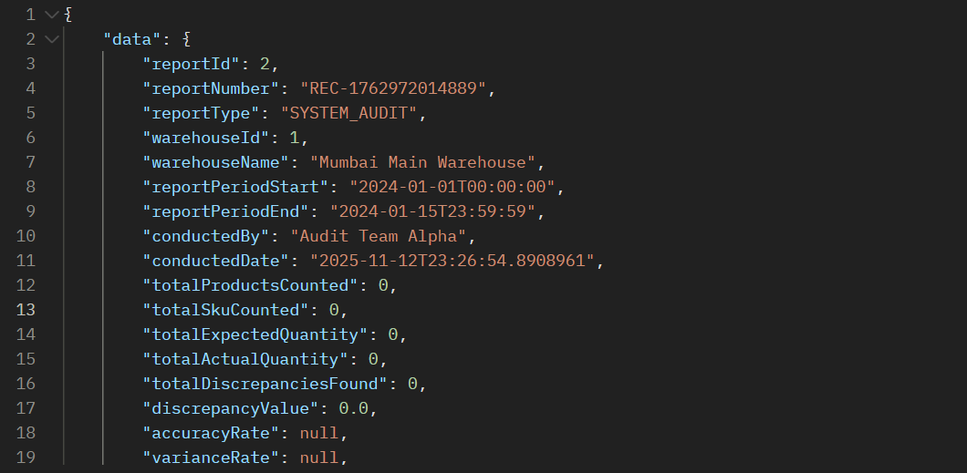

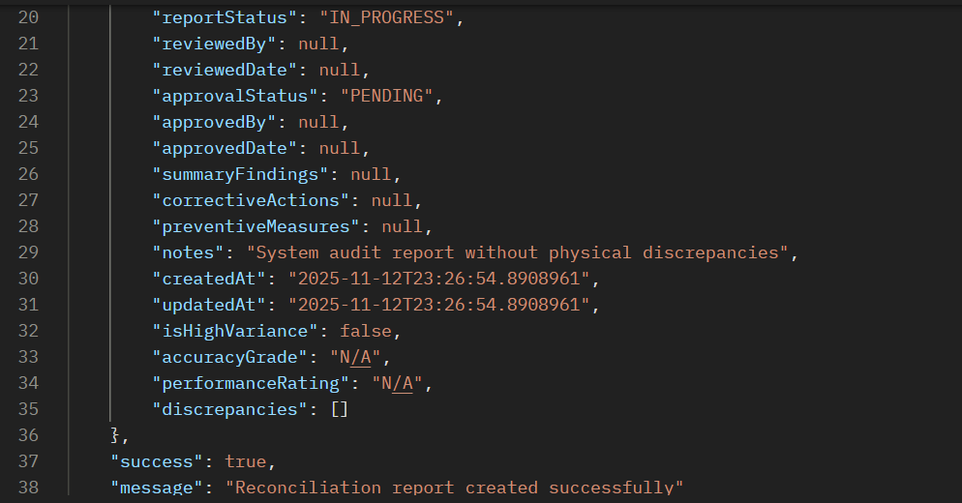

**15.2: Generate Inventory Report**

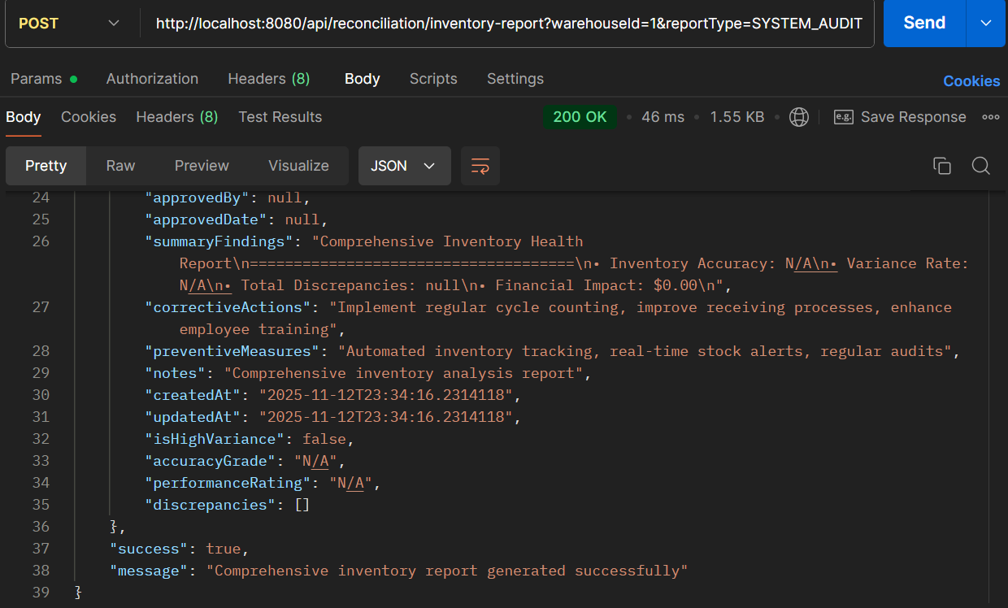

* **API Name: Generate Inventory Report**
* **Endpoint: http://localhost:8080/api/reconciliation/inventory-report?warehouseId=1&reportType=SYSTEM_AUDIT**
* **Method: POST**
* **Description: Generates comprehensive inventory reports with accuracy grading, performance ratings, and discrepancy analysis for specific warehouses and report types.**
* **Request Body:  
  *This endpoint uses query parameters (*warehouseId*and*reportType*) rather than a request body.***
* **Response Body:**

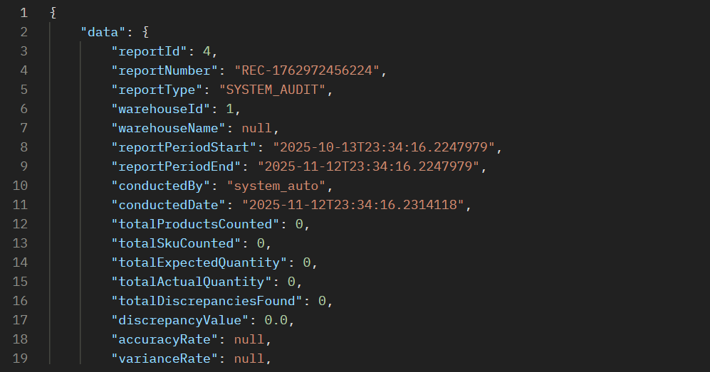

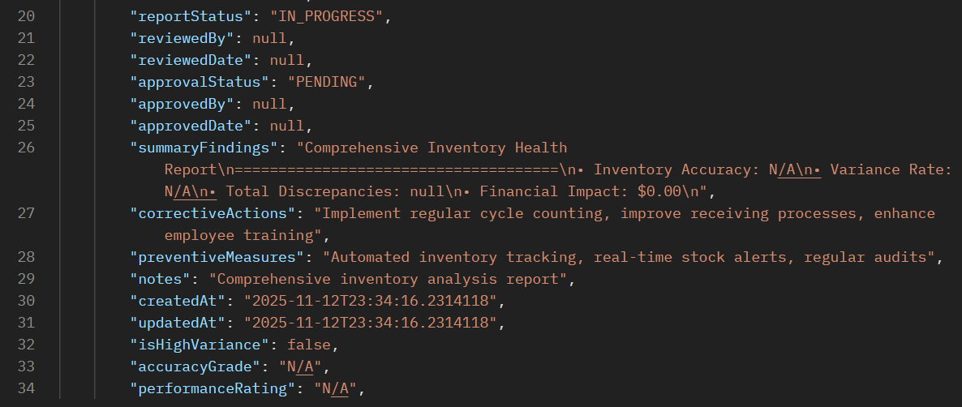

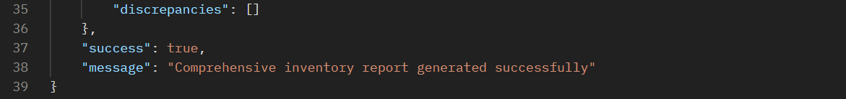

### ERROR SCENARIOS FOR PROCESS 15

**Error 1: Invalid Report Type**

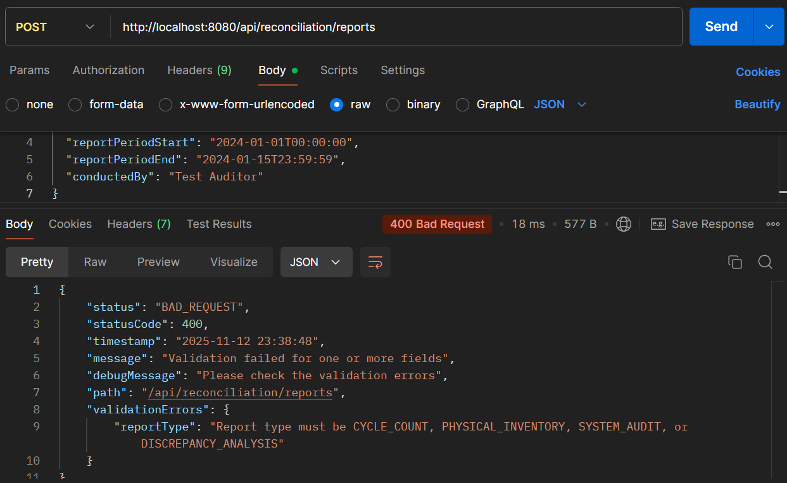

**Error 2: Get Non-existent Report**

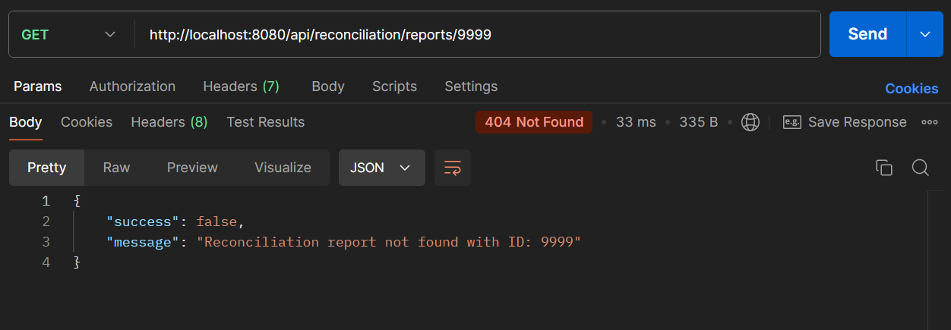

# **h) Database Design:**

**Database Name:** supply_chain_db  
**Server Version:** MySQL 8.0.44  
**Purpose:** Comprehensive supply chain management system handling procurement, inventory, warehousing, order fulfillment, shipping, and quality control.

## Table Structures and Relationships

**1. SUPPLIERS**

Stores supplier/vendor information.

| **Column** | **Data Type** | **Description** |
| --- | --- | --- |
| supplier_id | bigint (PK) | Unique supplier identifier |
| company_name | varchar(255) | Supplier company name |
| contact_person | varchar(100) | Primary contact name |
| email | varchar(100) UNIQUE | Supplier email address |
| phone | varchar(20) | Contact phone number |
| address | text | Full street address |
| city | varchar(100) | City location |
| state | varchar(100) | State/province |
| country | varchar(100) | Country |
| business_license | varchar(100) | Business license number |
| tax_id | varchar(50) | Tax identification number |
| payment_terms | varchar(100) | Payment terms (e.g., Net 30) |
| rating | double | Supplier performance rating |
| status | varchar(50) | Active/Inactive status |
| registered_at | datetime(6) | Registration timestamp |
| approved_at | datetime(6) | Approval timestamp |
| notes | text | Additional notes |

**Purpose:** Central repository for all supplier information, enabling supplier management and evaluation.

**2. CONTRACTS**

Manages supplier contracts and agreements.

| **Column** | **Data Type** | **Description** |
| --- | --- | --- |
| contract_id | bigint (PK) | Unique contract identifier |
| contract_number | varchar(50) UNIQUE | Contract reference number |
| contract_title | varchar(255) | Contract name/title |
| supplier_id | bigint | Foreign key to suppliers |
| contract_type | varchar(50) | Type of contract |
| contract_value | decimal(15,2) | Total contract value |
| currency | varchar(10) | Currency code (USD, EUR, etc.) |
| start_date | date | Contract start date |
| end_date | date | Contract end date |
| signed_date | date | Date contract was signed |
| status | varchar(50) | Active/Expired/Pending status |
| payment_terms | varchar(100) | Payment terms |
| renewal_terms | text | Renewal conditions |
| notes | text | Additional contract notes |
| created_at | datetime(6) | Record creation timestamp |
| updated_at | datetime(6) | Last update timestamp |

**Purpose:** Tracks formal agreements with suppliers, including terms, values, and timelines.

**Relationships:**

* Links to SUPPLIERS via supplier_id

**3. SLAS (Service Level Agreements)**

Defines performance metrics and targets for contracts.

| **Column** | **Data Type** | **Description** |
| --- | --- | --- |
| sla_id | bigint (PK) | Unique SLA identifier |
| contract_id | bigint | Associated contract |
| metric_name | varchar(255) | Performance metric name |
| metric_description | text | Detailed metric description |
| target_value | varchar(100) | Target performance level |
| minimum_acceptable | varchar(100) | Minimum acceptable level |
| measurement_unit | varchar(50) | Unit of measurement |
| monitoring_frequency | varchar(50) | How often to monitor |
| compliance_percentage | double | Current compliance rate |
| penalty_clause | text | Penalties for non-compliance |
| status | varchar(50) | Active/Inactive status |
| created_at | datetime(6) | Record creation timestamp |
| updated_at | datetime(6) | Last update timestamp |

**Purpose:** Ensures suppliers meet agreed-upon service levels and quality standards.

**Relationships:**

* Links to CONTRACTS via contract_id

**4. PRODUCTS**

Master product catalog.

| **Column** | **Data Type** | **Description** |
| --- | --- | --- |
| product_id | bigint (PK) | Unique product identifier |
| product_sku | varchar(255) UNIQUE | Stock keeping unit code |
| product_name | varchar(255) | Product name |
| description | text | Product description |
| category | varchar(255) | Product category |
| brand | varchar(255) | Brand name |
| barcode | varchar(255) | Barcode number |
| supplier_id | bigint | Default supplier |
| unit_of_measurement | varchar(255) | UOM (each, box, kg, etc.) |
| weight | double | Product weight |
| dimensions | varchar(255) | Length x Width x Height |
| cost_price | decimal(38,2) | Purchase/cost price |
| selling_price | decimal(38,2) | Retail/selling price |
| current_stock | int | Current inventory level |
| minimum_stock_level | int | Minimum stock threshold |
| maximum_stock_level | int | Maximum stock capacity |
| reorder_point | int | Reorder trigger level |
| status | varchar(255) | Active/Discontinued status |
| is_active | bit(1) | Active flag |
| image_url | varchar(255) | Product image URL |
| last_stock_update | datetime(6) | Last stock change |
| created_at | datetime(6) | Record creation timestamp |
| updated_at | datetime(6) | Last update timestamp |

**Purpose:** Central product master data repository for all inventory items.

**5. PURCHASE_ORDERS**

Purchase orders sent to suppliers.

| **Column** | **Data Type** | **Description** |
| --- | --- | --- |
| po_id | bigint (PK) | Unique PO identifier |
| po_number | varchar(50) UNIQUE | PO reference number |
| supplier_id | bigint | Supplier receiving the order |
| contract_id | bigint | Associated contract (if any) |
| order_date | date | Date order was created |
| expected_delivery_date | date | Expected delivery date |
| actual_delivery_date | date | Actual delivery date |
| status | varchar(50) | Draft/Approved/Received status |
| requested_by | varchar(100) | Employee who requested |
| approved_by | varchar(100) | Approving authority |
| approval_date | date | Approval date |
| total_amount | decimal(15,2) | Subtotal before tax/discount |
| tax_amount | decimal(15,2) | Tax amount |
| discount_amount | decimal(15,2) | Discount amount |
| final_amount | decimal(15,2) | Final total amount |
| currency | varchar(10) | Currency code |
| payment_terms | varchar(100) | Payment terms |
| delivery_address | text | Delivery location |
| notes | text | Additional notes |
| created_at | datetime(6) | Record creation timestamp |
| updated_at | datetime(6) | Last update timestamp |

**Purpose:** Manages procurement orders to suppliers.

**Relationships:**

* Links to SUPPLIERS via supplier_id
* Links to CONTRACTS via contract_id

**6. PURCHASE_ORDER_ITEMS**

Line items within purchase orders.

| **Column** | **Data Type** | **Description** |
| --- | --- | --- |
| item_id | bigint (PK) | Unique line item identifier |
| po_id | bigint (FK) | Parent purchase order |
| product_id | bigint | Product being ordered |
| product_sku | varchar(50) | Product SKU |
| product_name | varchar(255) | Product name |
| quantity | int | Quantity ordered |
| unit_price | decimal(12,2) | Price per unit |
| unit_of_measurement | varchar(20) | UOM |
| tax_rate | decimal(5,2) | Tax rate percentage |
| discount_rate | decimal(5,2) | Discount percentage |
| line_total | decimal(15,2) | Total for this line |
| received_quantity | int | Quantity received so far |
| notes | text | Item-specific notes |
| created_at | datetime(6) | Record creation timestamp |
| updated_at | datetime(6) | Last update timestamp |

**Purpose:** Details contents of each package for accurate shipping and delivery verification.

**Relationships:**

* Links to PACKAGES via package_id
* Links to PRODUCTS via product_id

**7. GOODS_RECEIPTS**

Records of goods received from suppliers.

| **Column** | **Data Type** | **Description** |
| --- | --- | --- |
| receipt_id | bigint (PK) | Unique receipt identifier |
| receipt_number | varchar(50) UNIQUE | Receipt reference number |
| po_id | bigint | Associated purchase order |
| po_number | varchar(50) | PO reference |
| supplier_id | bigint | Supplier who delivered |
| receipt_date | date | Date goods received |
| received_by | varchar(100) | Employee who received |
| delivery_note_number | varchar(50) | Supplier's delivery note |
| vehicle_number | varchar(50) | Delivery vehicle number |
| warehouse_location | varchar(100) | Receiving warehouse |
| total_items_ordered | int | Total items expected |
| total_items_received | int | Total items received |
| discrepancy_found | bit(1) | Flag for discrepancies |
| status | varchar(50) | Processing status |
| notes | text | Receipt notes |
| created_at | datetime(6) | Record creation timestamp |
| updated_at | datetime(6) | Last update timestamp |

**Purpose:** Tracks receipt of goods from suppliers and validates against purchase orders.

**Relationships:**

* Links to PURCHASE_ORDERS via po_id
* Links to SUPPLIERS via supplier_id

**8. INSPECTION_RECORDS**

Quality inspection records for received goods.

| **Column** | **Data Type** | **Description** |
| --- | --- | --- |
| inspection_id | bigint (PK) | Unique inspection identifier |
| receipt_id | bigint (FK) | Associated goods receipt |
| product_id | bigint | Product inspected |
| product_name | varchar(255) | Product name |
| product_sku | varchar(50) | Product SKU |
| batch_number | varchar(50) | Batch/lot number |
| ordered_quantity | int | Quantity ordered |
| received_quantity | int | Quantity received |
| accepted_quantity | int | Quantity accepted |
| rejected_quantity | int | Quantity rejected |
| damaged_quantity | int | Quantity damaged |
| inspector_name | varchar(100) | Inspector name |
| inspection_date | datetime(6) | Inspection timestamp |
| inspection_status | varchar(50) | Pass/Fail/Partial status |
| quality_rating | int | Quality score (1-10) |
| defect_type | varchar(100) | Type of defect found |
| action_taken | varchar(100) | Action taken (return, accept, etc.) |
| expiry_date | date | Product expiry date |
| photo_url | varchar(500) | Photo evidence URL |
| inspection_notes | text | Detailed inspection notes |
| created_at | datetime(6) | Record creation timestamp |
| updated_at | datetime(6) | Last update timestamp |

**Purpose:** Documents quality inspection results for incoming goods.

**Relationships:**

* Links to GOODS_RECEIPTS via receipt_id
* Links to PRODUCTS via product_id

**9. WAREHOUSES**

Warehouse locations and facilities.

| **Column** | **Data Type** | **Description** |
| --- | --- | --- |
| warehouse_id | bigint (PK) | Unique warehouse identifier |
| warehouse_code | varchar(20) UNIQUE | Warehouse code |
| warehouse_name | varchar(255) | Warehouse name |
| warehouse_type | varchar(50) | Type (distribution, cold storage, etc.) |
| address | text | Street address |
| city | varchar(100) | City |
| state | varchar(100) | State/province |
| country | varchar(100) | Country |
| postal_code | varchar(20) | Postal/ZIP code |
| manager_name | varchar(100) | Warehouse manager |
| contact_phone | varchar(20) | Contact phone |
| contact_email | varchar(100) | Contact email |
| total_capacity_sqft | double | Total square footage |
| used_capacity_sqft | double | Used square footage |
| available_capacity_sqft | double | Available square footage |
| capacity_utilization | double | Utilization percentage |
| total_shelves | int | Total shelf count |
| occupied_shelves | int | Occupied shelf count |
| temperature_zone | varchar(50) | Temperature control type |
| operating_hours | varchar(100) | Operating hours |
| is_active | bit(1) | Active flag |
| notes | text | Additional notes |
| created_at | datetime(6) | Record creation timestamp |
| updated_at | datetime(6) | Last update timestamp |

**Purpose:** Manages warehouse facilities and their capacities.

**10. STORAGE_ZONES**

Zones within warehouses for organizing inventory.

| **Column** | **Data Type** | **Description** |
| --- | --- | --- |
| zone_id | bigint (PK) | Unique zone identifier |
| warehouse_id | bigint (FK) | Parent warehouse |
| zone_code | varchar(20) | Zone code |
| zone_name | varchar(255) | Zone name |
| zone_type | varchar(50) | Type (picking, bulk, etc.) |
| zone_status | varchar(50) | Active/Inactive status |
| total_capacity_sqft | double | Total zone capacity |
| used_capacity_sqft | double | Used capacity |
| available_capacity_sqft | double | Available capacity |
| capacity_utilization | double | Utilization percentage |
| temperature_control | varchar(50) | Temperature requirements |
| access_requirements | varchar(100) | Access restrictions |
| aisle_count | int | Number of aisles |
| shelf_count | int | Number of shelves |
| max_weight_capacity_kg | double | Maximum weight capacity |
| current_weight_kg | double | Current weight |
| notes | text | Zone notes |
| created_at | datetime(6) | Record creation timestamp |
| updated_at | datetime(6) | Last update timestamp |

**Purpose:** Organizes warehouse space into logical zones for efficient storage.

**Relationships:**

* Links to WAREHOUSES via warehouse_id

**11. SHELF_LOCATIONS**

Specific shelf locations within warehouse zones.

| **Column** | **Data Type** | **Description** |
| --- | --- | --- |
| shelf_id | bigint (PK) | Unique shelf identifier |
| warehouse_id | bigint (FK) | Parent warehouse |
| zone_id | bigint (FK) | Parent zone |
| location_code | varchar(50) UNIQUE | Unique location code |
| aisle_number | varchar(10) | Aisle number |
| shelf_number | varchar(10) | Shelf number |
| level_number | varchar(10) | Level/tier number |
| bin_number | varchar(10) | Bin number |
| location_type | varchar(50) | Type (pallet, shelf, bin) |
| location_status | varchar(50) | Available/Occupied/Reserved |
| is_occupied | bit(1) | Occupancy flag |
| product_id | bigint | Product stored (if any) |
| product_sku | varchar(50) | Product SKU |
| product_name | varchar(255) | Product name |
| current_units | int | Current quantity stored |
| max_capacity_units | int | Maximum capacity |
| available_units | int | Available capacity |
| occupancy_rate | double | Occupancy percentage |
| current_weight_kg | double | Current weight |
| max_weight_kg | double | Maximum weight |
| dimensions | varchar(100) | Shelf dimensions |
| temperature_requirement | varchar(50) | Temperature needs |
| pick_frequency | int | Pick frequency counter |
| last_picked | datetime(6) | Last pick timestamp |
| last_restocked | datetime(6) | Last restock timestamp |
| notes | text | Location notes |
| created_at | datetime(6) | Record creation timestamp |
| updated_at | datetime(6) | Last update timestamp |

**Purpose:** Provides precise locations for inventory storage and picking.

**Relationships:**

* Links to WAREHOUSES via warehouse_id
* Links to STORAGE_ZONES via zone_id
* Links to PRODUCTS via product_id

**12. INVENTORY_MONITORING**

Real-time inventory tracking and monitoring.

| **Column** | **Data Type** | **Description** |
| --- | --- | --- |
| inventory_id | bigint (PK) | Unique inventory record |
| product_id | bigint UNIQUE | Product being monitored |
| product_sku | varchar(50) | Product SKU |
| product_name | varchar(255) | Product name |
| current_stock | int | Current stock level |
| available_stock | int | Available (not reserved) |
| reserved_stock | int | Reserved for orders |
| minimum_stock_level | int | Minimum threshold |
| maximum_stock_level | int | Maximum capacity |
| reorder_point | int | Reorder trigger level |
| stock_status | varchar(50) | In Stock/Low/Out of Stock |
| stock_value | double | Total inventory value |
| days_of_supply | int | Days until stockout |
| stock_turnover_rate | double | Turnover rate |
| movement_frequency | varchar(50) | Fast/Medium/Slow moving |
| last_sold_date | datetime(6) | Last sale date |
| last_restocked_date | datetime(6) | Last restock date |
| is_monitored | bit(1) | Active monitoring flag |
| created_at | datetime(6) | Record creation timestamp |
| updated_at | datetime(6) | Last update timestamp |

**Purpose:** Provides real-time visibility into inventory levels and movements.

**Relationships:**

* Links to PRODUCTS via product_id (one-to-one)

**13. STOCK_ALERTS**

Automated alerts for inventory issues.

| **Column** | **Data Type** | **Description** |
| --- | --- | --- |
| alert_id | bigint (PK) | Unique alert identifier |
| inventory_id | bigint | Inventory record |
| product_id | bigint | Product |
| product_sku | varchar(50) | Product SKU |
| product_name | varchar(255) | Product name |
| alert_type | varchar(50) | Low Stock/Overstock/Expired |
| alert_level | varchar(20) | Critical/High/Medium/Low |
| current_stock | int | Current stock level |
| threshold_stock | int | Threshold that triggered alert |
| message | text | Alert message |
| suggested_action | text | Recommended action |
| notification_sent | bit(1) | Notification sent flag |
| is_resolved | bit(1) | Resolution flag |
| resolved_by | varchar(100) | Who resolved it |
| resolved_at | datetime(6) | Resolution timestamp |
| resolution_notes | text | Resolution notes |
| created_at | datetime(6) | Alert creation timestamp |
| updated_at | datetime(6) | Last update timestamp |

**Purpose:** Notifies stakeholders of inventory issues requiring attention.

**Relationships:**

* Links to INVENTORY_MONITORING via inventory_id
* Links to PRODUCTS via product_id

**14. DEMAND_FORECASTS**

Demand forecasting and planning.

| **Column** | **Data Type** | **Description** |
| --- | --- | --- |
| forecast_id | bigint (PK) | Unique forecast identifier |
| product_id | bigint | Product |
| product_sku | varchar(50) | Product SKU |
| product_name | varchar(255) | Product name |
| forecast_date | date | Date forecast created |
| forecast_period | varchar(20) | Period (weekly, monthly, etc.) |
| start_date | date | Forecast period start |
| end_date | date | Forecast period end |
| forecast_method | varchar(50) | Forecasting method used |
| base_demand | int | Base demand level |
| predicted_demand | int | Predicted demand |
| adjusted_demand | int | Adjusted demand |
| actual_demand | int | Actual demand (after period) |
| forecast_error | int | Difference actual vs predicted |
| trend_factor | decimal(5,2) | Trend adjustment factor |
| seasonality_factor | decimal(5,2) | Seasonal adjustment |
| promotion_impact | decimal(5,2) | Promotion impact factor |
| confidence_level | decimal(5,2) | Confidence percentage |
| mean_absolute_error | decimal(10,2) | MAE metric |
| historical_accuracy | decimal(5,2) | Historical accuracy rate |
| forecast_status | varchar(50) | Active/Completed/Cancelled |
| created_by | varchar(100) | Creator |
| notes | text | Forecast notes |
| created_at | datetime(6) | Record creation timestamp |
| updated_at | datetime(6) | Last update timestamp |

**Purpose:** Predicts future demand to optimize inventory planning.

**Relationships:**

* Links to PRODUCTS via product_id

**15. REORDER_PLANS**

Automated reorder planning and suggestions.

| **Column** | **Data Type** | **Description** |
| --- | --- | --- |
| plan_id | bigint (PK) | Unique plan identifier |
| product_id | bigint | Product |
| product_sku | varchar(50) | Product SKU |
| product_name | varchar(255) | Product name |
| current_stock | int | Current stock level |
| reorder_point | int | Reorder trigger level |
| safety_stock | int | Safety stock buffer |
| lead_time_days | int | Supplier lead time |
| daily_demand_rate | int | Average daily demand |
| recommended_order_quantity | int | Suggested order quantity |
| economic_order_quantity | int | EOQ calculation |
| suggested_order_date | date | When to order |
| expected_delivery_date | date | Expected delivery |
| expected_stockout_date | date | Projected stockout date |
| stockout_risk_level | varchar(20) | Risk level |
| order_urgency | varchar(50) | Urgency level |
| estimated_cost | decimal(15,2) | Estimated order cost |
| supplier_id | bigint | Recommended supplier |
| supplier_name | varchar(255) | Supplier name |
| forecast_id | bigint | Related forecast |
| service_level_target | decimal(5,2) | Target service level |
| calculated_service_level | decimal(5,2) | Calculated service level |
| plan_status | varchar(50) | Pending/Approved/Converted |
| converted_to_po | bit(1) | Converted to PO flag |
| purchase_order_id | bigint | Generated PO (if any) |
| conversion_date | datetime(6) | Conversion timestamp |
| created_by | varchar(100) | Creator |
| notes | text | Plan notes |
| created_at | datetime(6) | Record creation timestamp |
| updated_at | datetime(6) | Last update timestamp |

**Purpose:** Automates reordering decisions based on inventory levels and demand.

**Relationships:**

* Links to PRODUCTS via product_id
* Links to SUPPLIERS via supplier_id
* Links to DEMAND_FORECASTS via forecast_id
* Links to PURCHASE_ORDERS via purchase_order_id

**16. CUSTOMER_ORDERS**

Customer orders received for fulfillment.

| **Column** | **Data Type** | **Description** |
| --- | --- | --- |
| order_id | bigint (PK) | Unique order identifier |
| order_number | varchar(50) UNIQUE | Order reference number |
| customer_id | bigint | Customer identifier |
| customer_name | varchar(255) | Customer name |
| customer_email | varchar(100) | Customer email |
| customer_phone | varchar(20) | Customer phone |
| order_status | varchar(50) | Pending/Processing/Shipped/Delivered |
| priority_level | varchar(20) | High/Medium/Low priority |
| total_amount | decimal(12,2) | Order subtotal |
| tax_amount | decimal(8,2) | Tax amount |
| discount_amount | decimal(8,2) | Discount amount |
| shipping_cost | decimal(8,2) | Shipping cost |
| final_amount | decimal(12,2) | Final total |
| currency | varchar(3) | Currency code |
| payment_method | varchar(50) | Payment method |
| payment_status | varchar(50) | Paid/Pending/Failed |
| shipping_address | text | Delivery address |
| billing_address | text | Billing address |
| estimated_delivery_date | datetime(6) | Estimated delivery |
| actual_delivery_date | datetime(6) | Actual delivery |
| warehouse_id | bigint | Fulfillment warehouse |
| pick_list_id | bigint | Associated pick list |
| quality_check_id | bigint | Quality check record |
| shipment_id | bigint | Shipment record |
| order_notes | text | Order notes |
| internal_notes | text | Internal notes |
| created_at | datetime(6) | Order creation timestamp |
| updated_at | datetime(6) | Last update timestamp |

**Purpose:** Manages customer orders from receipt to fulfillment.

**Relationships:**

* Links to WAREHOUSES via warehouse_id
* Links to PICK_LISTS via pick_list_id
* Links to QUALITY_CHECKS via quality_check_id
* Links to SHIPMENTS via shipment_id

**17. ORDER_ITEMS**

Line items within customer orders.

| **Column** | **Data Type** | **Description** |
| --- | --- | --- |
| order_item_id | bigint (PK) | Unique item identifier |
| order_id | bigint (FK) | Parent order |
| product_id | bigint | Product ordered |
| product_sku | varchar(50) | Product SKU |
| product_name | varchar(255) | Product name |
| category | varchar(100) | Product category |
| brand | varchar(100) | Product brand |
| quantity | int | Quantity ordered |
| unit_price | decimal(10,2) | Price per unit |
| total_price | decimal(10,2) | Line total |
| weight_kg | decimal(8,3) | Item weight |
| is_fragile | bit(1) | Fragile flag |
| requires_quality_check | bit(1) | QC required flag |
| inventory_id | bigint | Inventory record |
| shelf_location_id | bigint | Storage location |
| item_notes | text | Item notes |

**Purpose:** Details individual products within each customer order.

**Relationships:**

* Links to CUSTOMER_ORDERS via order_id
* Links to PRODUCTS via product_id
* Links to SHELF_LOCATIONS via shelf_location_id

**18. PICK_LISTS**

Picking lists for warehouse operations.

| **Column** | **Data Type** | **Description** |
| --- | --- | --- |
| pick_list_id | bigint (PK) | Unique pick list identifier |
| pick_list_number | varchar(50) UNIQUE | Pick list reference |
| order_id | bigint | Associated order |
| order_number | varchar(50) | Order reference |
| warehouse_id | bigint | Warehouse location |
| warehouse_name | varchar(255) | Warehouse name |
| assigned_to | varchar(100) | Picker assigned |
| pick_status | varchar(50) | Pending/In Progress/Completed |
| priority_level | varchar(20) | Priority level |
| total_items | int | Total items to pick |
| picked_items | int | Items picked so far |
| remaining_items | int | Items remaining |
| pick_route_optimized | bit(1) | Route optimization flag |
| zone_sequence | varchar(255) | Zone picking sequence |
| estimated_pick_time_minutes | int | Estimated time |
| actual_pick_time_minutes | int | Actual time taken |
| started_at | datetime(6) | Start timestamp |
| completed_at | datetime(6) | Completion timestamp |
| pick_notes | text | Picking notes |
| created_at | datetime(6) | Record creation timestamp |
| updated_at | datetime(6) | Last update timestamp |

**Purpose:** Guides warehouse staff in picking items for orders.

**Relationships:**

* Links to CUSTOMER_ORDERS via order_id
* Links to WAREHOUSES via warehouse_id

**19. PICK_LIST_ITEMS**

Individual items on pick lists.

| **Column** | **Data Type** | **Description** |
| --- | --- | --- |
| pick_item_id | bigint (PK) | Unique pick item identifier |
| pick_list_id | bigint (FK) | Parent pick list |
| product_id | bigint | Product to pick |
| product_sku | varchar(50) | Product SKU |
| product_name | varchar(255) | Product name |
| shelf_location_id | bigint | Where to pick from |
| location_code | varchar(50) | Location code |
| zone_code | varchar(20) | Zone code |
| aisle_number | varchar(10) | Aisle number |
| pick_sequence | int | Pick order sequence |
| required_quantity | int | Quantity needed |
| picked_quantity | int | Quantity picked |
| weight_per_unit_kg | double | Unit weight |
| is_picked | bit(1) | Picked flag |
| picked_at | datetime(6) | Pick timestamp |
| pick_notes | text | Item pick notes |

**Purpose:** Provides specific picking instructions for each item.

**Relationships:**

* Links to PICK_LISTS via pick_list_id
* Links to PRODUCTS via product_id
* Links to SHELF_LOCATIONS via shelf_location_id

**20. PACKAGES**

Package creation and preparation.

| **Column** | **Data Type** | **Description** |
| --- | --- | --- |
| package_id | bigint (PK) | Unique package identifier |
| tracking_number | varchar(100) UNIQUE | Tracking number |
| order_id | bigint | Associated order |
| order_number | varchar(50) | Order reference |
| pick_list_id | bigint | Pick list used |
| warehouse_id | bigint | Packing warehouse |
| package_type | varchar(50) | Box/Envelope/Pallet |
| package_size | varchar(50) | Small/Medium/Large |
| package_status | varchar(50) | Packed/Shipped/Delivered |
| weight_kg | decimal(8,2) | Package weight |
| dimensions | varchar(100) | L x W x H |
| is_fragile | bit(1) | Fragile flag |
| is_hazardous | bit(1) | Hazardous materials flag |
| requires_signature | bit(1) | Signature required |
| temperature_control | varchar(50) | Temperature requirements |
| carrier | varchar(100) | Shipping carrier |
| service_type | varchar(100) | Service level |
| shipping_cost | decimal(10,2) | Shipping cost |
| insurance_amount | decimal(10,2) | Insurance value |
| customs_declaration_required | bit(1) | Customs flag |
| packed_by | varchar(100) | Packer name |
| packed_at | datetime(6) | Packing timestamp |
| package_notes | text | Package notes |
| created_at | datetime(6) | Record creation timestamp |
| updated_at | datetime(6) | Last update timestamp |

**Purpose:** Manages package creation and preparation for shipping.

**Relationships:**

* Links to CUSTOMER_ORDERS via order_id
* Links to PICK_LISTS via pick_list_id
* Links to WAREHOUSES via warehouse_id

**21. PACKAGE_ITEMS**

Items contained in each package.

| **Column** | **Data Type** | **Description** |
| --- | --- | --- |
| package_item_id | bigint (PK) | Unique item identifier |
| package_id | bigint (FK) | Parent package |
| product_id | bigint | Product |
| product_sku | varchar(50) | Product SKU |
| product_name | varchar(255) | Product name |
| quantity | int | Quantity in package |
| unit_price | decimal(10,2) | Unit price |
| weight_kg | decimal(8,2) | Item weight |
| is_fragile | bit(1) | Fragile flag |
| requires_special_handling | bit(1) | Special handling flag |
| item_notes | text | Item notes |

**Purpose:** To record detailed information about each product contained within a shipment package for tracking and logistics management.

**22. QUALITY_CHECKS**

Quality inspection of outbound packages.

| **Column** | **Data Type** | **Description** |
| --- | --- | --- |
| check_id | bigint (PK) | Unique check identifier |
| check_number | varchar(50) UNIQUE | Check reference number |
| order_id | bigint | Associated order |
| order_number | varchar(50) | Order reference |
| package_id | bigint | Package inspected |
| tracking_number | varchar(100) | Tracking number |
| warehouse_id | bigint | Warehouse location |
| check_type | varchar(50) | Pre-ship/Final/Random |
| inspector_name | varchar(100) | Inspector name |
| check_status | varchar(50) | In Progress/Completed/Failed |
| overall_result | varchar(20) | Pass/Fail/Conditional |
| is_content_correct | bit(1) | Content accuracy flag |
| content_accuracy_score | int | Content score (0-100) |
| are_labels_correct | bit(1) | Label accuracy flag |
| label_accuracy_score | int | Label score (0-100) |
| is_package_damaged | bit(1) | Damage flag |
| package_integrity_score | int | Integrity score (0-100) |
| is_weight_accurate | bit(1) | Weight accuracy flag |
| weight_accuracy_score | int | Weight score (0-100) |
| is_hazardous_compliant | bit(1) | Hazmat compliance flag |
| safety_compliance_score | int | Safety score (0-100) |
| score_percentage | double | Overall score percentage |
| approved_for_shipment | bit(1) | Approval flag |
| recheck_required | bit(1) | Recheck flag |
| recheck_notes | text | Recheck notes |
| issues_found | text | Issues description |
| corrective_actions | text | Actions taken |
| started_at | datetime(6) | Start timestamp |
| completed_at | datetime(6) | Completion timestamp |
| check_notes | text | Inspection notes |
| created_at | datetime(6) | Record creation timestamp |
| updated_at | datetime(6) | Last update timestamp |

**Purpose:** Ensures outbound packages meet quality standards before shipping.

**Relationships:**

* Links to CUSTOMER_ORDERS via order_id
* Links to PACKAGES via package_id
* Links to WAREHOUSES via warehouse_id

**23. QUALITY_STANDARDS**

Quality control standards and criteria.

| **Column** | **Data Type** | **Description** |
| --- | --- | --- |
| standard_id | bigint (PK) | Unique standard identifier |
| standard_code | varchar(50) UNIQUE | Standard code |
| standard_name | varchar(255) | Standard name |
| check_type | varchar(50) | Type of check |
| product_category | varchar(100) | Applicable category |
| minimum_score | int | Minimum passing score |
| target_score | int | Target score |
| weight_tolerance_percentage | double | Weight tolerance % |
| dimension_tolerance_percentage | double | Dimension tolerance % |
| labeling_requirements | text | Label requirements |
| packaging_requirements | text | Package requirements |
| safety_requirements | text | Safety requirements |
| testing_procedures | text | Testing procedures |
| required_documentation | text | Required documents |
| version | varchar(20) | Standard version |
| is_active | bit(1) | Active flag |
| effective_date | datetime(6) | Effective date |
| expiry_date | datetime(6) | Expiry date |
| created_by | varchar(100) | Creator |
| notes | text | Standard notes |
| created_at | datetime(6) | Record creation timestamp |
| updated_at | datetime(6) | Last update timestamp |

**Purpose:** Defines quality standards and acceptance criteria for inspections.

**24. SHIPMENTS**

Shipment tracking and management.

| **Column** | **Data Type** | **Description** |
| --- | --- | --- |
| shipment_id | bigint (PK) | Unique shipment identifier |
| tracking_number | varchar(100) UNIQUE | Carrier tracking number |
| order_id | bigint | Associated order |
| order_number | varchar(50) | Order reference |
| package_id | bigint | Package shipped |
| carrier | varchar(100) | Shipping carrier |
| service_type | varchar(100) | Service level |
| shipment_status | varchar(50) | In Transit/Delivered/Exception |
| shipment_date | date | Ship date |
| pickup_date | date | Pickup date |
| estimated_delivery_date | date | Estimated delivery |
| actual_delivery_date | date | Actual delivery |
| origin_address | text | Origin address |
| destination_address | text | Destination address |
| recipient_name | varchar(255) | Recipient name |
| recipient_phone | varchar(20) | Recipient phone |
| recipient_email | varchar(100) | Recipient email |
| package_weight_kg | decimal(8,2) | Package weight |
| package_dimensions | varchar(100) | Package dimensions |
| shipping_cost | decimal(10,2) | Shipping cost |
| is_insured | bit(1) | Insurance flag |
| insurance_amount | decimal(10,2) | Insurance value |
| is_fragile | bit(1) | Fragile flag |
| requires_signature | bit(1) | Signature required |
| special_instructions | text | Special instructions |
| carrier_tracking_url | varchar(500) | Tracking URL |
| notes | text | Shipment notes |
| created_at | datetime(6) | Record creation timestamp |
| updated_at | datetime(6) | Last update timestamp |

**Purpose:** Manages shipment lifecycle from dispatch to delivery.

**Relationships:**

* Links to CUSTOMER_ORDERS via order_id
* Links to PACKAGES via package_id

**25. DISPATCH_SCHEDULES**

Dispatch planning and scheduling.

| **Column** | **Data Type** | **Description** |
| --- | --- | --- |
| schedule_id | bigint (PK) | Unique schedule identifier |
| shipment_id | bigint (FK) | Associated shipment |
| schedule_type | varchar(50) | Pickup/Delivery/Transfer |
| scheduled_date_time | datetime(6) | Scheduled time |
| actual_date_time | datetime(6) | Actual time |
| dispatch_status | varchar(50) | Scheduled/In Progress/Completed |
| driver_name | varchar(100) | Driver name |
| vehicle_number | varchar(50) | Vehicle identifier |
| notes | text | Schedule notes |
| created_at | datetime(6) | Record creation timestamp |
| updated_at | datetime(6) | Last update timestamp |

**Purpose:** Schedules and tracks dispatch operations.

**Relationships:**

* Links to SHIPMENTS via shipment_id

**26. TRACKING_EVENTS**

Detailed tracking events for shipments.

| **Column** | **Data Type** | **Description** |
| --- | --- | --- |
| tracking_event_id | bigint (PK) | Unique event identifier |
| shipment_id | bigint | Associated shipment |
| order_id | bigint | Associated order |
| package_id | bigint | Package |
| tracking_number | varchar(100) | Tracking number |
| event_type | varchar(50) | Picked Up/In Transit/Delivered |
| event_timestamp | datetime(6) | Event time |
| event_location | varchar(255) | Event location |
| event_description | varchar(255) | Event description |
| carrier | varchar(100) | Carrier name |
| carrier_status_code | varchar(50) | Carrier status code |
| carrier_status_description | varchar(255) | Carrier status |
| latitude | double | GPS latitude |
| longitude | double | GPS longitude |
| is_milestone | bit(1) | Milestone flag |
| signed_by | varchar(100) | Signed by (if delivered) |
| estimated_delivery | datetime(6) | Updated ETA |
| delivery_notes | text | Delivery notes |
| created_at | datetime(6) | Record creation timestamp |

**Purpose:** Provides detailed tracking history and real-time updates.

**Relationships:**

* Links to SHIPMENTS via shipment_id
* Links to CUSTOMER_ORDERS via order_id
* Links to PACKAGES via package_id

**27. DELIVERY_STATUS**

Current delivery status for shipments.

| **Column** | **Data Type** | **Description** |
| --- | --- | --- |
| delivery_status_id | bigint (PK) | Unique status identifier |
| tracking_number | varchar(100) UNIQUE | Tracking number |
| shipment_id | bigint | Associated shipment |
| order_id | bigint | Associated order |
| package_id | bigint | Package |
| carrier | varchar(100) | Carrier name |
| service_type | varchar(50) | Service level |
| current_status | varchar(50) | Current status |
| status_description | varchar(255) | Status description |
| last_location | varchar(255) | Last known location |
| last_updated | datetime(6) | Last status update |
| estimated_delivery | datetime(6) | Estimated delivery |
| actual_delivery | datetime(6) | Actual delivery |
| is_delivered | bit(1) | Delivered flag |
| signed_by | varchar(100) | Recipient signature |
| delivery_attempts | int | Number of attempts |
| is_exception | bit(1) | Exception flag |
| exception_reason | varchar(255) | Exception reason |
| exception_resolution | varchar(255) | Exception resolution |
| customer_notified | bit(1) | Notification sent flag |
| created_at | datetime(6) | Record creation timestamp |
| updated_at | datetime(6) | Last update timestamp |

**Purpose:** Maintains current delivery status snapshot for quick lookups.

**Relationships:**

* Links to SHIPMENTS via shipment_id
* Links to CUSTOMER_ORDERS via order_id
* Links to PACKAGES via package_id

**28. DELIVERY_EXCEPTIONS**

Tracks delivery problems and exceptions.

| **Column** | **Data Type** | **Description** |
| --- | --- | --- |
| exception_id | bigint (PK) | Unique exception identifier |
| exception_number | varchar(50) UNIQUE | Exception reference |
| shipment_id | bigint | Associated shipment |
| order_id | bigint | Associated order |
| package_id | bigint | Package |
| tracking_number | varchar(100) | Tracking number |
| exception_type | varchar(50) | Delay/Damage/Lost/Refused |
| exception_severity | varchar(20) | Critical/High/Medium/Low |
| exception_status | varchar(50) | Open/In Progress/Resolved |
| exception_date | datetime(6) | When exception occurred |
| exception_location | varchar(255) | Where it occurred |
| exception_description | text | Detailed description |
| carrier | varchar(100) | Carrier name |
| carrier_contact | varchar(255) | Carrier contact info |
| priority_level | varchar(20) | Priority level |
| assigned_to | varchar(100) | Assigned for resolution |
| reported_by | varchar(100) | Who reported it |
| customer_contacted | bit(1) | Customer contacted flag |
| customer_contact_date | datetime(6) | Contact timestamp |
| customer_response | varchar(255) | Customer response |
| requires_insurance_claim | bit(1) | Insurance claim flag |
| insurance_claim_filed | bit(1) | Claim filed flag |
| claim_reference | varchar(100) | Claim reference number |
| estimated_compensation_amount | double | Estimated compensation |
| estimated_resolution_date | datetime(6) | Expected resolution |
| created_at | datetime(6) | Record creation timestamp |
| updated_at | datetime(6) | Last update timestamp |

**Purpose:** Manages delivery problems and tracks resolution efforts.

**Relationships:**

* Links to SHIPMENTS via shipment_id
* Links to CUSTOMER_ORDERS via order_id
* Links to PACKAGES via package_id

**29. EXCEPTION_RESOLUTIONS**

Resolution details for delivery exceptions.

| **Column** | **Data Type** | **Description** |
| --- | --- | --- |
| resolution_id | bigint (PK) | Unique resolution identifier |
| exception_id | bigint (FK) UNIQUE | Associated exception |
| resolution_type | varchar(50) | Reshipped/Refunded/Replaced |
| resolution_date | datetime(6) | Resolution timestamp |
| resolution_description | text | Resolution details |
| resolved_by | varchar(100) | Who resolved it |
| resolution_duration_hours | int | Time to resolve |
| action_taken | text | Actions taken |
| root_cause_analysis | text | Root cause |
| preventive_measures | text | Prevention steps |
| compensation_amount | double | Compensation provided |
| compensation_approved_by | varchar(100) | Approval authority |
| cost_incurred | double | Cost of resolution |
| reshipment_tracking_number | varchar(100) | New tracking (if reshipped) |
| reshipment_date | datetime(6) | Reshipment date |
| customer_satisfaction_rating | int | Customer rating (1-5) |
| additional_notes | text | Additional notes |
| created_at | datetime(6) | Record creation timestamp |
| updated_at | datetime(6) | Last update timestamp |

**Purpose:** Documents how delivery exceptions were resolved and costs incurred.

**Relationships:**

* Links to DELIVERY_EXCEPTIONS via exception_id (one-to-one)

**30. RETURN_ORDERS**

Customer return requests and processing.

| **Column** | **Data Type** | **Description** |
| --- | --- | --- |
| return_order_id | bigint (PK) | Unique return identifier |
| return_number | varchar(50) UNIQUE | Return reference number |
| order_id | bigint | Original order |
| order_number | varchar(50) | Original order number |
| customer_id | bigint | Customer |
| customer_name | varchar(255) | Customer name |
| customer_email | varchar(100) | Customer email |
| return_type | varchar(50) | Return/Exchange/Refund |
| return_reason | varchar(100) | Reason for return |
| return_description | text | Detailed description |
| return_status | varchar(50) | Requested/Approved/Completed |
| request_date | datetime(6) | Request timestamp |
| approval_date | datetime(6) | Approval timestamp |
| approved_by | varchar(100) | Approving authority |
| rejection_reason | text | Rejection reason (if denied) |
| pickup_required | bit(1) | Pickup required flag |
| pickup_scheduled_date | datetime(6) | Scheduled pickup |
| pickup_completed_date | datetime(6) | Actual pickup |
| carrier_for_return | varchar(100) | Return carrier |
| return_tracking_number | varchar(100) | Return tracking number |
| warehouse_id | bigint | Return warehouse |
| quality_grade | varchar(20) | Item condition grade |
| quality_check_notes | text | QC notes |
| is_restockable | bit(1) | Restockable flag |
| refund_amount | double | Refund amount |
| refund_method | varchar(50) | Refund method |
| refund_status | varchar(50) | Pending/Processed/Completed |
| restocking_fee | double | Restocking fee |
| shipping_cost_refund | double | Shipping refund |
| total_refund_amount | double | Total refund |
| store_credit_amount | double | Store credit issued |
| exchange_order_id | bigint | Exchange order (if applicable) |
| customer_comments | text | Customer comments |
| resolution_notes | text | Resolution notes |
| created_at | datetime(6) | Record creation timestamp |
| updated_at | datetime(6) | Last update timestamp |

**Purpose:** Manages customer returns, exchanges, and refunds.

**Relationships:**

* Links to CUSTOMER_ORDERS via order_id
* Links to WAREHOUSES via warehouse_id

**31. RETURN_ITEMS**

Items being returned by customer.

| **Column** | **Data Type** | **Description** |
| --- | --- | --- |
| return_item_id | bigint (PK) | Unique return item identifier |
| return_order_id | bigint (FK) | Parent return order |
| product_id | bigint | Product |
| product_sku | varchar(50) | Product SKU |
| product_name | varchar(255) | Product name |
| original_order_item_id | bigint | Original order item |
| original_quantity | int | Original quantity |
| return_quantity | int | Quantity being returned |
| unit_price | double | Unit price |
| return_reason | varchar(100) | Reason for return |
| item_condition | varchar(50) | New/Used/Damaged |
| is_restockable | bit(1) | Restockable flag |
| restock_quantity | int | Quantity to restock |
| quality_notes | text | Quality assessment |

**Purpose:** Details individual items within return orders.

**Relationships:**

* Links to RETURN_ORDERS via return_order_id
* Links to PRODUCTS via product_id

**32. RESTOCK_RECORDS**

Records of returned items being restocked.

| **Column** | **Data Type** | **Description** |
| --- | --- | --- |
| restock_id | bigint (PK) | Unique restock identifier |
| return_order_id | bigint (FK) | Associated return |
| product_id | bigint | Product |
| product_sku | varchar(50) | Product SKU |
| product_name | varchar(255) | Product name |
| warehouse_id | bigint | Warehouse |
| shelf_location_id | bigint | Storage location |
| location_code | varchar(50) | Location code |
| restock_quantity | int | Quantity restocked |
| sellable_quantity | int | Sellable quantity |
| item_condition | varchar(50) | Item condition |
| quality_grade | varchar(20) | Quality grade |
| is_sellable | bit(1) | Sellable flag |
| requires_repair | bit(1) | Repair needed flag |
| repair_notes | text | Repair notes |
| original_cost | double | Original cost |
| current_value | double | Current value |
| value_adjustment_reason | varchar(255) | Value adjustment reason |
| restock_date | datetime(6) | Restock timestamp |
| restocked_by | varchar(100) | Who restocked |
| restock_notes | text | Restock notes |
| created_at | datetime(6) | Record creation timestamp |
| updated_at | datetime(6) | Last update timestamp |

**Purpose:** Tracks returned inventory being put back into stock.

**Relationships:**

* Links to RETURN_ORDERS via return_order_id
* Links to PRODUCTS via product_id
* Links to WAREHOUSES via warehouse_id
* Links to SHELF_LOCATIONS via shelf_location_id

**33. RECONCILIATION_REPORTS**

Periodic inventory reconciliation reports.

| **Column** | **Data Type** | **Description** |
| --- | --- | --- |
| report_id | bigint (PK) | Unique report identifier |
| report_number | varchar(50) UNIQUE | Report reference number |
| warehouse_id | bigint | Warehouse |
| warehouse_name | varchar(255) | Warehouse name |
| report_type | varchar(50) | Cycle Count/Full/Spot Check |
| report_status | varchar(50) | In Progress/Completed/Approved |
| report_period_start | datetime(6) | Period start |
| report_period_end | datetime(6) | Period end |
| conducted_date | datetime(6) | Conduct date |
| conducted_by | varchar(100) | Who conducted |
| reviewed_by | varchar(100) | Reviewer |
| reviewed_date | datetime(6) | Review date |
| approved_by | varchar(100) | Approver |
| approved_date | datetime(6) | Approval date |
| approval_status | varchar(50) | Approval status |
| total_sku_counted | int | Total SKUs counted |
| total_products_counted | int | Total products counted |
| total_expected_quantity | int | Expected quantity |
| total_actual_quantity | int | Actual quantity |
| total_discrepancies_found | int | Number of discrepancies |
| discrepancy_value | double | Total discrepancy value |
| accuracy_rate | double | Accuracy percentage |
| variance_rate | double | Variance percentage |
| summary_findings | text | Summary |
| corrective_actions | text | Actions taken |
| preventive_measures | text | Prevention measures |
| notes | text | Report notes |
| created_at | datetime(6) | Record creation timestamp |
| updated_at | datetime(6) | Last update timestamp |

**Purpose:** Documents periodic inventory counts and reconciliation activities.

**Relationships:**

* Links to WAREHOUSES via warehouse_id

**34. INVENTORY_DISCREPANCIES**

Specific discrepancies found during reconciliation.

| **Column** | **Data Type** | **Description** |
| --- | --- | --- |
| discrepancy_id | bigint (PK) | Unique discrepancy identifier |
| report_id | bigint (FK) | Parent reconciliation report |
| warehouse_id | bigint | Warehouse |
| product_id | bigint | Product |
| product_sku | varchar(50) | Product SKU |
| product_name | varchar(255) | Product name |
| shelf_location_id | bigint | Location |
| location_code | varchar(50) | Location code |
| expected_quantity | int | Expected quantity |
| actual_quantity | int | Actual quantity |
| variance_quantity | int | Difference |
| variance_type | varchar(255) | Overage/Shortage |
| variance_value | double | Monetary value |
| unit_cost | double | Unit cost |
| discrepancy_category | varchar(50) | Damage/Theft/Error |
| discrepancy_severity | varchar(20) | Critical/High/Medium/Low |
| root_cause | varchar(255) | Root cause |
| resolution_status | varchar(50) | Open/In Progress/Resolved |
| assigned_to | varchar(100) | Assigned for resolution |
| corrective_action | text | Action taken |
| is_adjusted_in_system | bit(1) | System adjusted flag |
| system_adjustment_date | datetime(6) | Adjustment timestamp |
| adjusted_by | varchar(100) | Who adjusted |
| resolved_by | varchar(100) | Who resolved |
| resolution_date | datetime(6) | Resolution timestamp |
| resolution_notes | text | Resolution notes |
| notes | text | Discrepancy notes |
| created_at | datetime(6) | Record creation timestamp |
| updated_at | datetime(6) | Last update timestamp |

**Purpose:** Details specific inventory count discrepancies for investigation and resolution.

### Relationships:

* Links to RECONCILIATION_REPORTS via report_id
* Links to WAREHOUSES via warehouse_id
* Links to PRODUCTS via product_id
* Links to SHELF_LOCATIONS via shelf_location_id

## CRUD Operations for 15 Main Business Processes

### 1. Inventory Management & Stock Control

**Create - Add New Product to Inventory**

  


**Read - Check Stock Levels**  
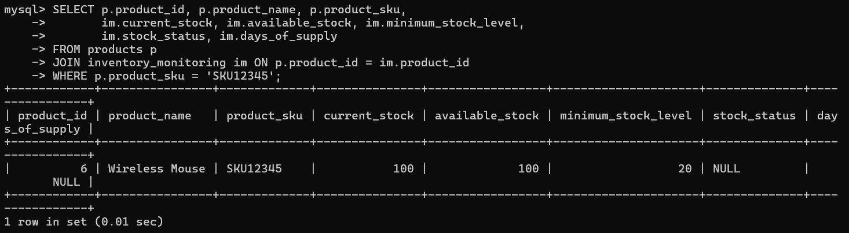

**Update - Update Stock After Sale**

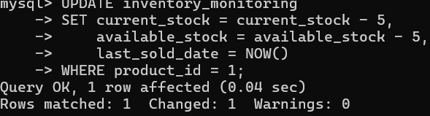  
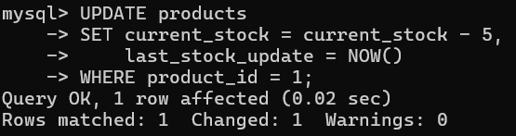

**Delete - Remove Discontinued Product**

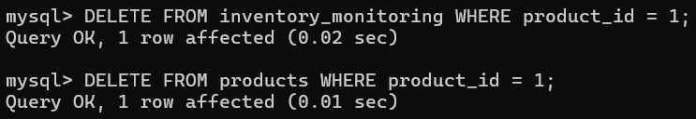

### 2. Purchase Order Processing

**Create - New Purchase Order**

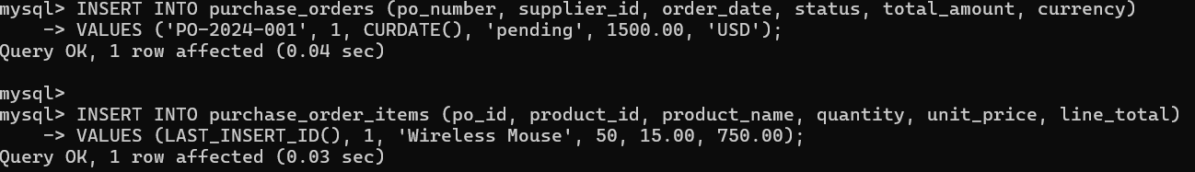

**Read - View PO Details**

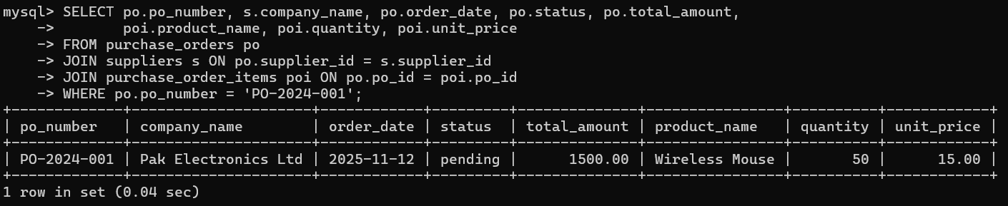

**Update - Update PO Status**

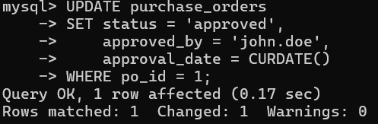

**Delete - Cancel Purchase Order**

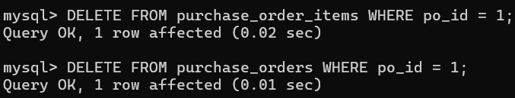

### 3. Warehouse & Storage Management

**Create - Add New Shelf Location**

**  
Read - Check Warehouse Capacity**

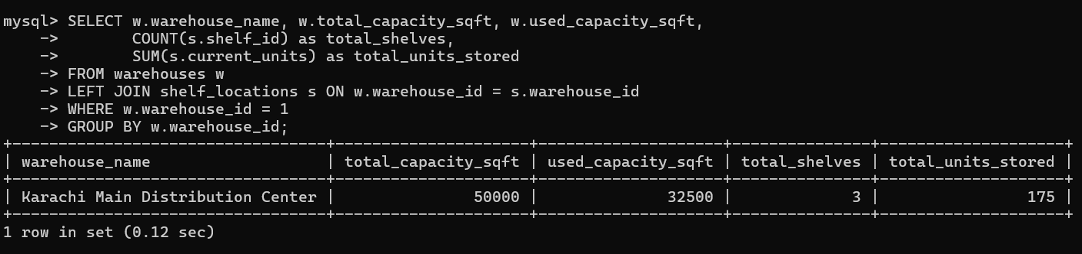

**Update - Update Shelf Occupancy**

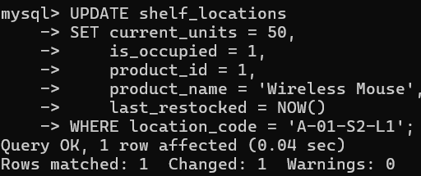

**Delete - Remove Shelf Location**

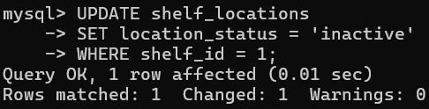

### 4. Order Fulfillment & Picking

**Create - Generate Pick List**



**Read - View Active Pick Lists**

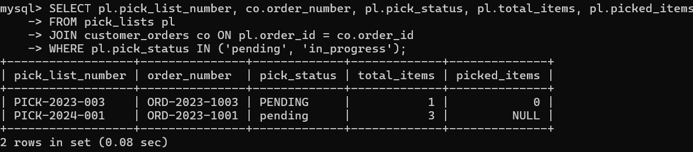

**Update - Mark Item as Picked**

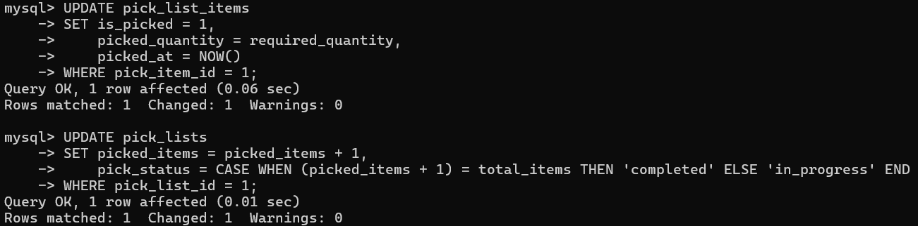

**Delete - Remove Pick List Item**



### 5. Quality Control & Inspection

**Create - New Quality Check**

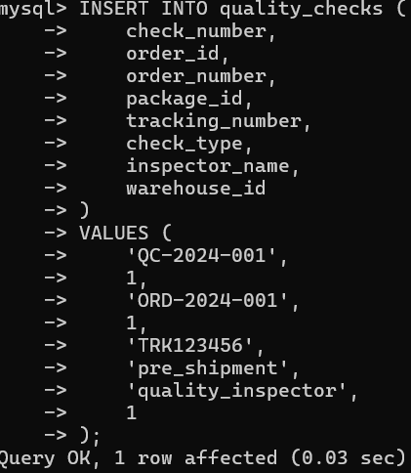

**Read - Get Quality Check Results**

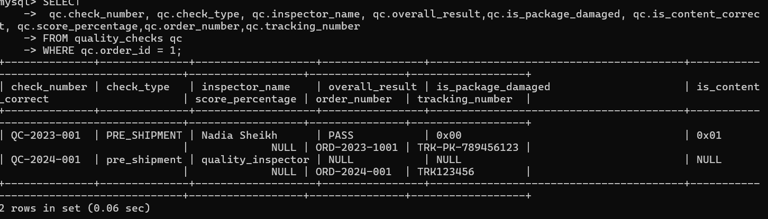

**Update - Record Quality Check Results**



**Delete - Remove Quality Check**



### 6. Shipping & Dispatch Management

**Create - Create Shipment**



**Read - Track Shipment Status**

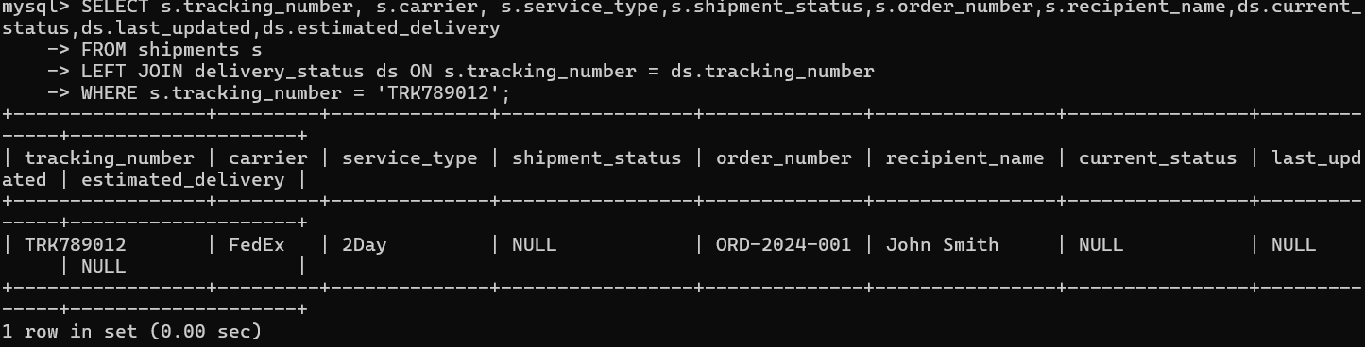

**Update - Update Shipment Status**

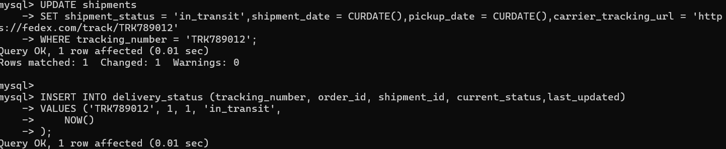

**Delete - Cancel Shipment**

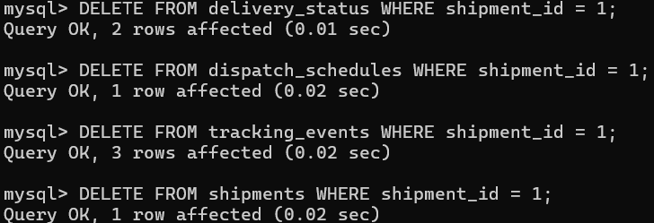

### 7. Delivery & Tracking Management

**Create - Record Delivery Status**



**Read - Get Delivery Timeline**

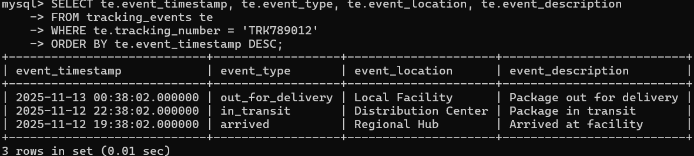

**Update - Mark as Delivered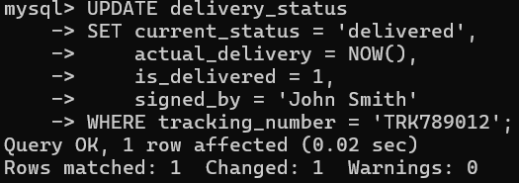  
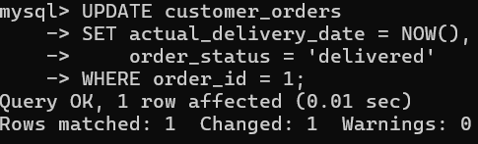**

**Delete - Remove Tracking Event**



### 8. Returns Processing

**Create - Initiate Return Request**

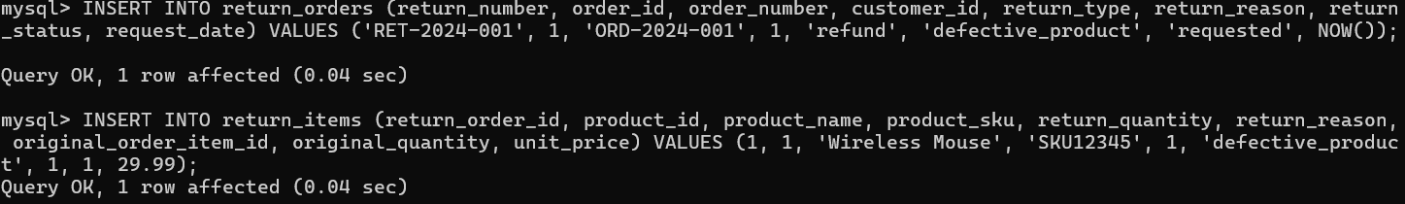

**Read - View Return Requests**

**Update - Process the return**

**Delete - Remove return if needed**



### 9. Supplier & Contract Management

**Create - Add New Supplier**



**Read - View Supplier Performance**

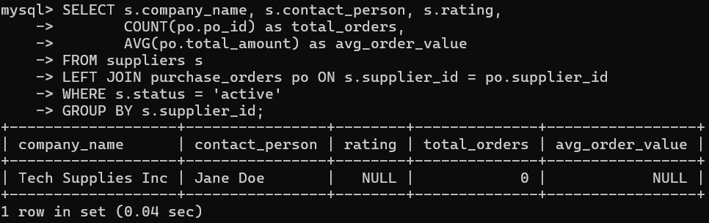

**Update - Update Supplier Rating**

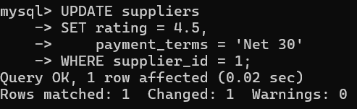

**Delete - Deactivate Supplier**

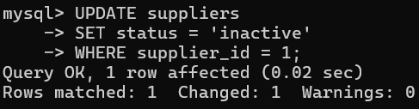

### 10. Demand Forecasting & Planning

**Create - Generate Demand Forecast**



**Read - Get Forecast Data**

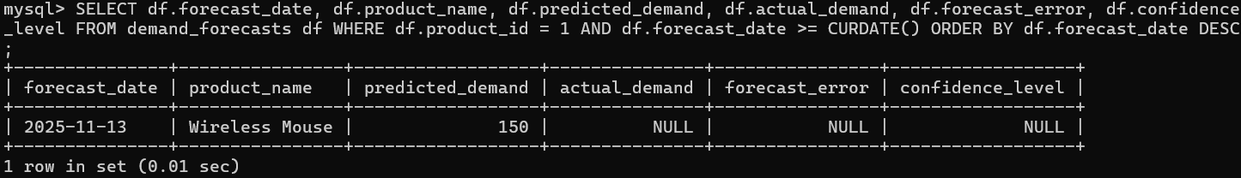

**Update - Update Forecast with Actuals**



**Delete - Remove Old Forecast**



### 11. Goods Receipt & Inspection

**Create - Record Goods Receipt**



**Read - View Receipt Details**

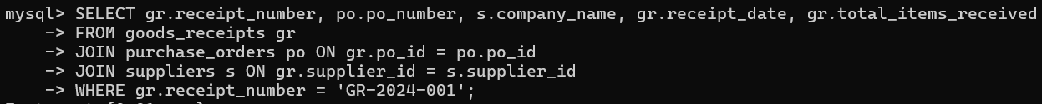

**Update - Update Receipt Status**

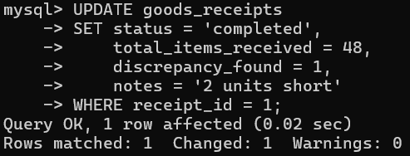

**Delete - Remove Receipt Record**

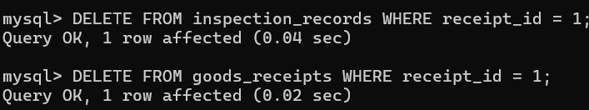

### 12. Package & Shipment Preparation

**Create - Create Package**

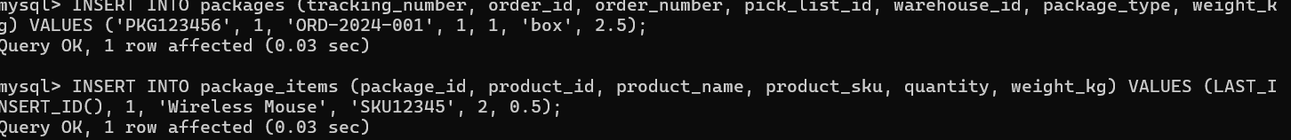

**Read - View Package Contents**

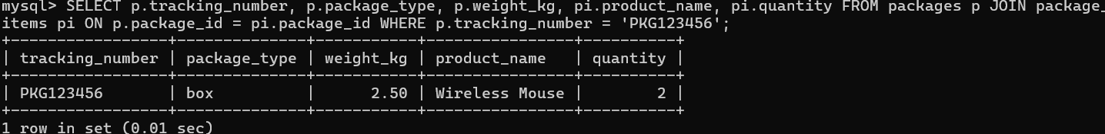

**Update - Update Package Status**



**Delete - Remove Package**



### 13. Inventory Reconciliation

**Create - Start Reconciliation Report**

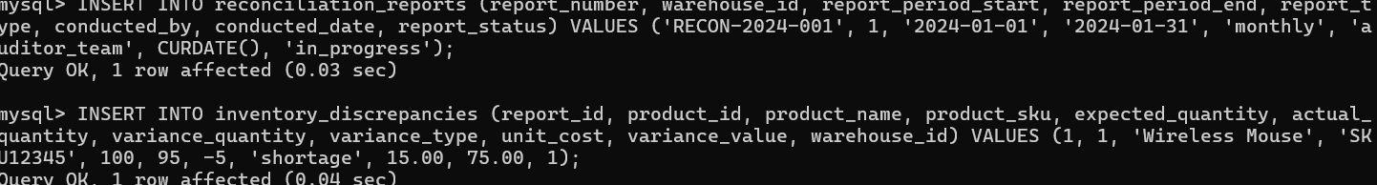

**Read - View Reconciliation Results**



**Update - Resolve Discrepancy**



**Delete - Remove Reconciliation Report**



### 14. Customer Order Management

**Create - Create Customer Order**

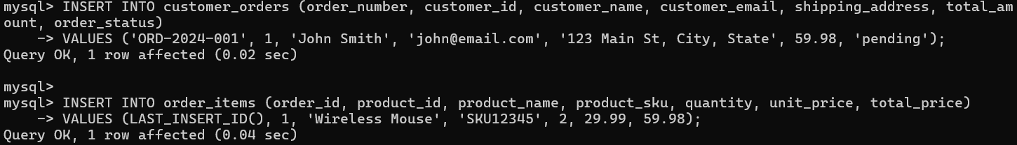

**Read - View Customer Order History**

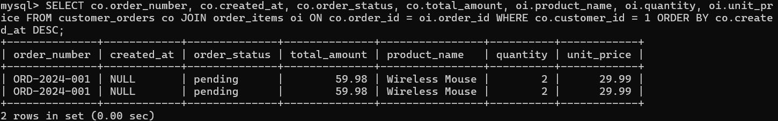

**Update - Update Order Status**



**Delete - Cancel Order**



### 15. Exception & Resolution Management

**Create - Log Delivery Exception**



**Read - View Open Exceptions**

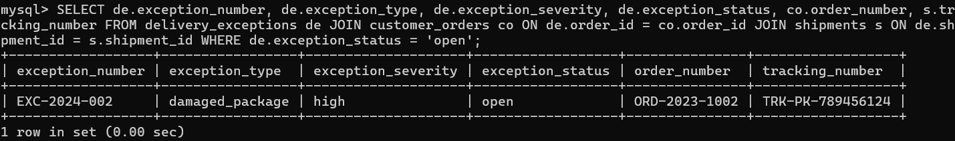

**Update - Resolve Exception**



**Delete - Remove Exception Record**



## Primary Data Flow

SUPPLIERS → CONTRACTS → SLAS

↓

PURCHASE_ORDERS → PURCHASE_ORDER_ITEMS → PRODUCTS

↓

GOODS_RECEIPTS → INSPECTION_RECORDS

↓

WAREHOUSES → STORAGE_ZONES → SHELF_LOCATIONS

↓

INVENTORY_MONITORING → STOCK_ALERTS

↓

DEMAND_FORECASTS → REORDER_PLANS → (back to PURCHASE_ORDERS)

↓

CUSTOMER_ORDERS → ORDER_ITEMS

↓

PICK_LISTS → PICK_LIST_ITEMS

↓

PACKAGES → PACKAGE_ITEMS

↓

QUALITY_CHECKS (validates against QUALITY_STANDARDS)

↓

SHIPMENTS → DISPATCH_SCHEDULES

↓

TRACKING_EVENTS → DELIVERY_STATUS

↓

DELIVERY_EXCEPTIONS → EXCEPTION_RESOLUTIONS

↓

RETURN_ORDERS → RETURN_ITEMS → RESTOCK_RECORDS

↓

RECONCILIATION_REPORTS → INVENTORY_DISCREPANCIES

## Database Design Documentation

### Database Design Rationale

**1. Architectural Philosophy**

The database follows a **supply chain-centric design** that models the complete order-to-delivery lifecycle while maintaining flexibility for various business scenarios.

**2. Core Design Principles**

* **Process-Oriented Structure**: Tables organized around business workflows (procurement → storage → fulfillment → delivery → returns)
* **Audit Trail Compliance**: All major entities include created_at and updated_at timestamps
* **Status-Driven Workflows**: Comprehensive status tracking across all processes
* **Hierarchical Relationships**: Clear parent-child relationships (e.g., Orders → Order Items → Packages)

**3. Key Design Decisions**

* **Separate Inventory Tracking**: inventory_monitoring table decoupled from products for real-time stock management
* **Modular Quality System**: Independent quality checks and standards tables
* **Comprehensive Exception Handling**: Dedicated tables for delivery exceptions and resolutions
* **Flexible Location Management**: Multi-level storage hierarchy (Warehouse → Zone → Shelf)

## Normalization Approach

**1. Third Normal Form (3NF) Compliance**

The schema achieves 3NF with minimal controlled redundancy:

Example of 3NF compliance:  
Products (product_id, sku, name, category, supplier_id) – No transitive dependencies  
Suppliers (supplier_id, company_name, contact_info) – All non-key attributes depend only on primary key

**2. Intentional Denormalization**

Strategic redundancy introduced for performance and business needs:

Business-justified denormalization:  
customer_orders (customer_name, customer_email) – Despite customer_id existence  
order_items (product_name, product_sku) – Despite product_id foreign key

**Justification:**

* **Performance**: Reduces joins for frequent queries
* **Historical Integrity**: Preserves order details even if products change
* **Reporting Efficiency**: Supports analytical queries without complex joins

**3. Data Integrity Preservation**

* All denormalized fields have source-of-truth references
* Application-level consistency enforcement required
* Audit trails maintain data lineage

## Constraints and Their Purposes

**1. Primary Key Constraints**

PRIMARY KEY (contract_id)  
**Purpose:** Entity identification and referential integrity foundation

**2. Unique Constraints**

UNIQUE KEY contract_number  
**Purpose:** Prevent duplicate business identifiers across:

* Contract numbers
* Order numbers
* Tracking numbers
* PO numbers
* Return numbers

**3. Foreign Key Constraints**

FOREIGN KEY (shipment_id) REFERENCES shipments (shipment_id)  
**Purpose:** Maintain referential integrity for:

* Parent-child relationships (Orders → Items)
* Process dependencies (Shipments → Tracking)
* Entity associations (Products → Suppliers)

**4. NOT NULL Constraints**

order_number varchar(50) NOT NULL  
customer_email varchar(100) NOT NULL

**Purpose:** Enforce data completeness for critical business fields:

* Customer contact information
* Order identification
* Product SKUs
* Process statuses

**5. Check Constraints (Logical)**

*Note: MySQL implements these via application logic*

Status validation: order_status IN (pending, processing, shipped, delivered, cancelled)  
Quantity validation: quantity > 0  
Date validation: end_date > start_date

**6. Data Type Constraints**

contract_value decimal(15,2) – Precision for financial data  
quantity int – Whole numbers for counts  
status varchar(50) – Standardized status lengths

**7. Default Constraints**

created_at datetime(6) DEFAULT NULL – Audit trail automation  
is_active bit(1) DEFAULT NULL – Boolean flag standardization  
status varchar(50) DEFAULT NULL – Process state initialization

## Constraint Categories by Business Purpose

**A. Business Process Integrity**

* **Order Fulfillment**: Ensures order → pick list → package → shipment lineage
* **Inventory Management**: Maintains stock consistency across transactions
* **Quality Control**: Links inspections to receipts and shipments

**B. Data Quality Enforcement**

* **Customer Data**: Validates contact information and addresses
* **Product Information**: Ensures SKU uniqueness and categorization
* **Financial Data**: Maintains monetary precision and currency consistency

**C. Workflow Compliance**

* **Status Transitions**: Enforces valid state changes
* **Date Sequencing**: Ensures logical process timelines
* **Approval Chains**: Maintains authorization requirements

**D. Regulatory and Compliance**

* **Audit Requirements**: Complete historical tracking
* **Quality Standards**: Documentation of inspections and standards
* **Contract Management**: SLA compliance tracking

## Entity Relationship Diagram:

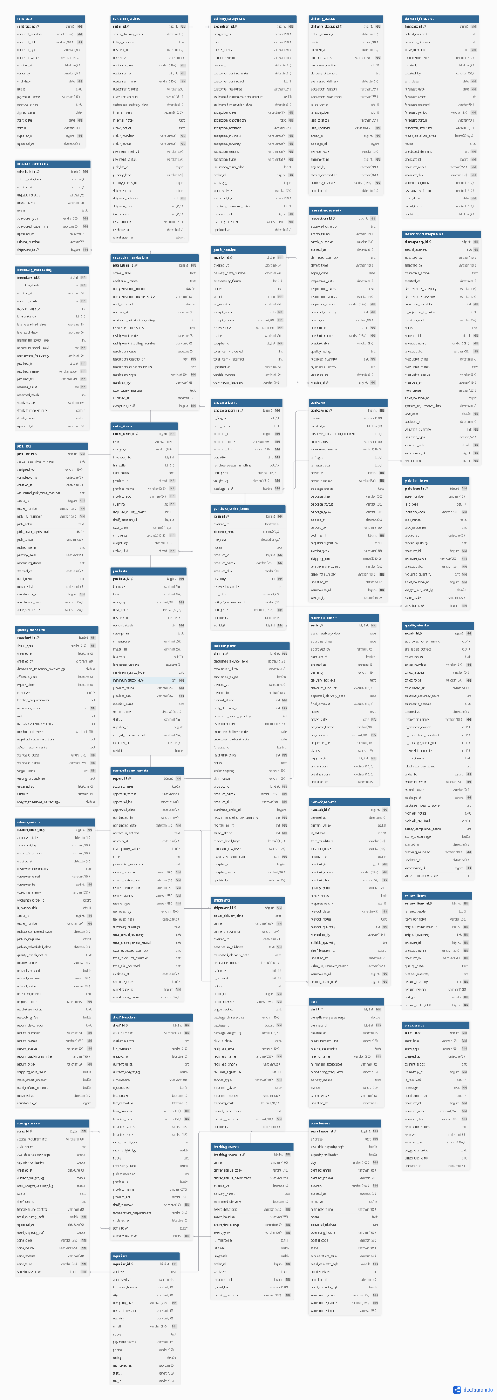

# **Frontend – Supply Chain Management System**

## 1. Project Overview

The Supply Chain Management (SCM) Frontend is a **React-based dashboard** designed to integrate with a Java Spring Boot backend that manages suppliers, procurement, catalog, inventory, forecasting, warehouse storage, picking/packing, shipments, tracking, returns, and reconciliation processes.

The frontend provides operational visibility through:

* Real-time data fetching
* CRUD operations across all entities
* Monitoring dashboards
* Alerts & exceptions
* Charts and analytics

This documentation describes the **architecture**, **API integration**, **routing**, and **UI components**, along with placeholders for screenshots.

## 2. Technology Stack

| **Layer** | **Technology** |
| --- | --- |
| Framework | React (Vite) |
| UI | HTML, CSS, Vanilla styling |
| Charts | Recharts |
| Routing | React Router v6 |
| API Calls | Fetch API (custom request wrapper) |
| Backend communication | RESTful JSON over HTTP |
| Build Tool | Vite |

## 3. Project Setup

**Install & Run**

bun install

bun run dev

**Directory Structure**

src/

├── pages/

│ ├── Dashboard.jsx

│ ├── SupplierManagement.jsx

│ ├── VendorContractManagement.jsx

│ ├── Procurement.jsx

│ ├── GoodsReceivingInspection.jsx

│ ├── CatalogStockManagement.jsx

│ ├── InventoryMonitoring.jsx

│ ├── DemandForecasting.jsx

│ ├── WarehouseStorage.jsx

│ ├── OrderPickingPackaging.jsx

│ ├── QualityControl.jsx

│ ├── ShipmentScheduling.jsx

│ ├── TrackingUpdates.jsx

│ ├── DeliveryExceptions.jsx

│ └── ReconciliationReporting.jsx

├── services/

│ └── api.js

├── App.jsx

├── main.jsx

└── styles.css

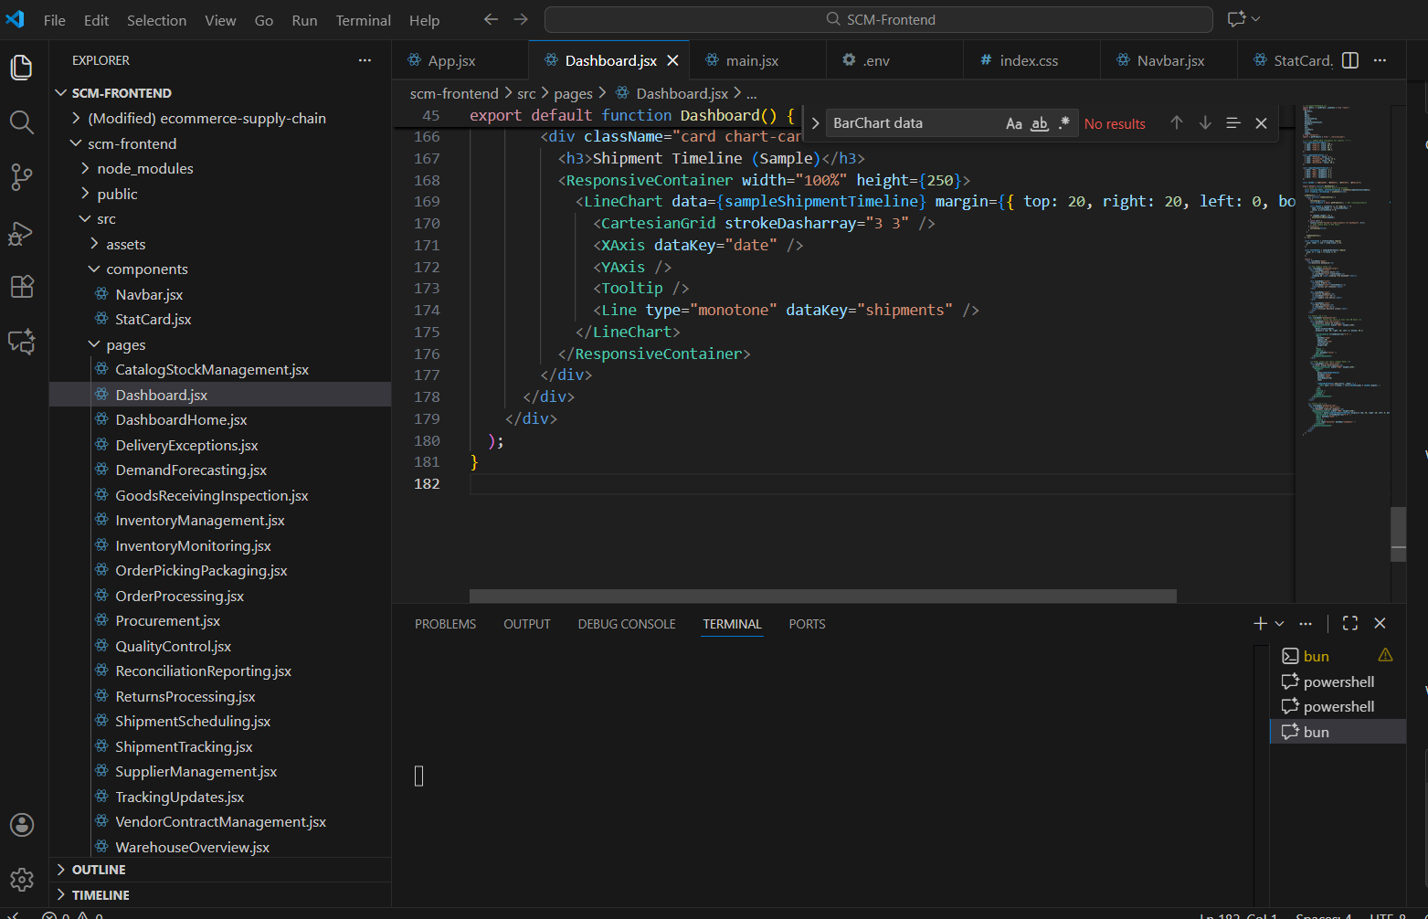

## 4. API Integration (services/api.js)

All API calls are centralized in a single file:  
src/services/api.js

**4.1 Base Request Wrapper**

Handles errors, logs backend messages, and parses JSON.

async function request(path, options = {}) {

const res = await fetch(`${BASE_URL}${path}`, {

headers: { "Content-Type": "application/json" },

...options,

});

if (!res.ok) {

let errBody = await res.json().catch(() => ({}));

throw new Error(errBody.message || "Unexpected API Error");

}

if (res.status === 204) return null;

return res.json();

}

**4.2 API Modules**

The API file includes more than **30 endpoint implementations**, including:

* **Supplier API**
* **Catalog API**
* **Inventory API**
* **Forecasting API**
* **Warehouse API**
* **Picking API**
* **Orders API**
* **Shipments API**
* **Tracking API**
* **Returns API**
* **Reconciliation API**

Each module exports functions used directly by components.

Example:

export const getProducts = () => request("/catalog/products");

export const createReorderPlan = (body) =>

request("/forecasting/reorder-plans", {

method: "POST",

body: JSON.stringify(body),

});

## 5. Routing Structure (App.jsx)

src/App.jsx defines the navigation bar and all page routes.

<Routes>

<Route path="/" element={<Navigate to="/suppliers" replace />} />

<Route path="/suppliers" element={<SupplierManagement />} />

<Route path="/contracts" element={<VendorContractManagement />} />

<Route path="/procurement" element={<Procurement />} />

<Route path="/receiving" element={<GoodsReceivingInspection />} />

<Route path="/catalog" element={<CatalogStockManagement />} />

<Route path="/monitoring" element={<InventoryMonitoring />} />

<Route path="/forecasting" element={<DemandForecasting />} />

<Route path="/storage" element={<WarehouseStorage />} />

<Route path="/picking" element={<OrderPickingPackaging />} />

<Route path="/quality" element={<QualityControl />} />

<Route path="/shipments" element={<ShipmentScheduling />} />

<Route path="/tracking" element={<TrackingUpdates />} />

<Route path="/exceptions" element={<DeliveryExceptions />} />

<Route path="/returns" element={<ReturnsProcessing />} />

<Route path="/reconciliation" element={<ReconciliationReporting />} />

</Routes>

Navigation uses <NavLink> to highlight active pages.

## 6. Page-Level Documentation

Below is a description of each main page.

### 6.1 Dashboard (Charts + Analytics)

Provides:

* Total inventory count (real DB)
* Total orders
* Active shipments
* Exceptions count
* Inventory levels bar chart
* Order status pie chart
* Shipment timeline line chart

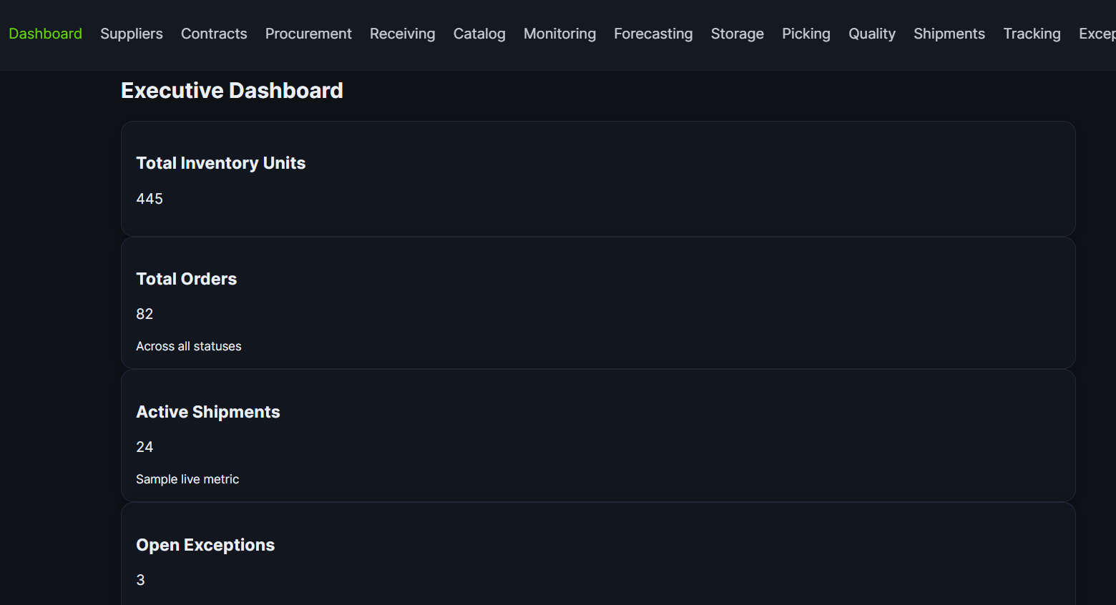

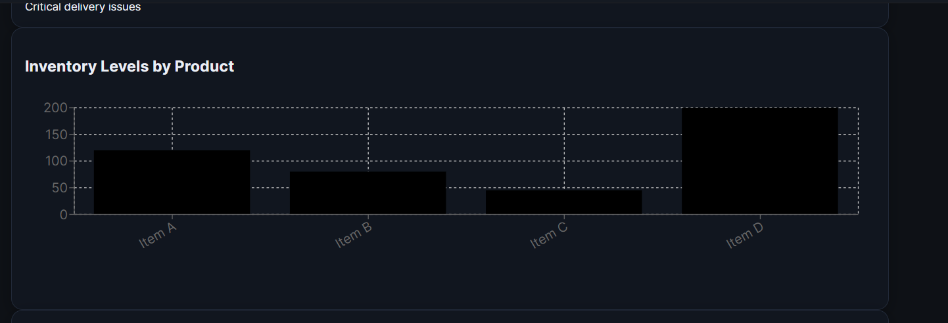

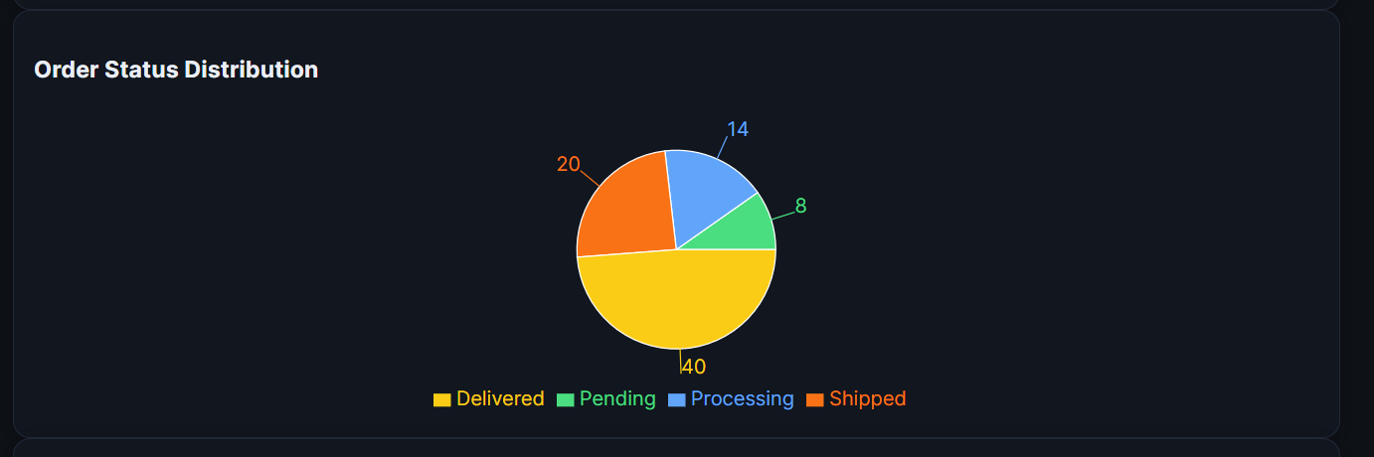

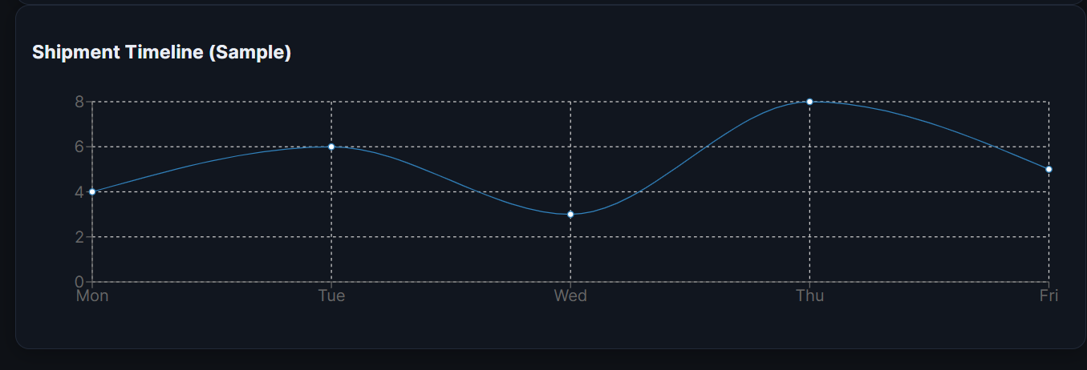

### 6.2 Supplier Management

Features:

* Register Supplier (POST)
* List Suppliers (GET)
* Approve / Reject Supplier (PUT)
* Display supplier table

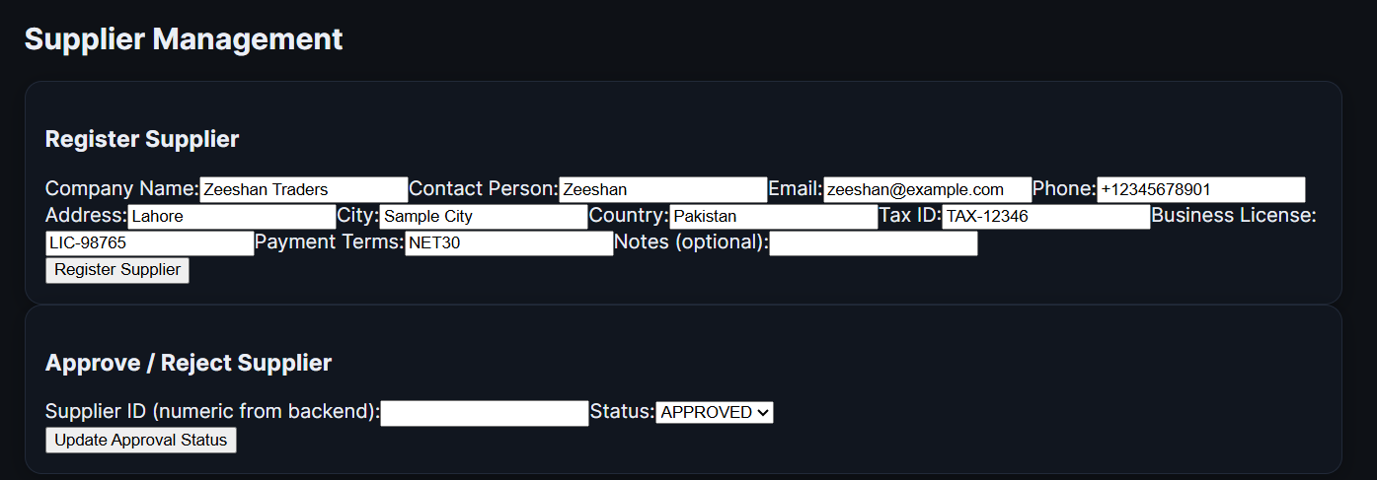

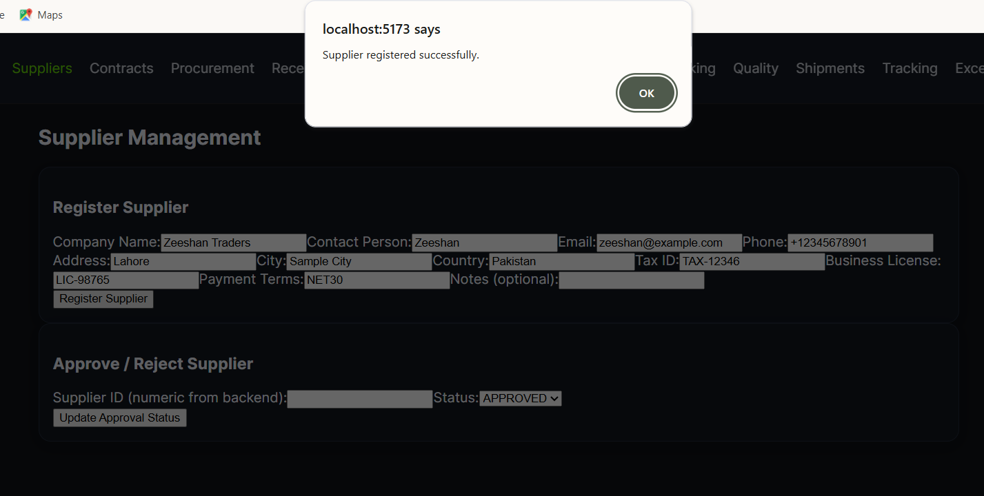

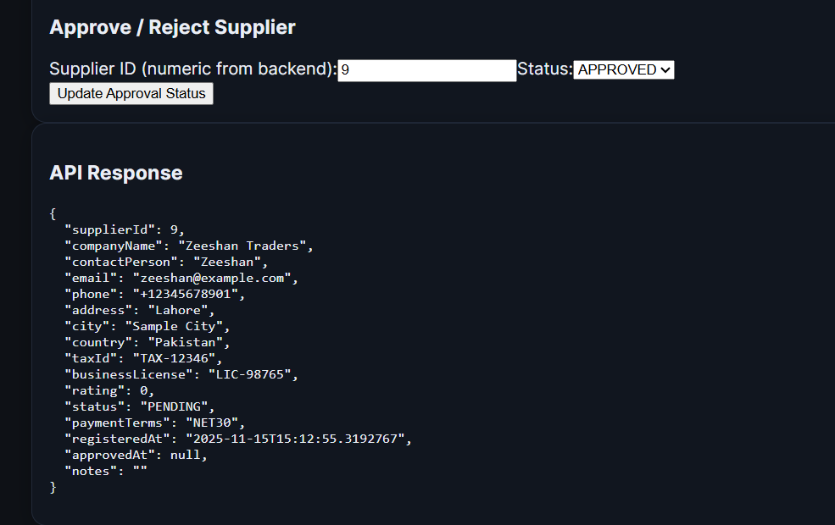

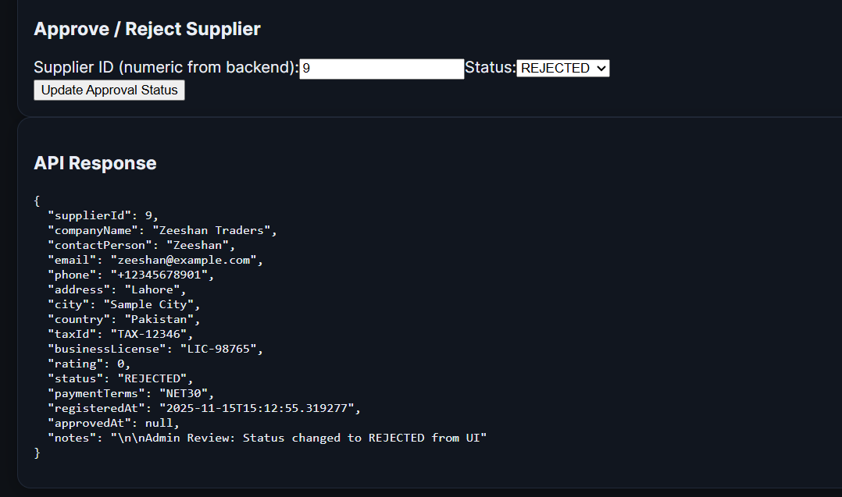

### 6.3 Vendor Contract Management

Includes:

* Create contract
* List contracts
* Add SLA to contracts
* Fetch contract details

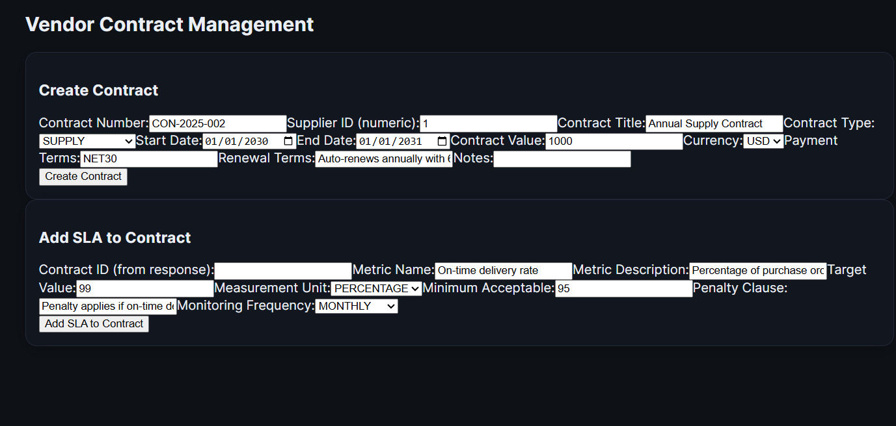

### 6.4 Procurement

Includes:

* Create Purchase Order
* List Purchase Orders
* Approve purchase orders

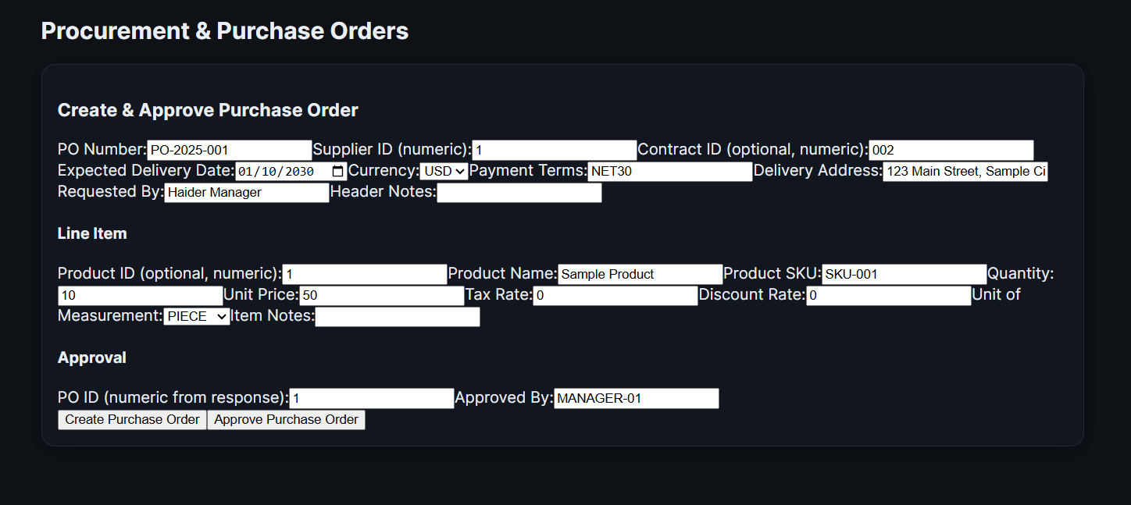

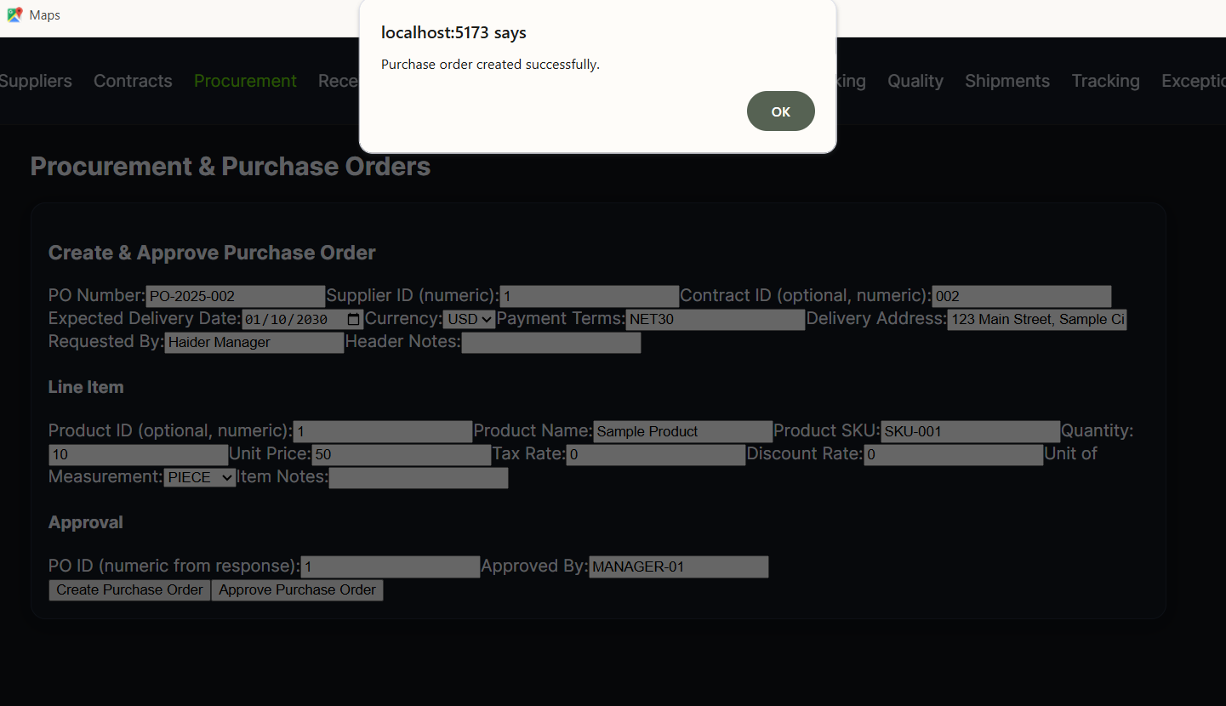

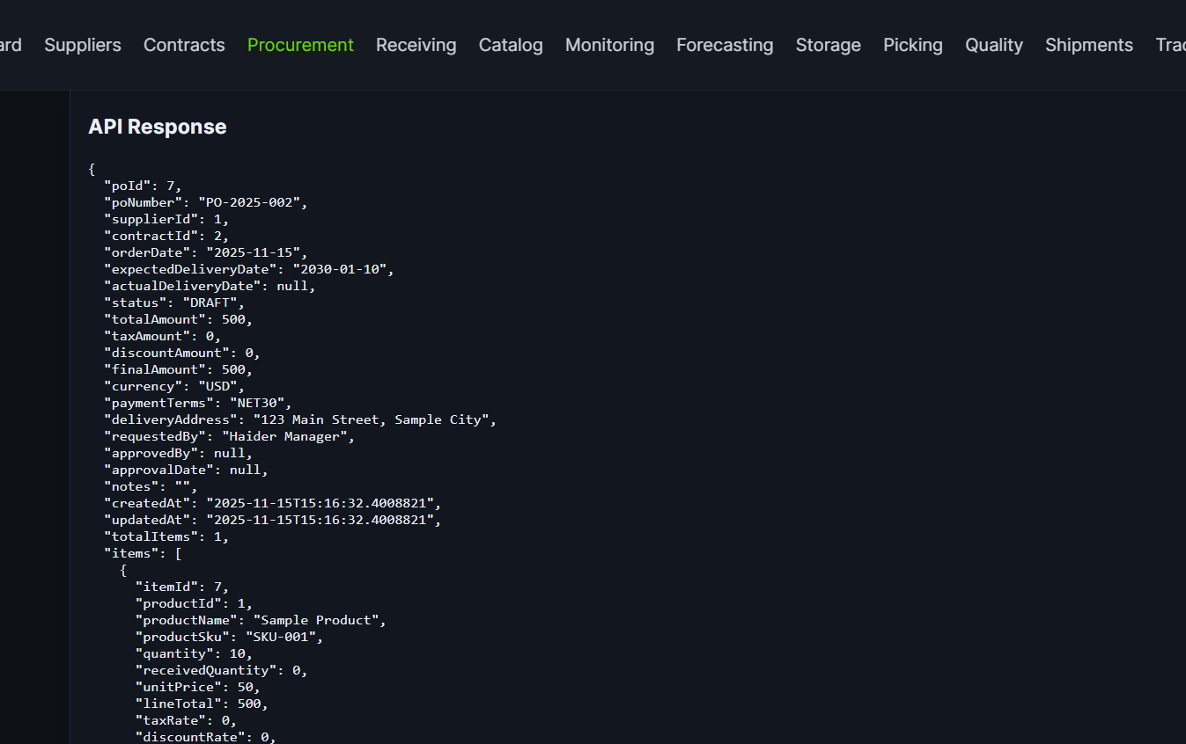

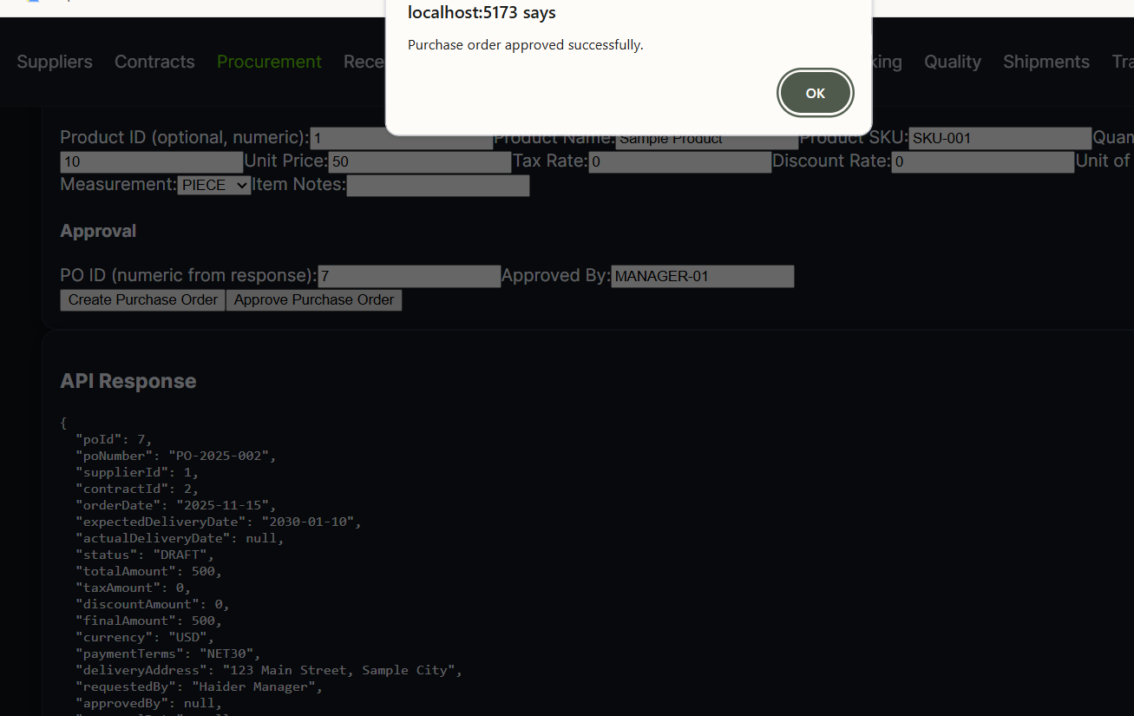

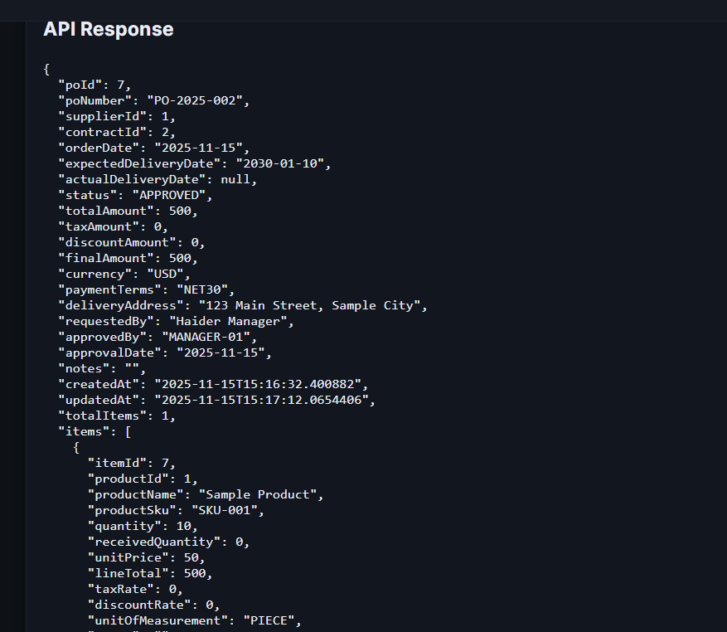

### 6.5 Receiving & Inspection

Supports:

* Goods Receipt creation
* Listing received goods
* Inspection results submission

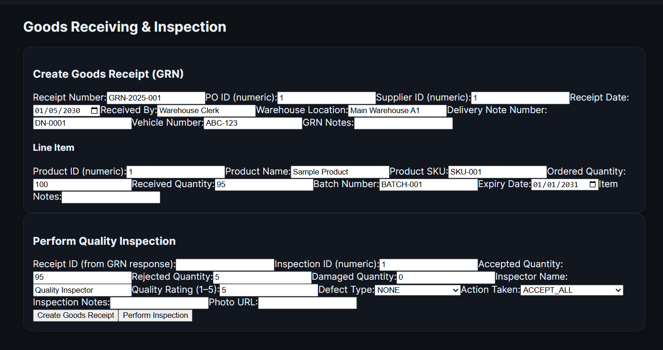

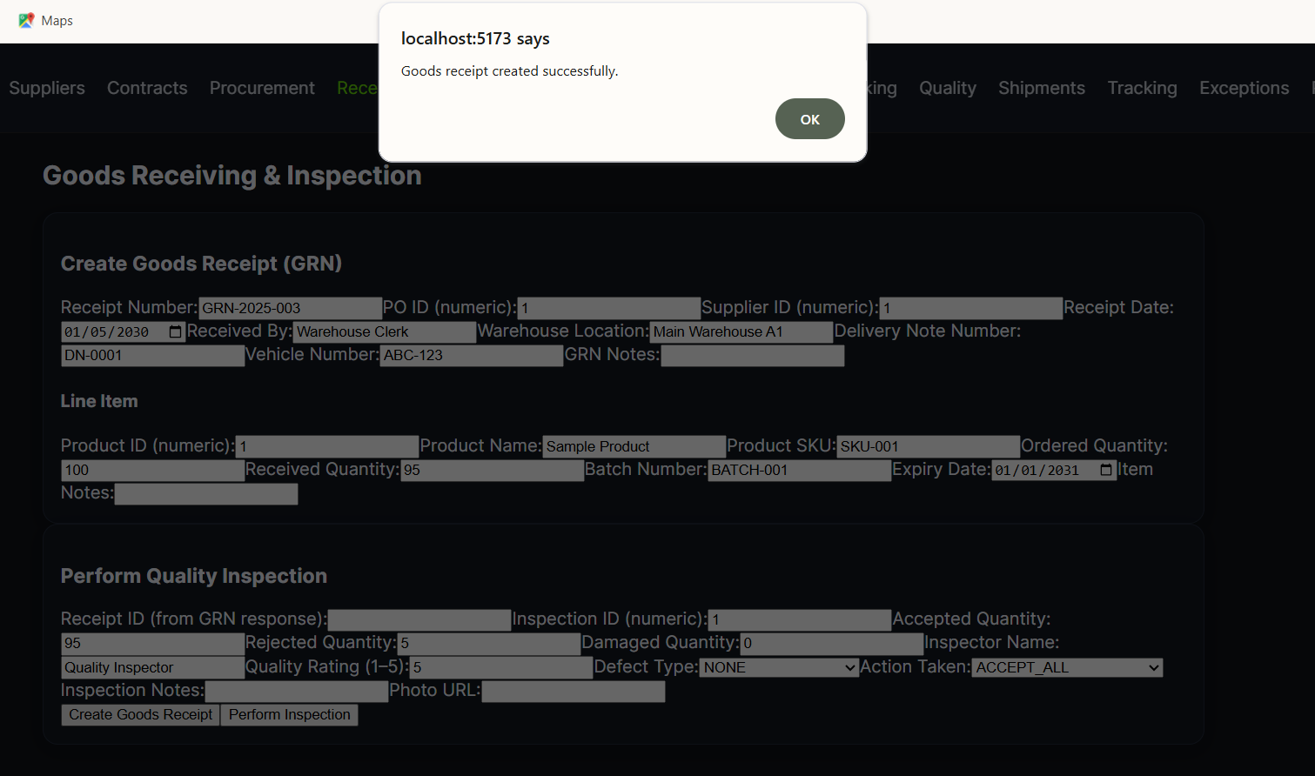

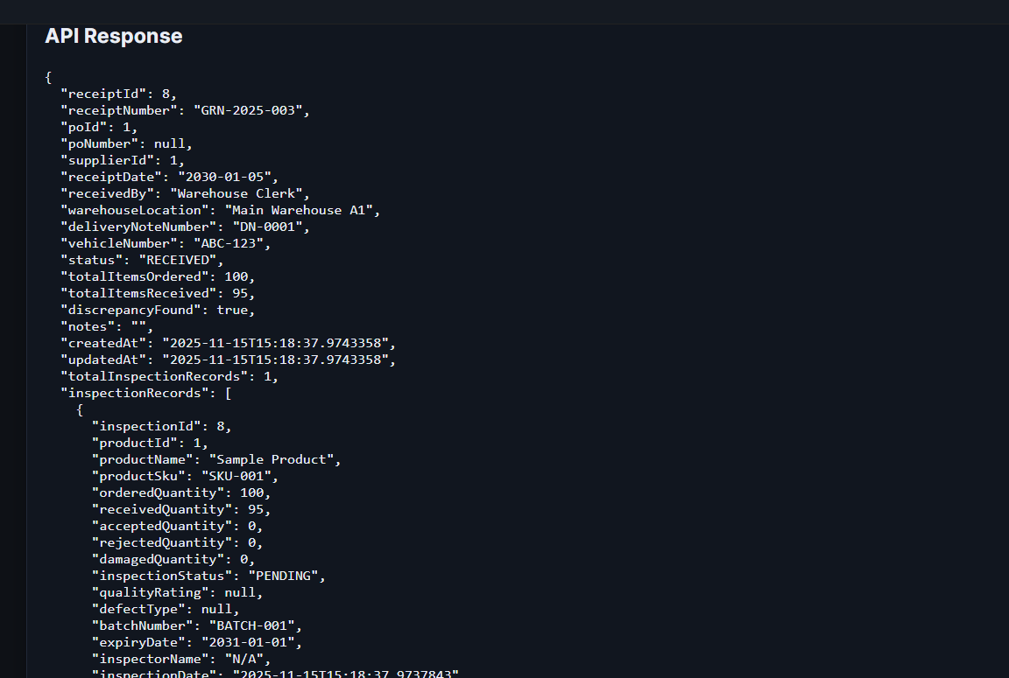

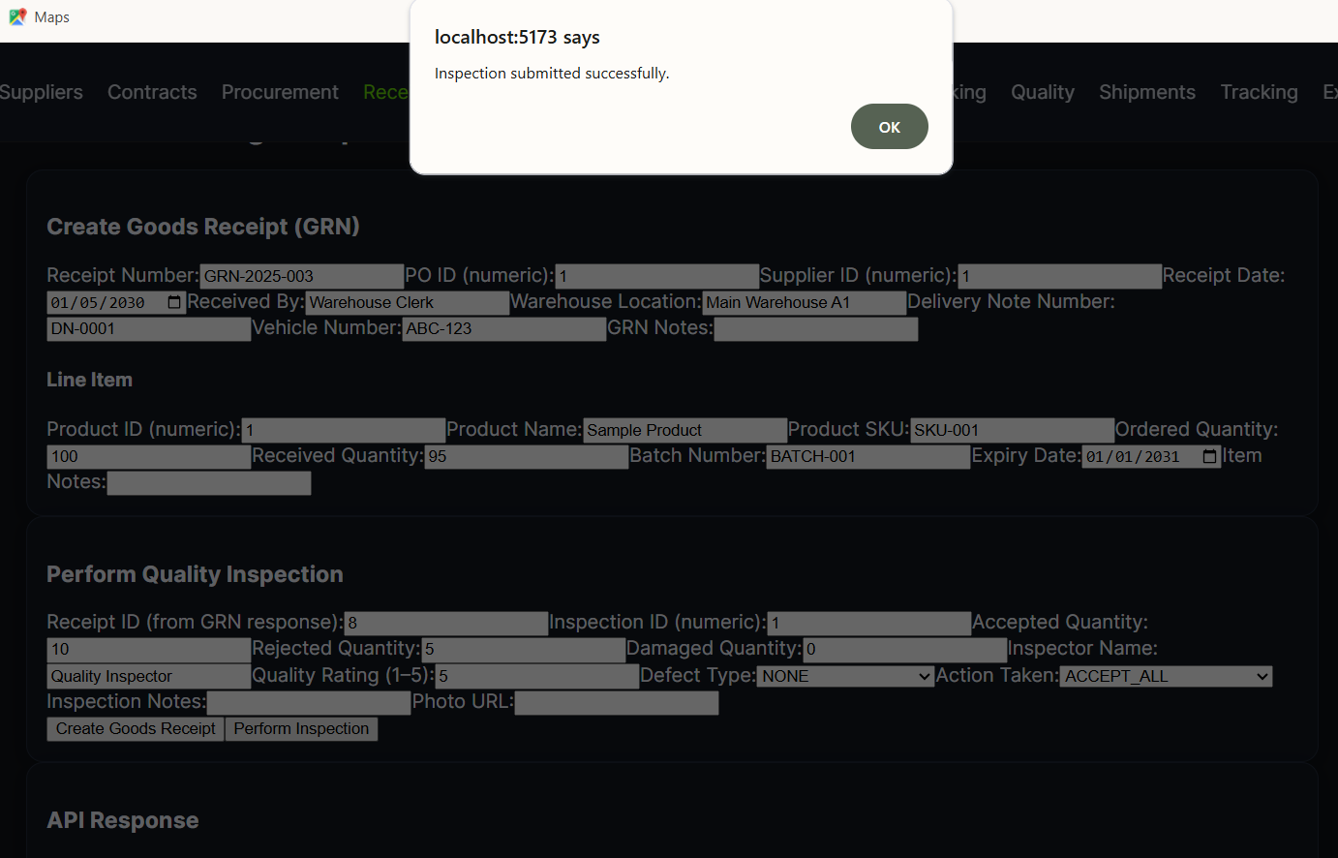

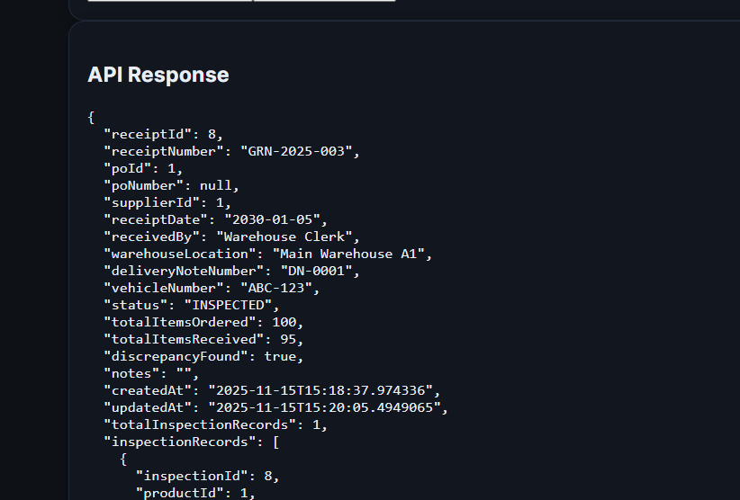

### 6.6 Catalog & Stock Management

Includes:

* Create/update/delete products
* Stock updates
* View product catalog

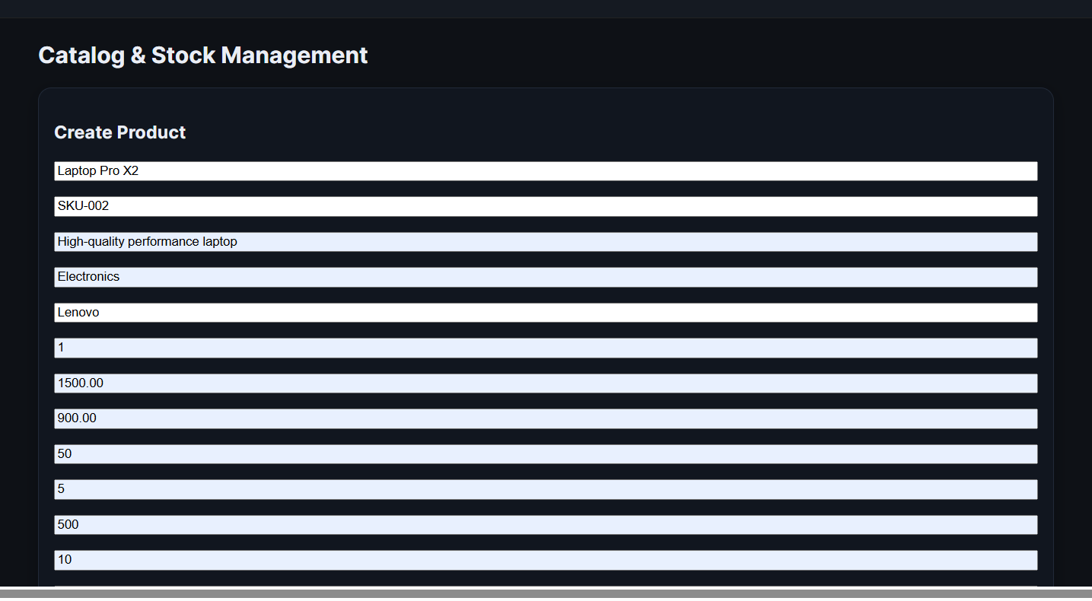

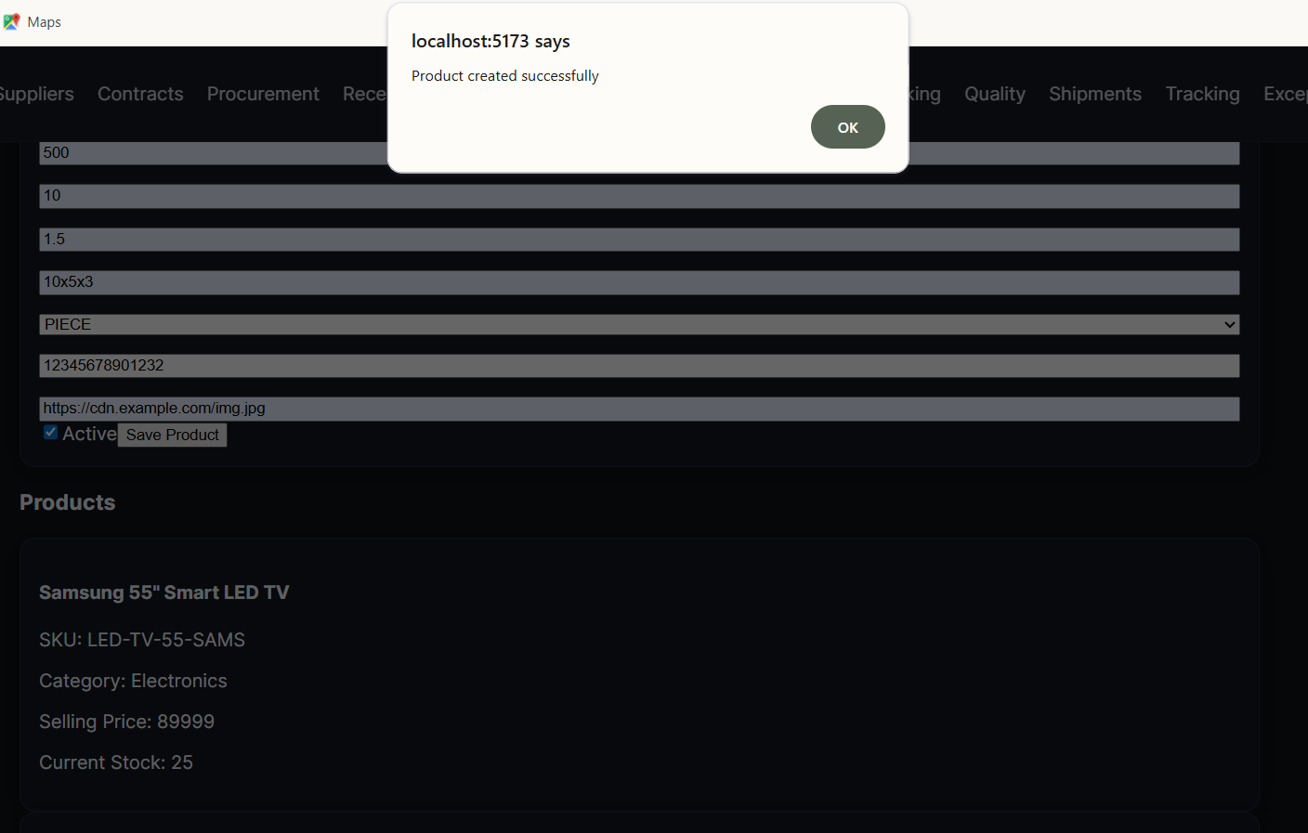

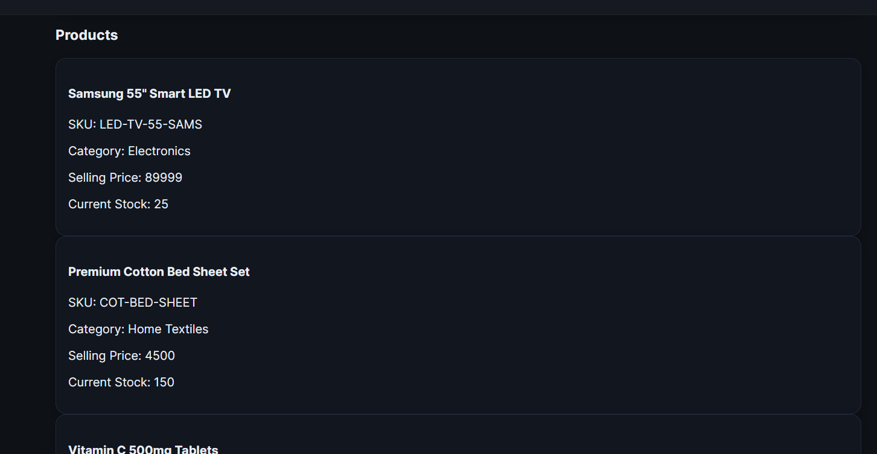

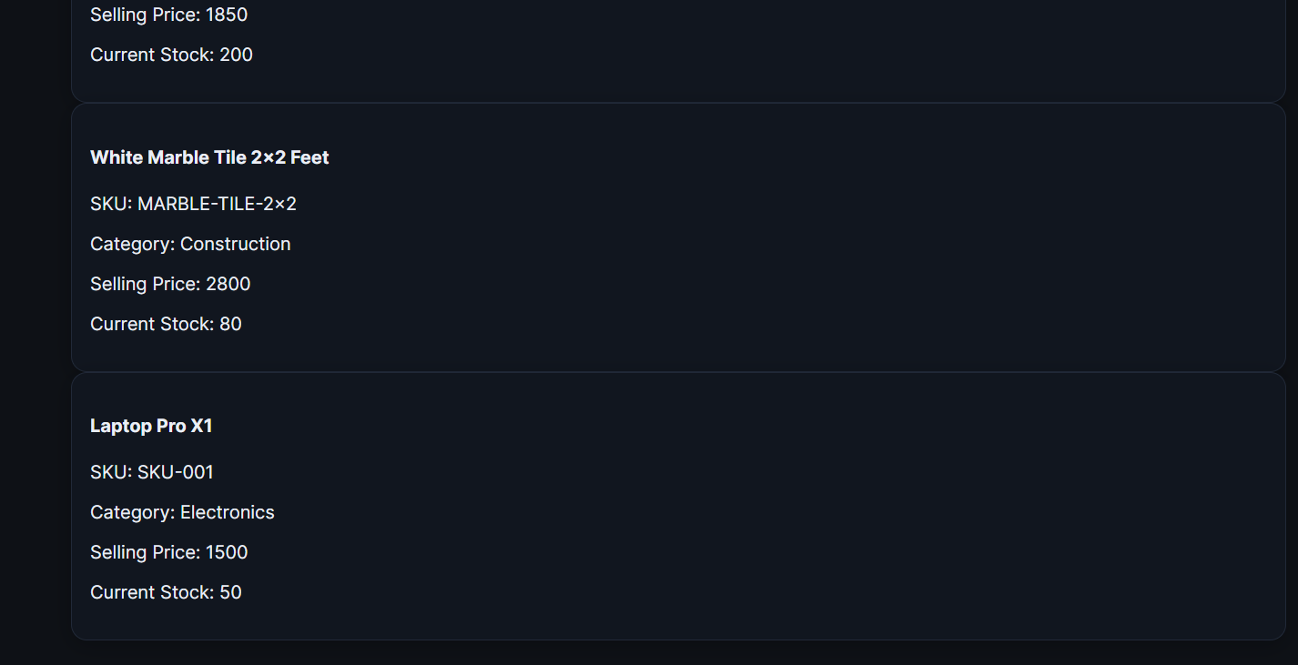

### 6.7 Inventory Monitoring & Alerts

Features:

* Configure product monitoring (min level / reorder point)
* Update stock (INBOUND/OUTBOUND)
* Run automated health check
* View active alerts
* Resolve alerts

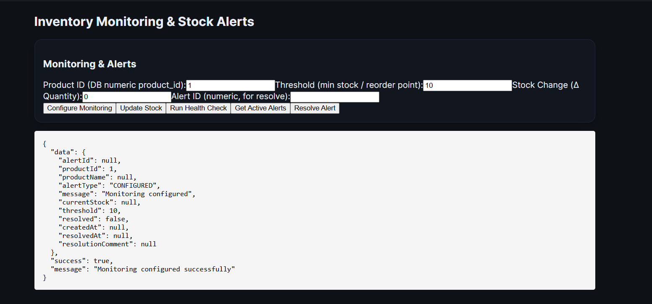

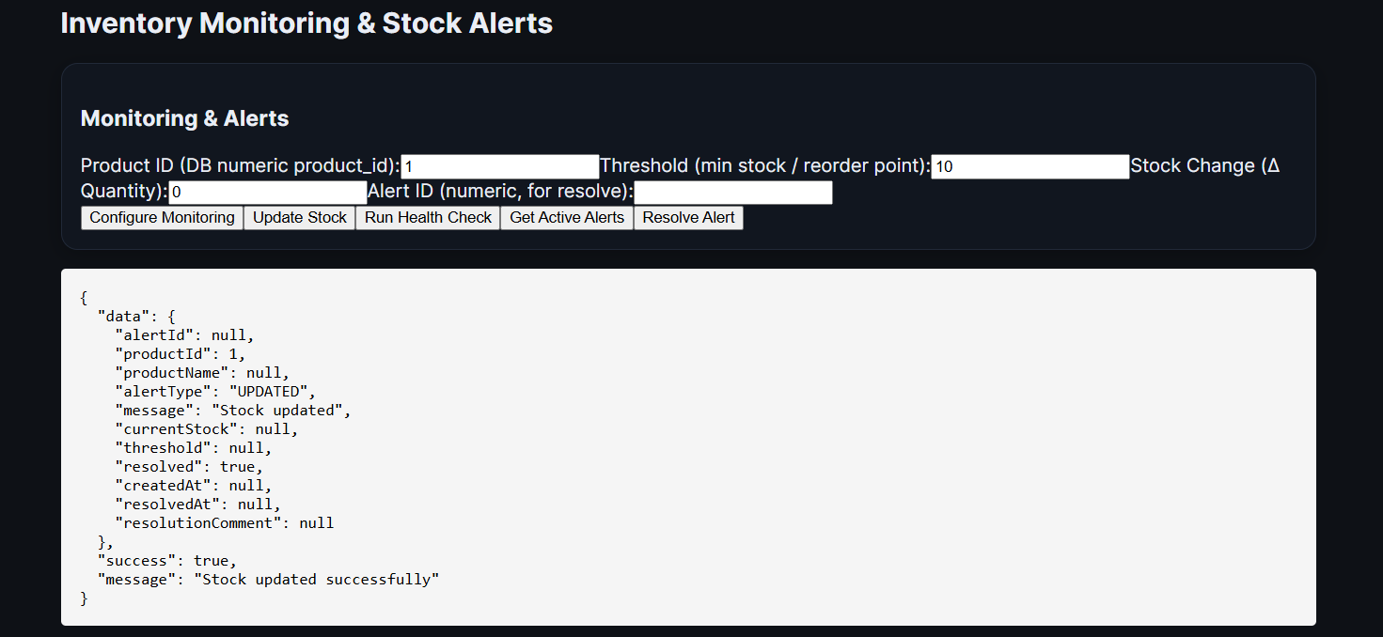

### 6.8 Forecasting & Reorder Planning

Provides:

* Create demand forecasts
* List forecasts
* Generate reorder plans based on safety stock
* Convert plans to purchase orders (if backend supports later)

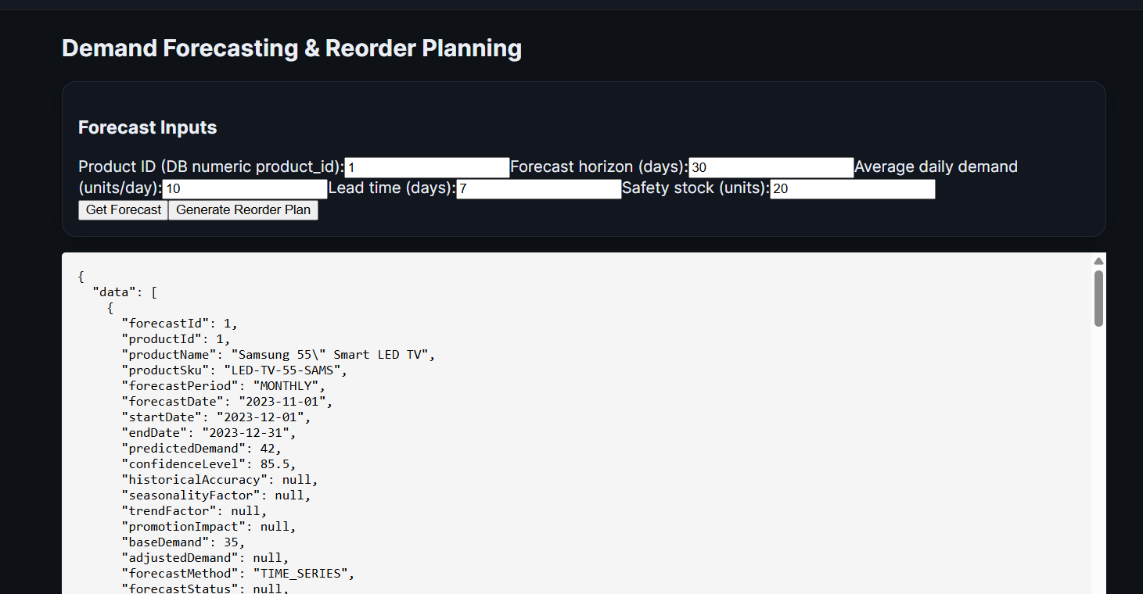

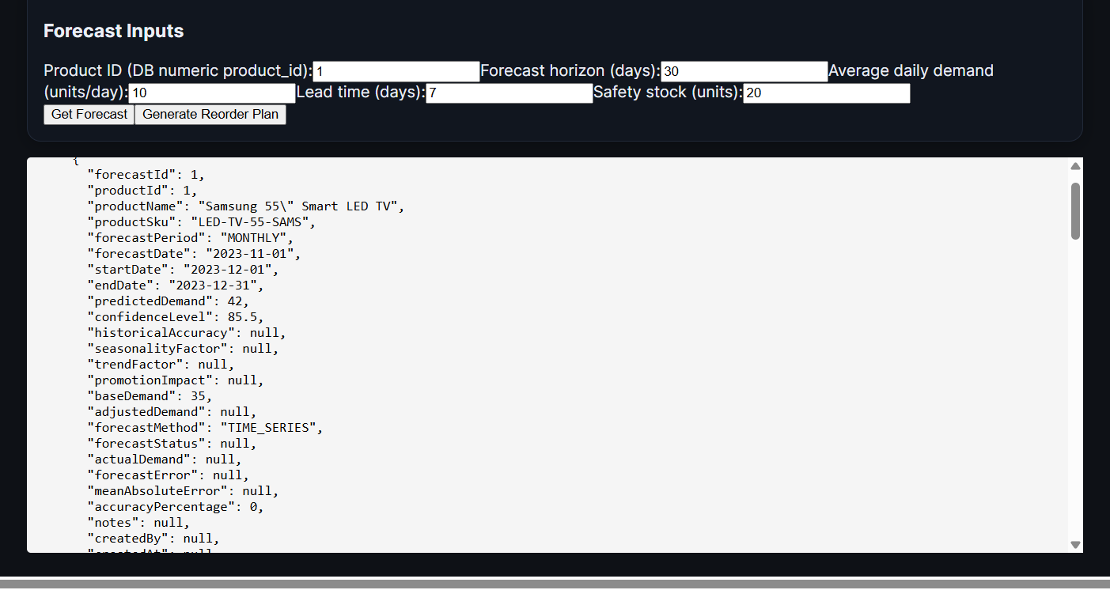

### 6.9 Warehouse Storage

Includes:

* View warehouses
* Get available shelves
* Assign items to shelves

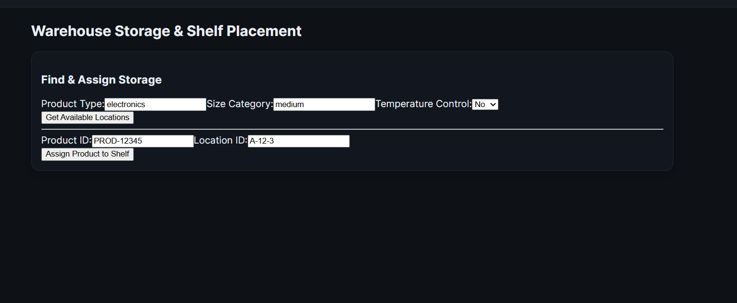

### 6.10 Picking & Packaging

Includes:

* Create picking list
* Update pick item status
* Create packaging
* Mark packages as packed

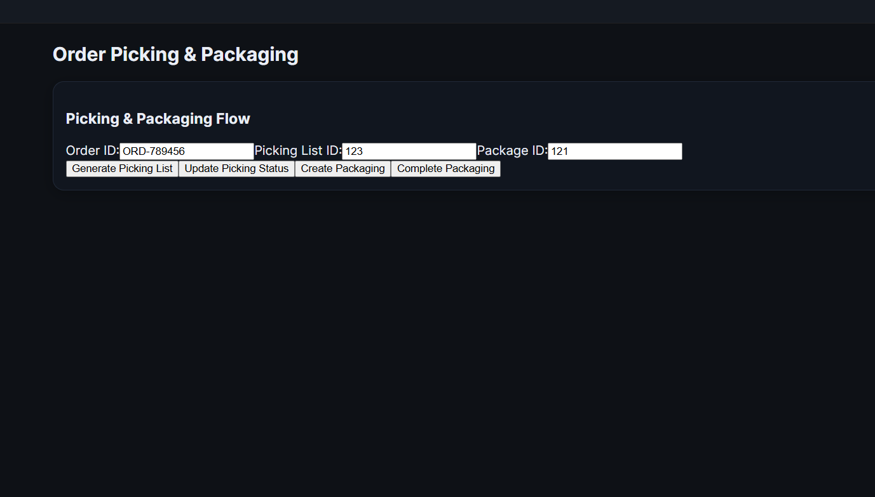

### 6.11 Quality Control

Supports:

* Create quality checks
* Submit QC results
* Request recheck on failed inspections

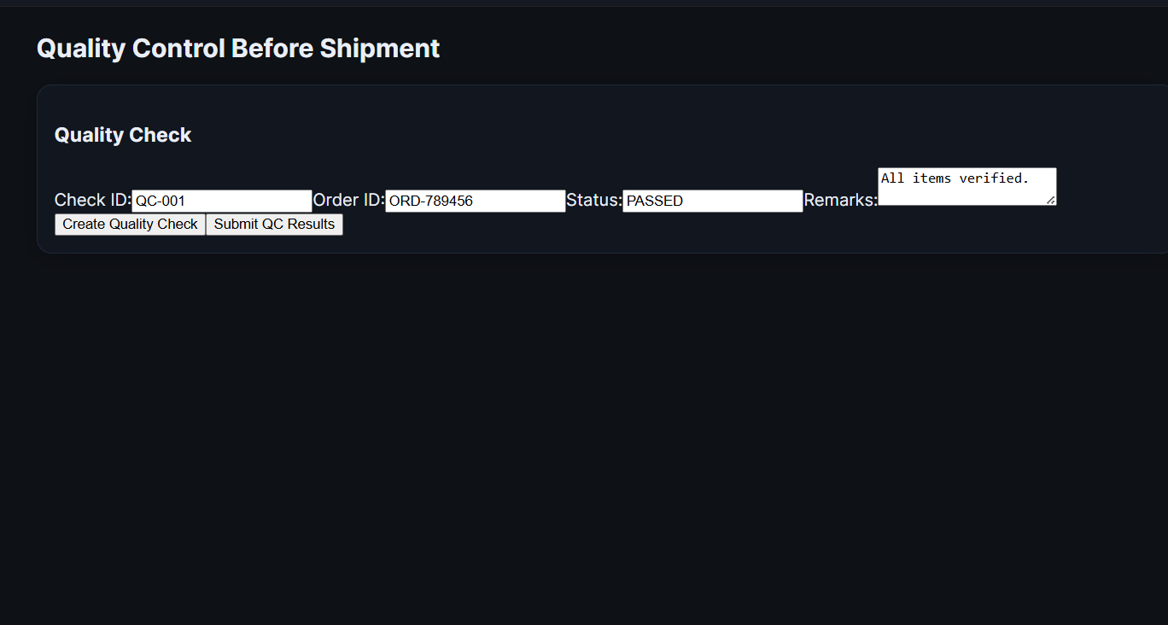

### 6.12 Shipment Scheduling

Features:

* Schedule shipments
* Fetch shipment list
* Update shipment status

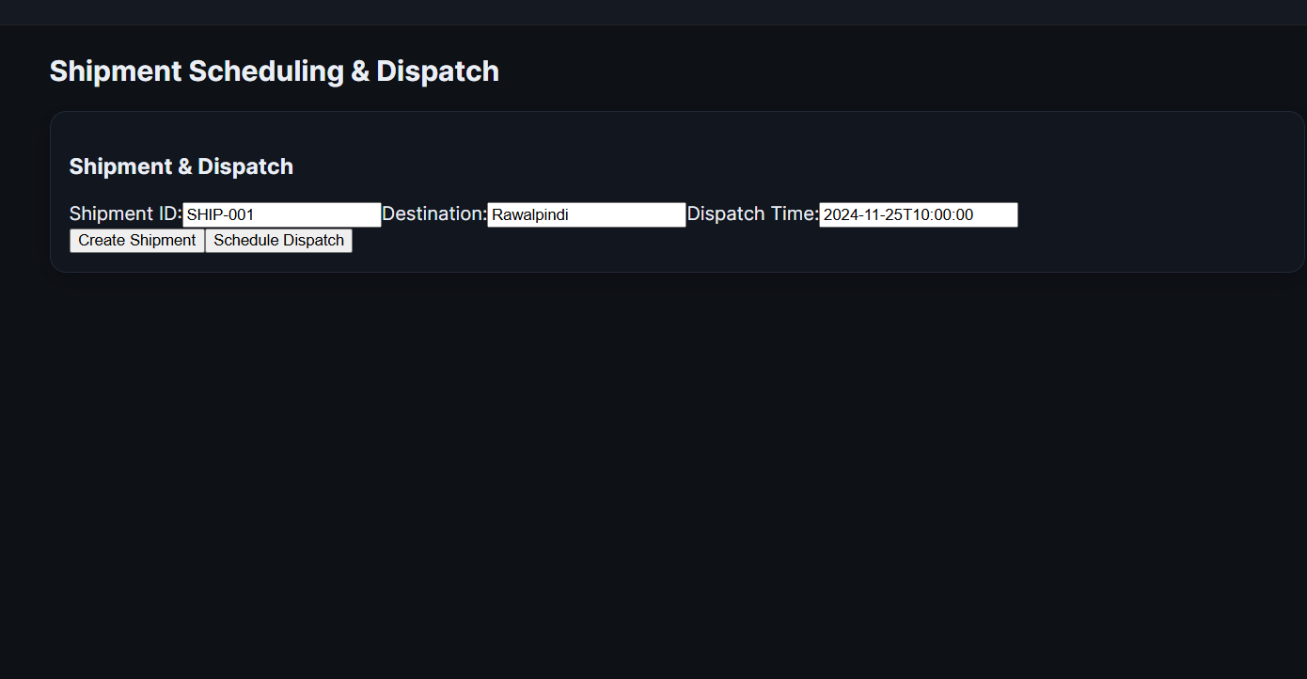

### 6.13 Tracking Updates

Supports:

* Add tracking event
* View shipment history
* Check delivery status

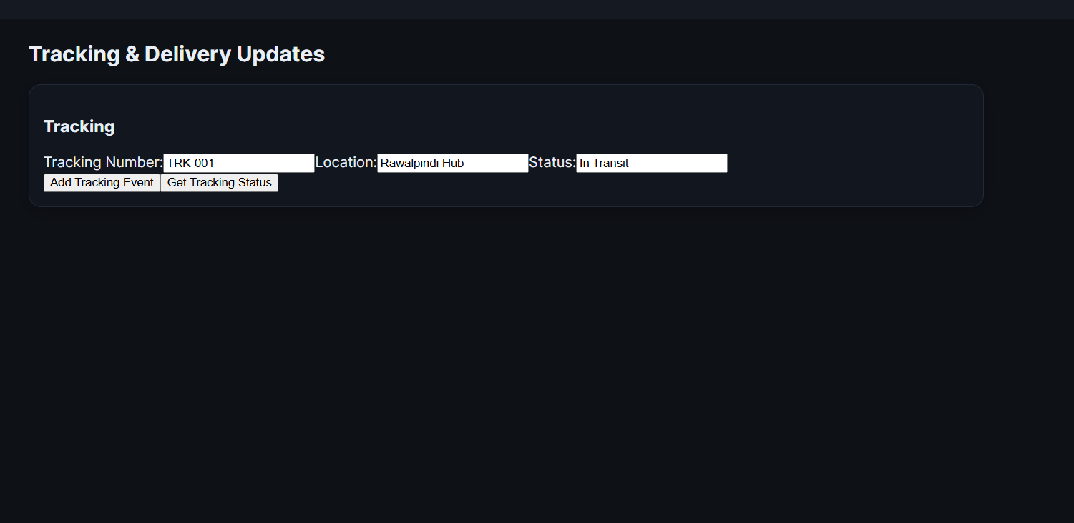

### 6.14 Delivery Exceptions

Features:

* Create delivery exceptions
* Resolve exceptions

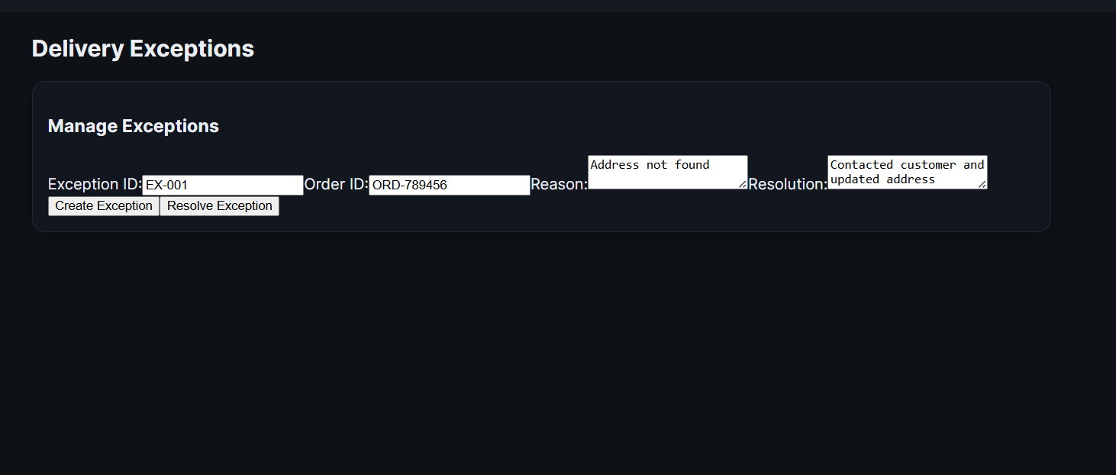

### 6.15 Returns Processing

Includes:

* Create return order
* Create restock record
* View return restock results

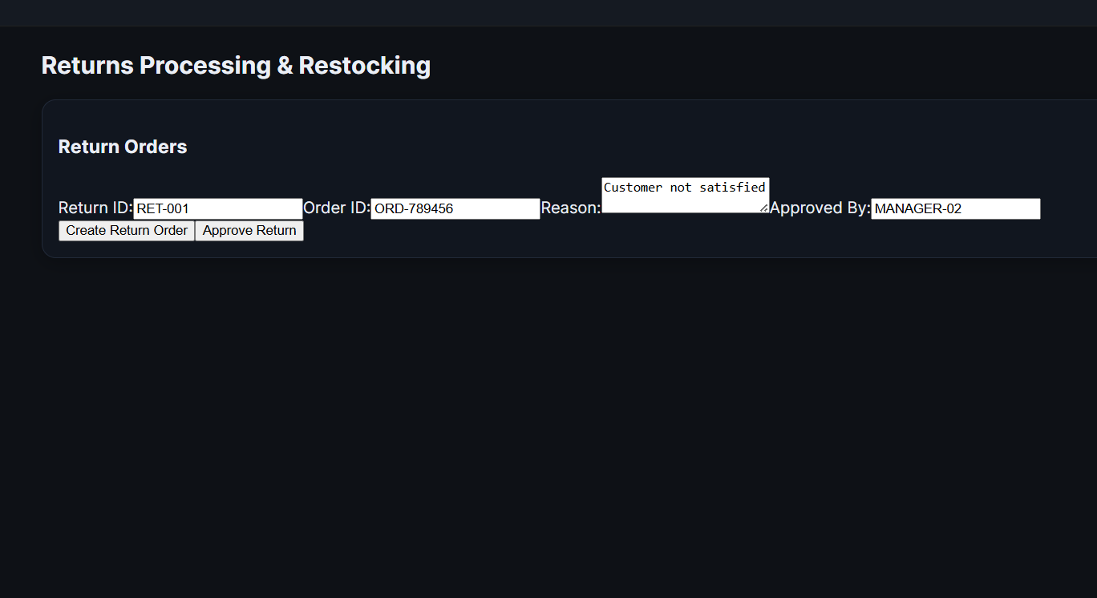

### 6.16 Reconciliation & Reporting

Supports:

* Create reconciliation reports
* View reports
* Finalize reconciliation

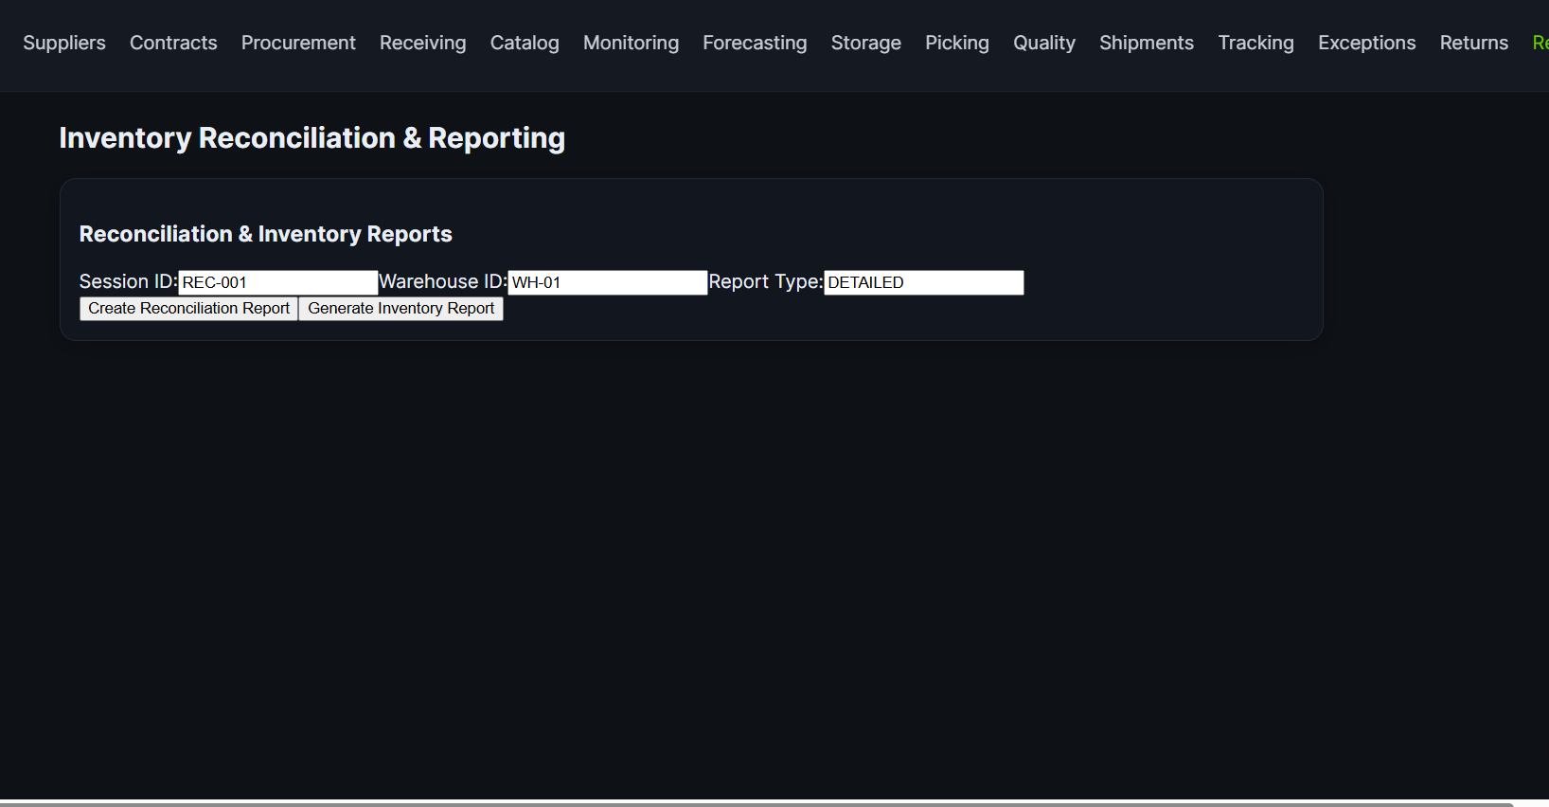

## 7. Testing & Validation

**Functional Testing Performed:**

| **Feature** | **Status** |
| --- | --- |
| API connectivity | ✓ |
| Form submissions | ✓ |
| Error handling | ✓ |
| Stock update logic | ✓ |
| Alerts & monitoring | ✓ |
| Forecasting inputs | ✓ |
| Routing & navigation | ✓ |
| Charts rendering | ✓ |

# **Conclusion**

The development of the Inventory & Supply Chain Management System successfully demonstrates how modern e-commerce businesses can streamline operations through a structured, automated, and integrated workflow. By dividing the system into fifteen core business processes, spanning procurement, inventory control, warehouse operations, order fulfillment, shipment management, delivery tracking, exception handling, and returns, the project captures the full lifecycle of goods movement in an end-to-end supply chain environment.

The system implementation, built using **Spring Boot (Java)** for backend services, **React.js** for the frontend, and **MySQL** for data persistence, follows clean and modular architectural principles. The use of **REST APIs**, layered architecture, and patterns such as **MVC**, **Repository**, and **DTO** ensures code reusability, maintainability, and scalability. Each process was implemented with clear business logic, validations, structured error handling, and separation of concerns, providing a robust foundation for real-world extension.

The integration of all fifteen processes into unified workflows, such as order fulfillment, inventory replenishment, exception handling, and returns management, highlights how data flows seamlessly across modules. These workflows clearly depict how decisions in one stage (e.g., stock update, QC result, dispatch confirmation) directly influence the next stage, ensuring a synchronized and responsive supply chain. API sequencing and inter-process dependencies further emphasize the importance of coordination between Inventory, Quality Check, Shipment, and Tracking modules.

Overall, the project achieves its core objective: **to design a simplified yet realistic e-commerce supply chain system that mirrors how professional industry solutions operate**. While the implementation focuses on simplified logic and demonstration-level functionalities, the architectural choices, process flows, and API designs lay a foundation that can be extended into a production-ready system with database persistence, automation, microservices, security hardening, and cloud deployment.

In conclusion, this project not only meets the academic requirements but also provides a strong conceptual and technical understanding of how modern inventory and supply chain systems are engineered, integrated, and optimized. It serves as a comprehensive learning experience in system design, REST-based development, workflow documentation, and enterprise software architecture, skills that are directly applicable in real-world engineering and e-commerce technology environments.